Year 2
Class 2 – Home learning
Look at the images on the next 3 pages, think carefully about the sense work we completed for our setting description on the Flotsam book. Imagine you are there in the different pictures, write a detailed description of each one. Think about what you can see, hear, smell and touch.
Mrs Horton’s model.
Nestled amongst the trees was a long, winding path that led into the forest of hope. Nervously, I began to tread along the rickety, wooden path. With each step, the creaks became louder and louder. My hands tightly grabbed onto the rough green rope guiding me along the trail. I looked ahead, surrounded by misty fog and green trees, I really wasn’t sure if I was ever going to make it. I could hear the birds singing in the distance, getting quieter and quieter with every step I took. I wanted to turn back and go home but that wasn’t an option. I continued my journey forward….
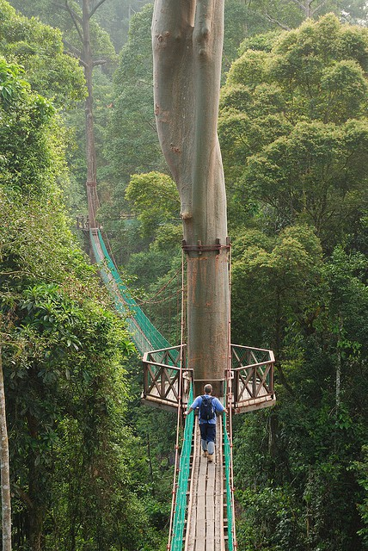
Once completed, why not share some of your descriptive writing by email. I would love to read your work.

Images to describe.

Long, winding roads.

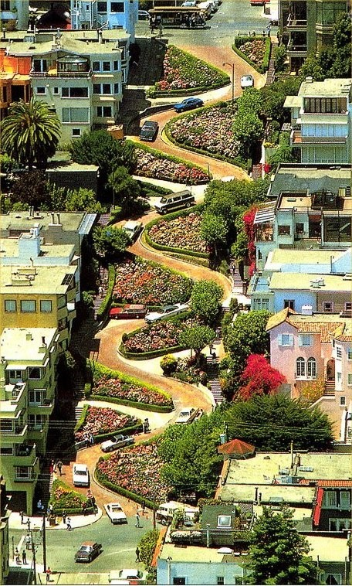

Trees swaying in the wind.

