Can I measure angles accurately?
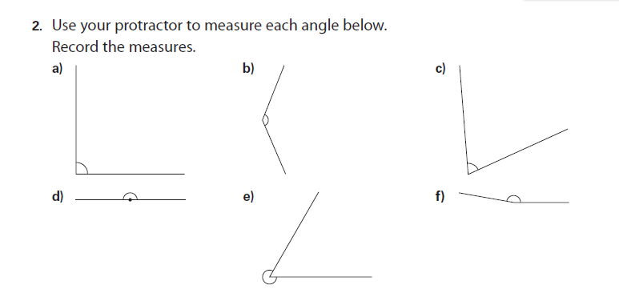
- Show me that you understand the 4 different types of angle: acute, reflex, right-angled and obtuse.
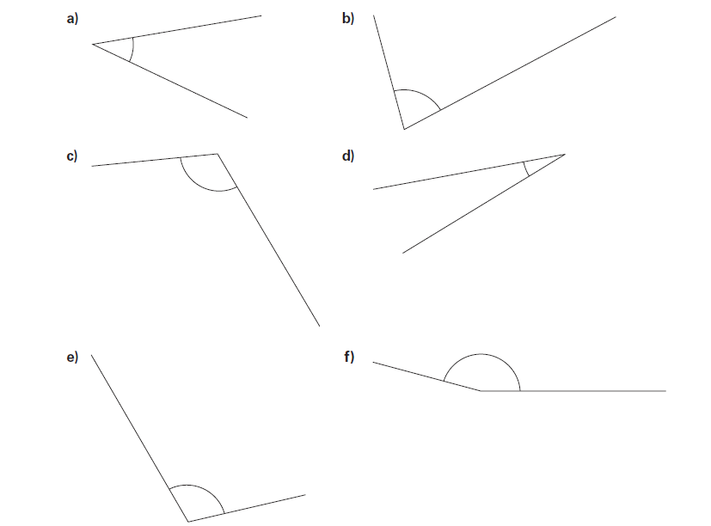
Can I measure angles accurately?
- Show me that you understand the 4 different types of angle: acute, reflex, right-angled and obtuse.
- Estimate and then measure each of these angles:

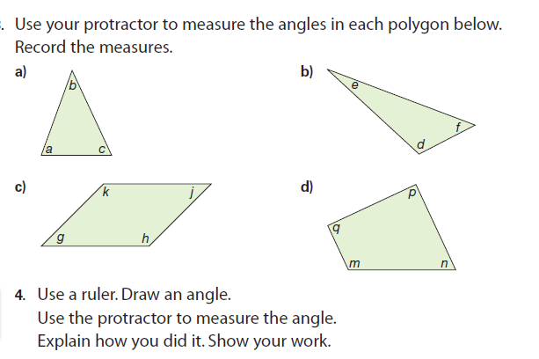
Can I measure angles accurately?
- Show me that you understand the 4 different types of angle: acute, reflex, right-angled and obtuse.
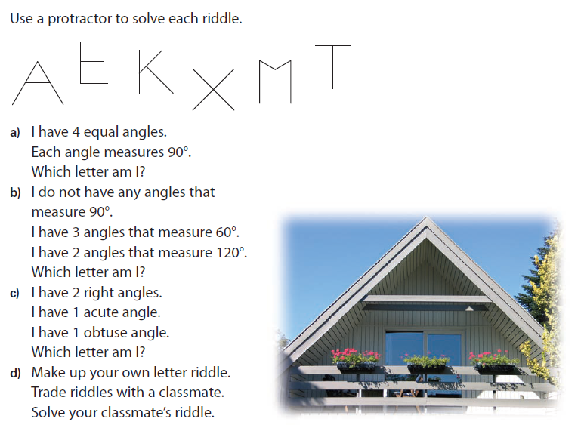
- Estimate and then measure each of these angles:
Extension:
