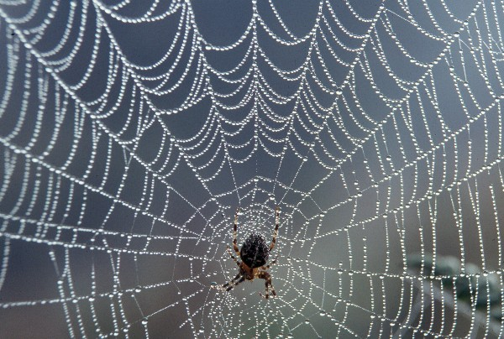
SPINNERS
SPINNERS

Introduction
Humans have been interested in spiders for hundreds, perhaps thousands, of years. Some people see them as horrible and scary. Others see these animals as a sign of good luck. Whether you like them or not, spiders are very useful members of the animal kingdom, which help the balance of nature by eating lots of insects.
The Spider Web
Each kind of web-building spider builds its own kind of web. However, not all spiders spin webs, but they can all make silk. They spin their silk through organs called spinnerets. The silk starts as a sticky liquid, which hardens to form a very light but very strong thread.
If you make a steel thread as fine as a thread of a spider silk, the silk would be just as strong as the steel.
The moment a spider hatches from its egg, it knows how to spin a certain pattern by instinct.
In the next section, you can see how one garden spider spins its web.
How a spider spins a web
It takes a spider about an hour to spin an orb web. The fine silk thread looks delicate but it can hold 1,000 times the spider’s own weight!
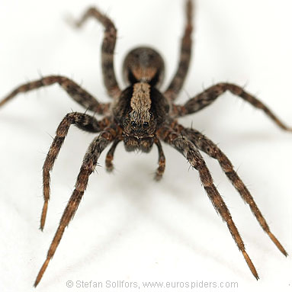
After finishing its web, the spider usually waits out of sight with one leg on a ‘signal thread’. When an insect lands in the web, the thread shakes. Instantly, the spider pounces.
Parts of the orb are made of a special sticky silk, so insects can’t escape before the spider arrives.

Glossary
orb | rounded shape
organ | part of the body
instinct | by nature/not learnt
signal a message
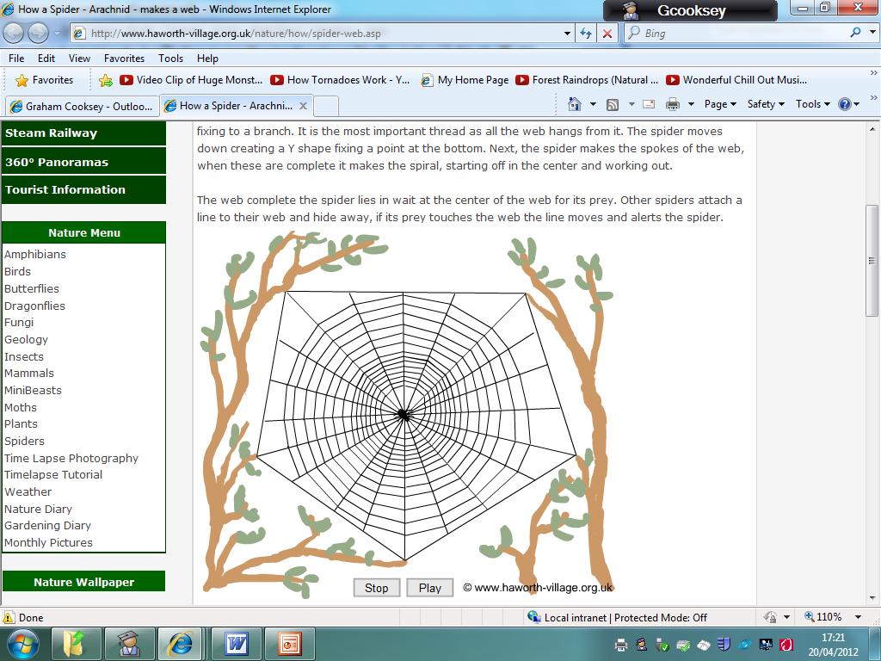
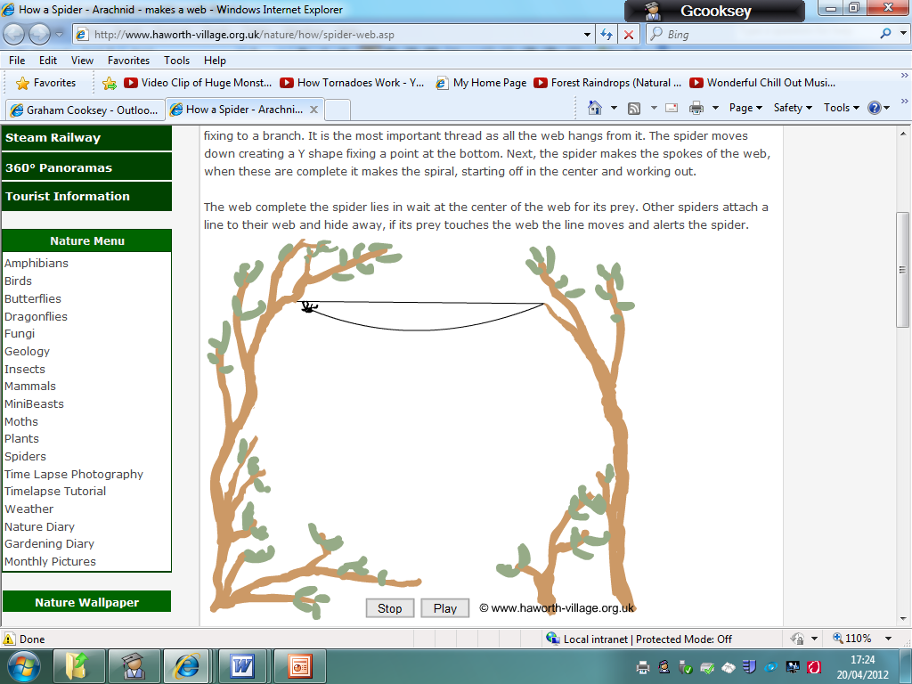
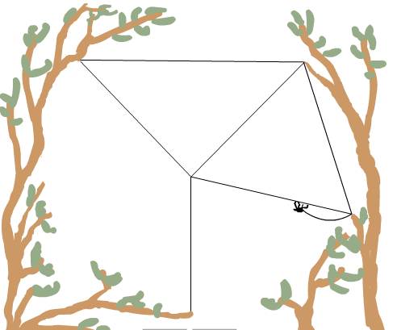
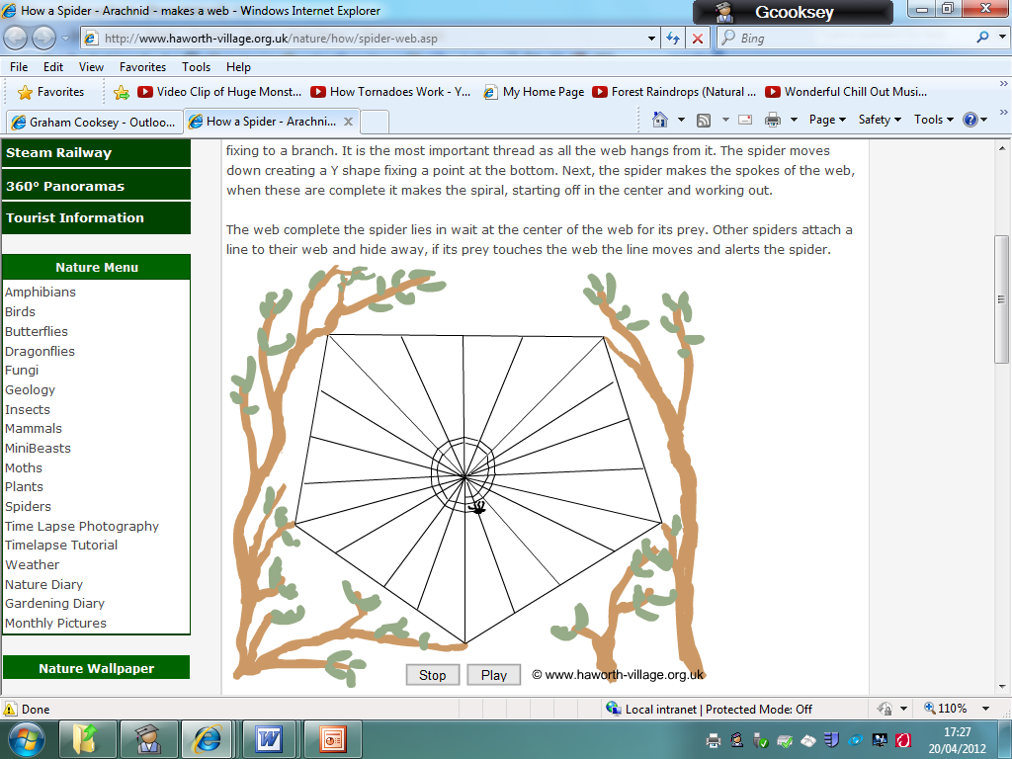
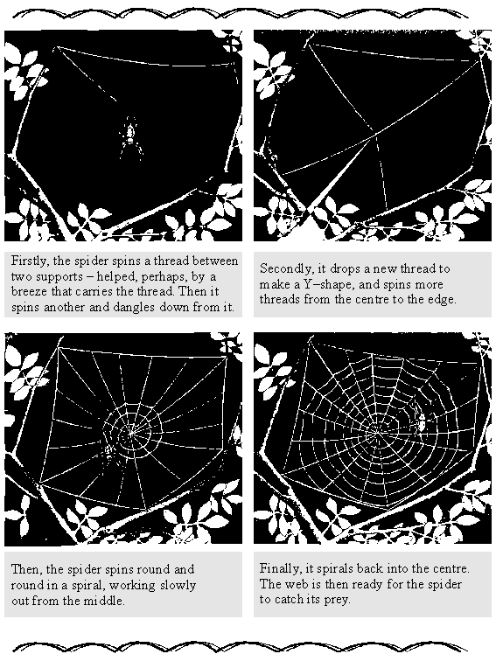
Extract taken from Amazing Spiders © Dorling Kindersley

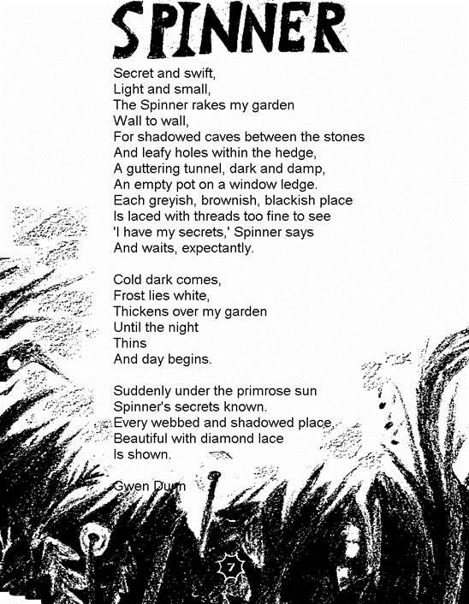
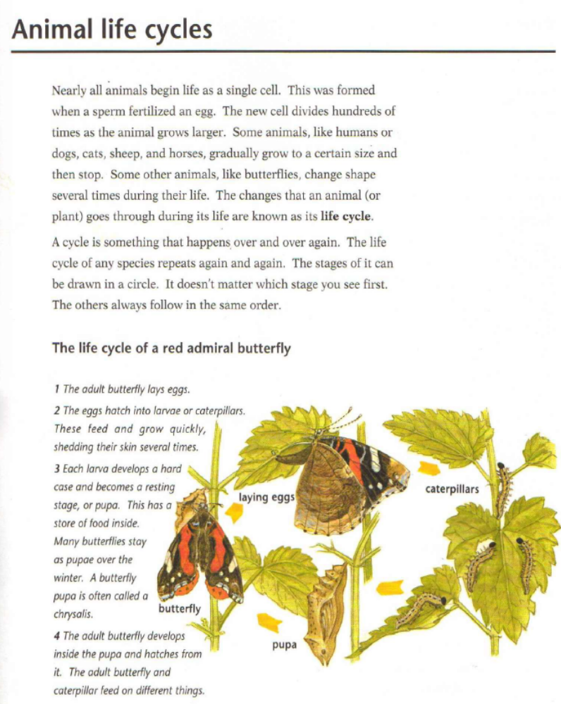
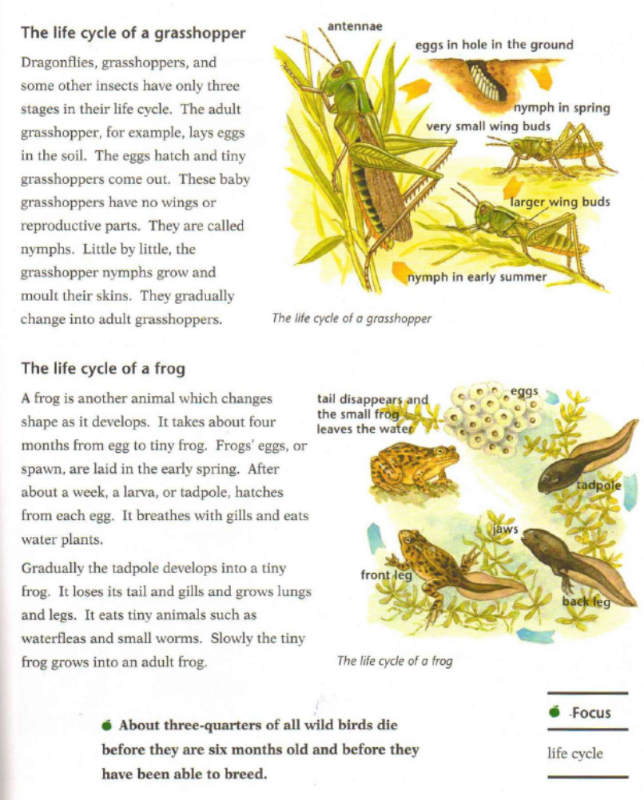
Spider Web
Choose the best group of words to fit the passage and put a ring around your choice.
1. You can find out how a garden spider spins a web. It takes the spider about

2. To spin a web. Spiders know how to spin their webs and catch flies
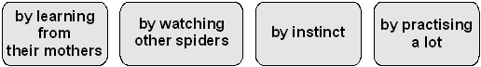

3. When it has finished its web, the spider
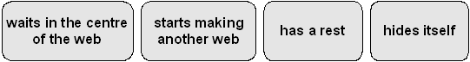

4. Once an insect is caught, it cannot get away because
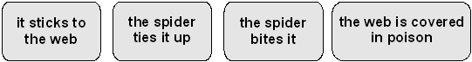

5. The information tells us how a spider spins a web.
Below is a summary of the four stages, but they are mixed up.
Number each stage to show the correct order, the first has been done for you.

 | spins third thread downwards
 | returns spinning from outside to middle
 | spins thread to join two supports
  1
 | spins from inside to edge

6. Write down two facts from the text which show that spiders’ silk is very strong.
1 ............................................................................................................................
...............................................................................................................................
2 ............................................................................................................................
...............................................................................................................................

7. Instantly, the spider pounces.
In reality, spiders cannot pounce or jump on the web.
Why, then, do you think the writer chose to use the word pounces in the last paragraph?
...............................................................................................................................
...............................................................................................................................
...............................................................................................................................

8. Look at the four boxes showing you how a spider spins a web.
How do you know the order in which to follow the information?
Write down two ways.
1 ............................................................................................................................
2 ............................................................................................................................
2 marks

9. These questions are about the way in which the information is presented.

These questions are about the poem, Spinner
1. What creature is this poem about?
....................................................................................
1 mark

2. What sorts of places does the Spinner look for in the first part of the poem?
...............................................................................................................................
...............................................................................................................................
2 marks

3. What two changes take place in the second part of the poem that give the Spinner’s secrets away?
1 ............................................................................................................................
2 ............................................................................................................................
2 marks

4. The last line of the poem is: Is shown.
What would you see if you were there?
...............................................................................................................................
...............................................................................................................................
2 marks

5 Find five words to do with darkness in the first part of the poem.
Write one word next to each dot.
• .....................................................................
• .....................................................................
• .....................................................................
• .....................................................................
• .....................................................................
2 marks

6. In the third part of the poem, the webs are described as:
diamond lace.
What does the word diamond tell you about the webs?
...............................................................................................................................
...............................................................................................................................
...............................................................................................................................
2 marks

7. The second part of the poem is different from the first and third parts.
Write down one main way in which it is different
...............................................................................................................................
...............................................................................................................................
...............................................................................................................................
1 mark

8. In the second part of the poem we read:
… the night
Thins
Explain what these words mean and why you think the poet chose the word thins.
...............................................................................................................................
...............................................................................................................................
...............................................................................................................................
...............................................................................................................................
...............................................................................................................................
...............................................................................................................................
...............................................................................................................................
...............................................................................................................................
3 marks

These questions are about the section called Animal life cycles.

“Slowly, the tiny frog grows into an adult frog.”

Find TWO other words or phrases that suggest that young animals develop slowly.

__________________________ and ____________________________

Why is a grasshopper’s life like a cycle?

______________________________________________________________________

______________________________________________________________________

How has the author made the information on this page easier to read?

______________________________________________________________________

______________________________________________________________________

______________________________________________________________________

What are the differences between the way a frog grows and a grasshopper
develops?

______________________________________________________________________

______________________________________________________________________

______________________________________________________________________

Why are the lives of dragonflies and grasshoppers similar?

______________________________________________________________________

Read the fact about wild birds, at the bottom of p.25. What effect was the
author trying to make with this fact?

______________________________________________________________________

______________________________________________________________________

Which of these 3 sections (butterfly, grasshoppers, frogs) was most clearly?
Write your reasons, by referring to the text.

______________________________________________________________________

______________________________________________________________________

______________________________________________________________________

______________________________________________________________________

______________________________________________________________________
ANSWERS
Spider Web
Award 1 mark for each correct choice.

1.
2. | 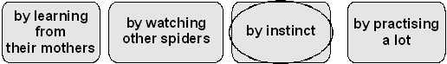
3. | 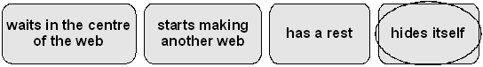
4. | 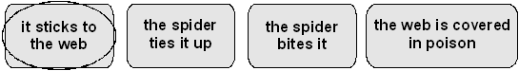

up to 4 marks
5 Focus of question: sequencing of information
Award 1 mark for two or three stages correctly numbered.
Award 2 marks for all stages correctly numbered.

2 | spins third thread downwards
4 | returns spinning from outside to middle
1 | spins thread to join two supports
3 | spins from inside to edge

up to 2 marks

6 Focus of question: textual evidence
Award 1 mark each for answers along the following lines up to a maximum of 2:
• can hold 1000 times the spider’s own weight (Accept 10,000 or 100);
• as strong as steel thread.
Do not accept:
• the insects cannot escape from the web;
• the liquid silk hardens;
• a light but strong thread (given).
up to 2 marks
7 Focus of question: effect of word choice
Award 1 mark for answers which refer only to the speed or sudden movement of the spider, eg:
• because the spider moves fast / runs / leaps / rushes;
• because it grabs / snatches its food / the insect (before it gets away).

Award 2 marks for answers that refer implicitly or explicitly to effect / authorial intent / aptness of word choice in suggesting speed / sudden movement, eg:
• he wanted to make us think that the spider gets to the fly fast.
Note: references to effect / authorial intent may be expressed in very simple ways and may be recognised by such phrases / words as the following:
• it’s like..., as if..., it’s a good word for..., it means..., it looks like..., it makes it seem / sound..., to tell / show you that..., to say that... / give the impression / indicate / suggest that..., s/he wants you to know that....
Also, award 2 marks for answers that make reference to hunting / predation / ruthlessness /eagerness or refer to the author’s intention to compare the spider’s movement to the action of predatory animals:
• because it attacks its prey;
• to make it seem fierce like a tiger / lion / other animals that pounce on their prey;
• because it makes it sound vicious / powerful / fierce;
• so that you know the spider is the predator and the fly is the prey. up to 2 marks
Do not accept:
• because it describes it well / it is a good word;
• because that is what the spider does.

8 Focus of question: understanding of organisational devices
Award 1 mark for each answer along the following lines up to a maximum of 2:
• reference to: firstly, secondly, finally (one or more of these);
• usual to read from left to right / top to bottom;
• the illustrations become increasingly complete
• the illustrations show the steps / stages more of the web is shown in each picture
• starts with a small amount of thread, then there’s more and more.

up to 2 marks
Do not accept:
• by looking at the pictures.
9 Focus of questions: understanding organisational and presentational features of text
(a) Award 1 mark for appropriate explanations about the prominence of these words, eg:
• it is the main heading / title of the whole page / it is the title;
• tells you what the whole page is about;
• so your eye is drawn to it first of all.
Do not accept:
• so you can see it / to catch your eye (implicit in question);
• it’s important;
• it’s the title of the paragraph;
• it is the main information.

(b) Award 1 mark for explanations that refer to subheadings or their features, eg:
• it is a subheading / side-heading;
• tells you what one section is about;
• they are not as important as the main heading;
• because it’s still about webs but it’s a different part.
(c) (i) Award 1 mark for definitions such as:
• it tells you what words mean;
• it’s like a little dictionary;
• a key to the meaning of words.
Do not accept:
• a key.
(ii) Award 1 mark for explanations about the effect of typographical variation, eg:
• so you can tell the word from its meaning;
• to distinguish the words from the explanations;
• because that is the word they are telling you about / that is being explained;
• because they are words taken from the text.
Do not accept:
• they are the difficult / hard words.
up to 4 marks
M2. Spinner
1 Focus of question: identification of the subject of the poem
Award 1 mark for
• a spider
Do not accept:
• Spinner
1 mark
2 Focus of question: retrieval of detail
Award 1 mark for answers that are taken directly from the text and refer to two or more of the following:
• shadowed / caves;
• stones;
• pots;
• dark / tunnel;
• hedge;
• gutter;
• (leafy) holes;
• in the wall;
• greyish / brownish / blackish place(s).

Award 2 marks for answers that summarise, categorise or generalise from the poem, eg:
• dark / shady / shadowy places;
• somewhere where it can hide away.
Do not accept:
• garden
or direct quotations of the first three lines of the poem.
up to 2 marks

3 Focus of question: retrieval of detail
Award 1 mark each for one answer from each group, up to a maximum of 2:
• frost / ice / dew;
• sun / daylight / dawn.
up to 2 marks
4 Focus of question: identification of image
Award 1 mark for answers that reveal understanding of the key feature of the final stanza, ie webs:
• a web / webs;
• beautiful webs / webs like lace.
Award 2 marks for a fuller description of what is revealed, eg:
• a spider’s webs covered in frost / drops / dew;
• a spider’s webs glistening in the sunshine;
• dew clinging to the webs and sparkling.
Do not accept only direct quotation from the text.
up to 2 marks
5 Focus of question: retrieval; interpretation of language
Award 1 mark for four correctly identified words.
Award 2 marks for five correctly identified words.
• shadowed; • holes; • tunnel;
• greyish; • brownish; • caves;
• dark; • secrets; • blackish.
up to 2 marks
Do not accept:
• damp.

6 Focus of question: interpretation of imagery
Award 1 mark for answers which refer only to the shining / glistening / sparkling quality of diamonds.
Award 2 marks for answers which refer to other aspects of diamonds, such as their value or use in jewellery, eg:
• shiny, glittering and valuable;
• the webs are like diamond necklaces because the spider’s silk is like the thread on which the diamonds of dewdrops are laced;
• the web is as precious to the spider as a diamond is to us and it is also beautiful the way it shines in the sun;
• beautiful chains of crystals,transparent and sparkling.
Do not accept answers that refer only to the strength or shape of spiders’ webs.
up to 2 marks
7 Focus of question: understanding of structure
Award 1 mark for answers which refer either to line /word length or to change of content, eg:
• not about the spider / it is about the weather / time of day;
• the lines are shorter.
Do not accept:
• it is shorter;
• it is dark.
1 mark
8 Focus of question: understanding of theme
Main contrasts:
• darkness / light
• secrecy / revelation
• mystery / openness
• mundane / beautiful, magical.
Award 1 mark for a contrast or contrasts expressed in very general terms, or rather trivial or implicit contrasts, eg:
• verse 1 is about the spider’s hiding places, verse 3 is about the webs;
• in part 1 it’s saying where it tries to put its web, in part 3 the spider has put up its web.
Award 2 marks for answers which include one of the main contrasts and reference to the text, eg:
• the webs are all hidden in dark places in verse 1, in the last verse they are still in those same places but the sun has shone on them, so they’re in the light;
• you don’t know what it’s all about in part 1, but in part 3 you find out what the secret is;
• the poet contrasted darkness with day and the spider making the web with the finished web.

Award 3 marks for explaining and exploring at least two of the contrasts, eg:
• In the first part everything is dark and secret with the spider hiding its webs in all sorts of nasty, dark places, so that they can’t be seen by the flies. In the last part it shows you how lovely they are in the light, with the sun shining to make them look like strings of diamonds;
• The first part is very descriptive in a way that is realistic. The third part is descriptive but leaves things to your imagination. The first part is just a setting whereas the third part is the revealing of the magic.
up to 3 marks
9 Focus of question: understanding of imagery
Award 1 mark for answers which focus only on one part of the question, either identifying the image (night fades) or giving an obvious reason why the poet might have chosen the word thins, eg:
• it was getting light;
• it was starting to be morning;
• to make it rhyme with ‘begins’.
Award 2 marks for answers which identify the image and explain either the choice of words or the gradual nature of change, eg:
• to tell you that it was getting light slowly;
• I think the poet chose this because day is coming and this rhymes with begins;
• I think the poet chose the word thins because it describes how the night slowly drifted away bit by bit instead of suddenly turning into morning with a bang.
Award 3 marks for answers which identify the image and explain its use in the context of the whole stanza / poem, eg:
• the poet uses it as an opposite to thickens, which is two lines above. As the night goes on, the frost gets thicker and then, as the night passes and it gets lighter, the frost starts to thin and melt away;
• I think ‘night thins’ means that it is no longer pure black - it’s like dropping water into black paint, it gets thinner and less dark. I think the poet chose the word ‘thins’ because it is a good way to show that it was a gradual return to sunlight in the next verse;
• the poet means that the night thins and disappears as the daylight arrives; darkness dissolves into light and reveals the spider’s doings, as if the night shrinks and shrinks and evaporates into daytime.
Do not accept:
• it is an interesting / adventurous / unusual word.
up to 3 marks

These questions are about the section called Animal life cycles.

“Slowly the tiny frog grows into an adult frog.”

Find TWO other words or phrases that suggest that young animals develop slowly.

Accept words/ phrases that create the impression of slowness/ length of time e.g. gradually, steadily, day by day… upto 2 marks

Why is a grasshopper’s life like a cycle?

Accept descriptions, however approximate, of how each stage of the life is in an order and that it repeats, returning time and time again. upto 2 marks

How has the author made the information on this page easier to read?

Accept answers that include: labels, numbers, arrows, key vocabulary highlighted, images
Up to 2 marks

Read the fact about wild birds, at the bottom of p.25. Why did the writer include this fact?

To capture reader’s attention – brings the plight of wild birds to the readers’ attentions.

Which of these 3 sections (butterfly, grasshoppers, frogs) was most clearly?
Write your reasons, by referring to the text.

Justified answers using evidence from the text Up to 3 marks

