Class 2 English Homework Menu.
Pick one activity per week to complete. Don’t forget the every day tasks.
Autumn 1
Every day  1 point per day. | Practise letter formation.  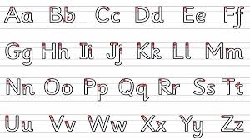 | Read your school reading book with an adult. Don’t forget to ask them to sign your reading record too! | Practise reading and spelling the words from the Y1 and Y2 spelling list. Choose 5 every day.
You will be awarded bonus house points for these activities if you complete the everyday tasks.
Please bring your homework books in on a Wednesday.
English | Write all about it!  Keep a diary for a week and write about the things you have done and how you are feeling. You might want to add in illustrations. | Fire!  Create a fact file with at least 5 important facts or information about the Great Fire of London. | Word choice.  Use 5 spellings from the Y1 / 2 list and put them into a sensible sentence. Make sure you have used a capital letter and full stop!
 | Parent signature:  Date: | Parent signature:  Date: | Parent signature:  Date:
English | Adjective work  Write a description of your favourite place to visit, using adjectives to write 10 ‘list sentences’.  Can you make a 2 adjective sentence? | Book work  Write a book review of your current book. Tell me: what it is called, what it’s about, what your favourite part is and why you like it. | Choose 5 of the spellings from Y1 and 2 and put them into silly sentences, using a conjunction in each: when, if, that, because, and, but, so, yet.
 | Parent signature:  Date: | Parent signature:  Date: | Parent signature:  Date:

