Literacy homework: 12/10/18
This week in Literacy we have been improving our poetry skills, practising using a range of different features, whilst describing elements of Harvest time.
A well-known type of poem is called an Acrostic poem, which is where the name of something is used as sentence starters, and all of the sentences relate back to the subject.
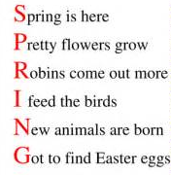
e.g.

Can you make your own Acrostic poem based on an element of Harvest-time? For example your word could be: harvest, giving, farmer, autumn, vegetables etc! Try to use features such as; adjectives, commas in a list and prepositions!

Literacy homework: 12/10/18
This week in Literacy we have been improving our poetry skills, practising using a range of different features, whilst describing elements of Harvest time.
A well-known type of poem is called an Acrostic poem, which is where the name of something is used as sentence starters, and all of the sentences relate back to the subject.
e.g.

Can you make your own Acrostic poem based on an element of Harvest-time? For example your word could be: harvest, giving, farmer, autumn, vegetables etc! Try to use features such as; adjectives, commas in a list and prepositions!

