Class 2 Maths Homework Grid
Autumn 2
PLEASE CHOOSE ONE ACTIVITY PER WEEK.THIS IS HOMEWORK UP UNTIL CHRISTMAS.
Please put the date and the title at the top of each page.

Every day activities. | 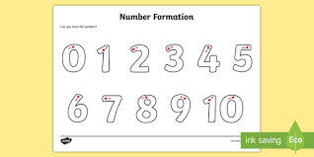  Practise number formation. Write them out neatly in your book. | Every other day: (5 mins)  Count in 2’s 5’s 10’s – Year 1  Practise reciting 2, 5 10 x table – Year 2  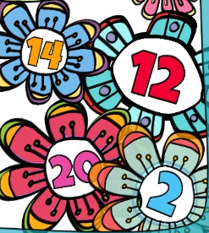 | Play on Times Table Rockstars for 10 minutes.
Maths | Addition and subtraction. (Y2)  Write the number sentences in your books and show your calculations. Show your working out on a number line or bar models.  - 25 + ? = 47  - 58 – 14 =  - 34 + 23 =  - ? + 15 = 32  - 64 - ? = 22 | Number bonds (Y1 and Y2)  Practise writing your number bonds in 10, 20 and 100 systematically.  Example:  0 + 10 = 10  1 + 9 = 10  2 + 8 = 10 and so on | Addition and subtraction (Y1)  Write the number sentences in your books and show your calculations. Show your working out on a number line or bar models.  - 11 + 7 =  - 19 – 6 =  - 18 + 4 =  - 12 – 5 =  - ? + 7 = 19
 | Parent signature:  Date: | Parent signature:  Date: | Parent signature:  Date:
Maths | Time Yourself  How long does it take you to do different things? Suggestions: Brush your teeth/eat breakfast/get to school/have a shower/clean your room/do 10 star jumps/ hop around the garden/play a favourite game, etc. What can you do in two minutes? Try lots of different things!  Record these timed activities in a table and write questions for someone to find the answers from the data collected. | Fruit and Veg  Find a variety of fruit and vegetables. Estimate how much they weigh, then weigh them accurately in grams and kilograms. Record in a table like this:  Name Estimate Weight  Banana 150g 100g  carrot 50g 75g  (Extension activity) Put the items in order of mass smallest to largest.  Can you add any together to make 300g, 50g, 2Kg etc. | A number story  If the answer was 25, what could the question be?  Use addition, subtraction, multiplication and division facts to show me as many different ways.  Choose a different answer, and then write the questions for that answer.
 | Parent signature:  Date: | Parent signature:  Date: | Parent signature:  Date:

