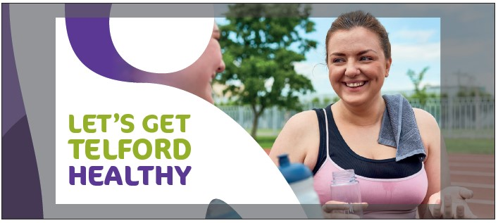

The coronavirus pandemic has highlighted to many people how important it is to take care of their health, taking care of your long term health includes maintaining a healthy weight, keeping active and quitting smoking which are all part of living a healthy lifestyle.

To help you with making changes to your lifestyle we have a NEW e-mail programme from the Healthy Lifestyle Team to guide you through all you need to know about getting healthy.

Sign up to our FREE support and you’ll receive messages over a 12 week period that introduces a different topic each week to help you make the changes you chose. We will also send you weekly messages with tips and ideas for you to try out. We will include videos, case studies and useful links to help you reach your goals.

You can contact us for additional help if you feel you need it, as well as joining the Healthy Lifestyles Chat group on Facebook for support from others on their journey https://www.facebook.com/groups/4921986791160613

So sign up today to start your journey and receive your welcome email with more information https://public.govdelivery.com/accounts/UKTW/signup/18627 and don’t forget to share your journey using the hashtag #LetsGetTelfordHealthy on Facebook, Twitter or Instagram.

The Healthy Lifestyle Team

