Maths – Addition Symbol
https://vimeo.com/462716121
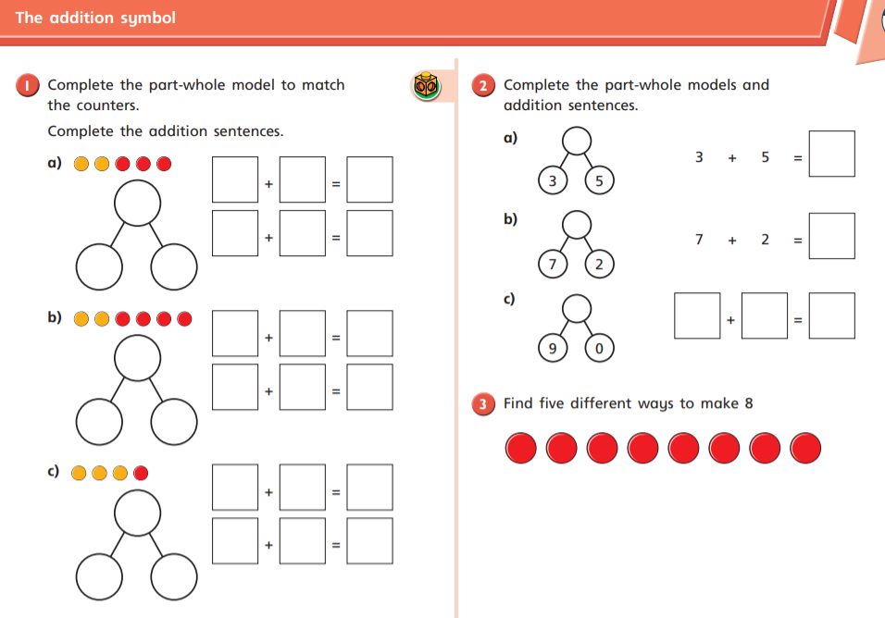

Science
In science this half term we are looking at ‘Our Local Habitat’. Today we will be identifying seasonal changes that happened in out local habitat.
How do the trees change throughout the yeah in your local area?
Show the seasonal changes of a tree using the sheet below.
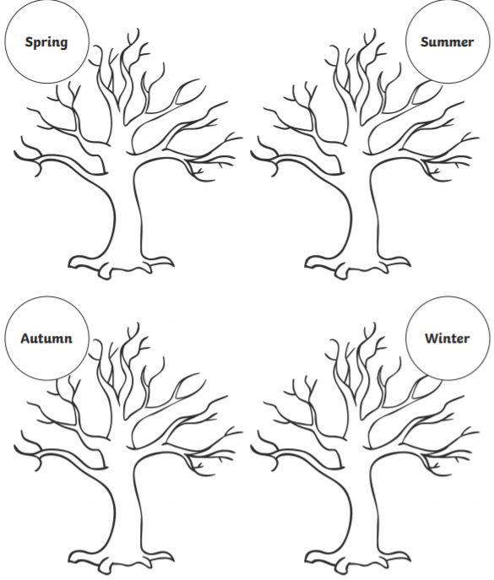

Phonics
Recap the tricky words on your bookmark.
Write a sentence about this picture using the ‘ur’ digraph (burnt).
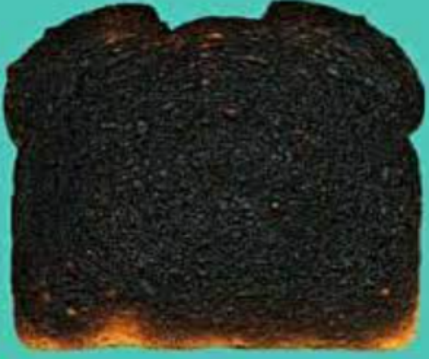
Reading
Please try to read your book every day.

