English
This week we are going to be writing a non-chronological report about Katherine Johnson for Black History Month. Today you will be recording information about Katherine Johnson.
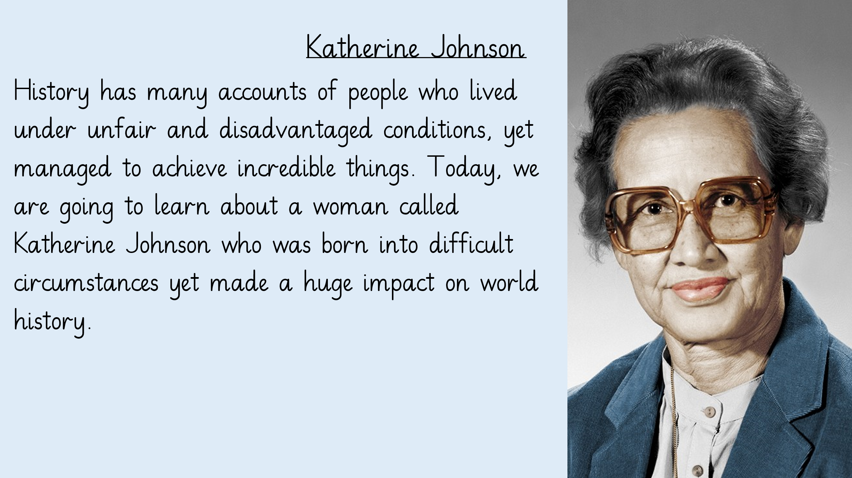
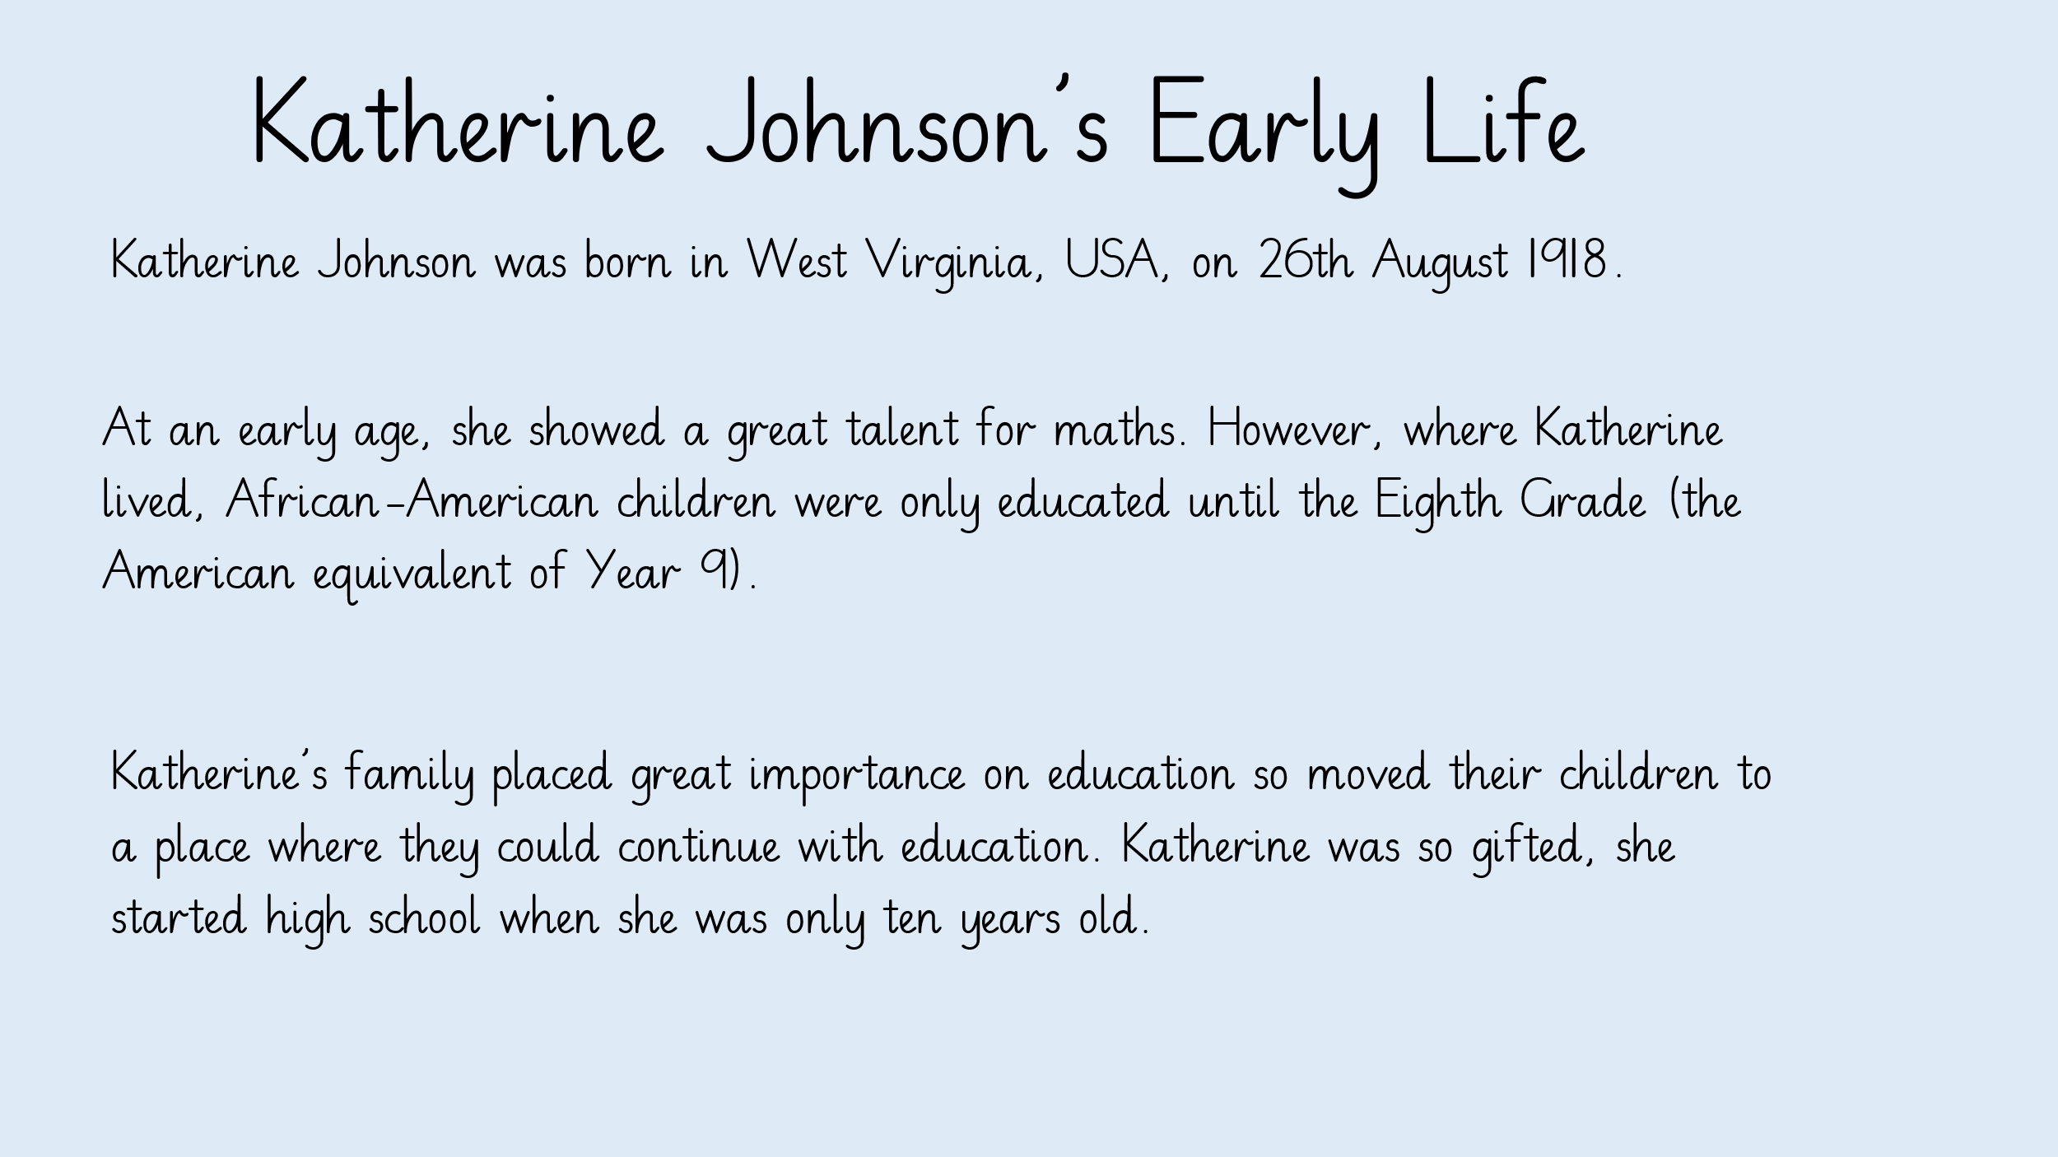
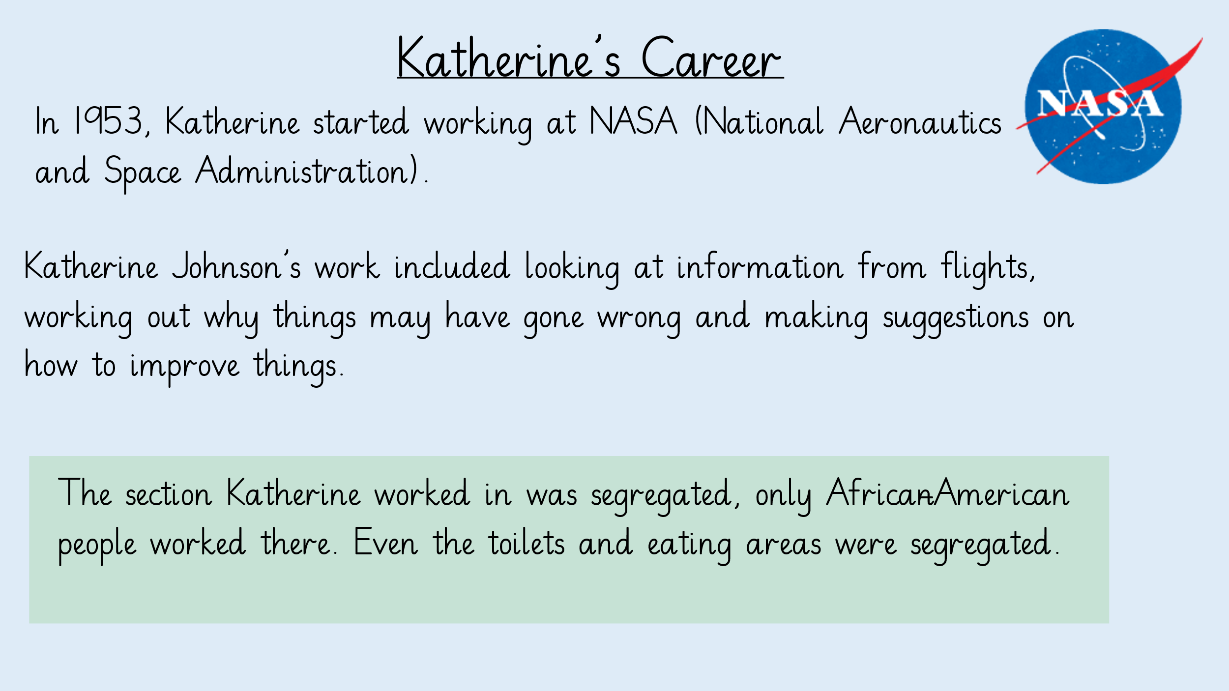
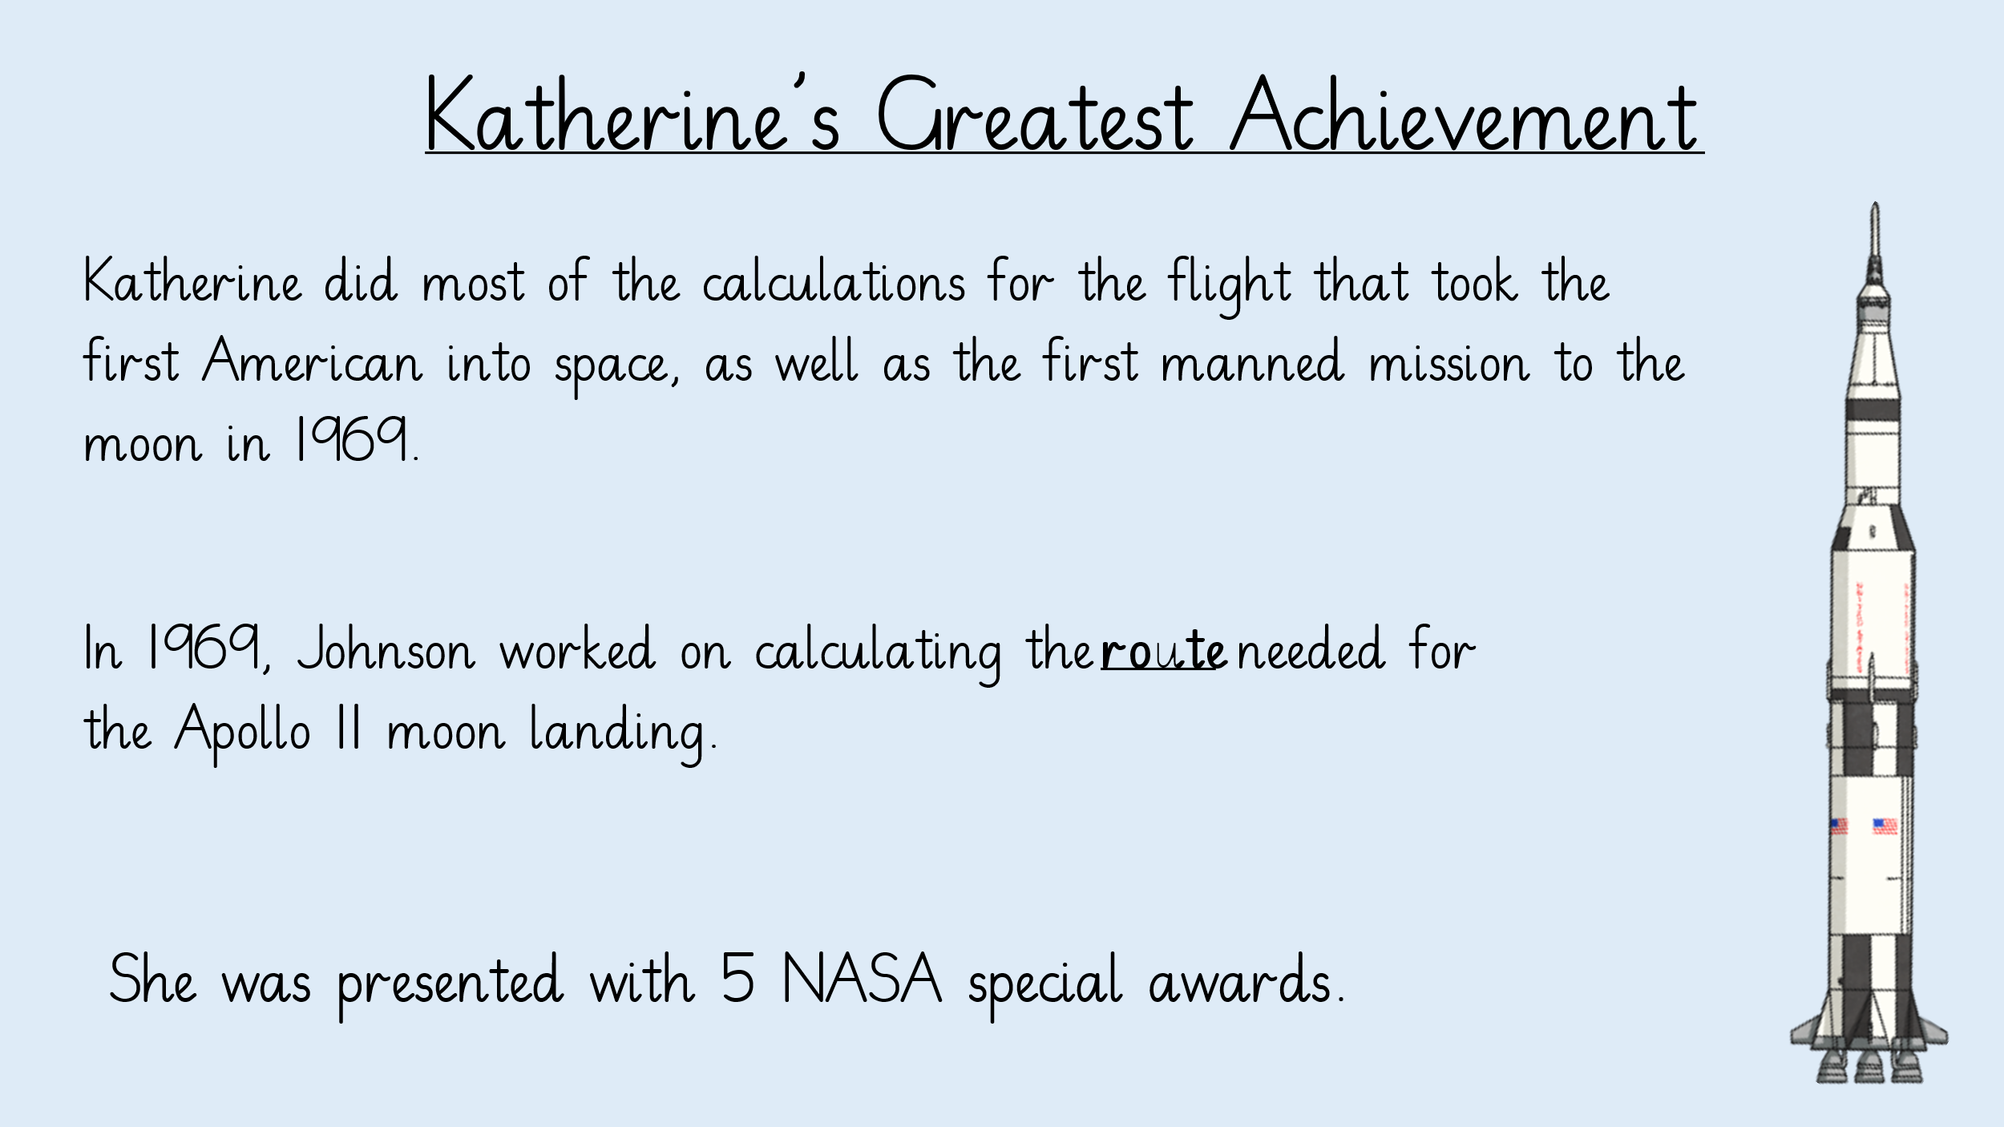

Use the information from these slides to complete a mind map about Katherine Johnson.
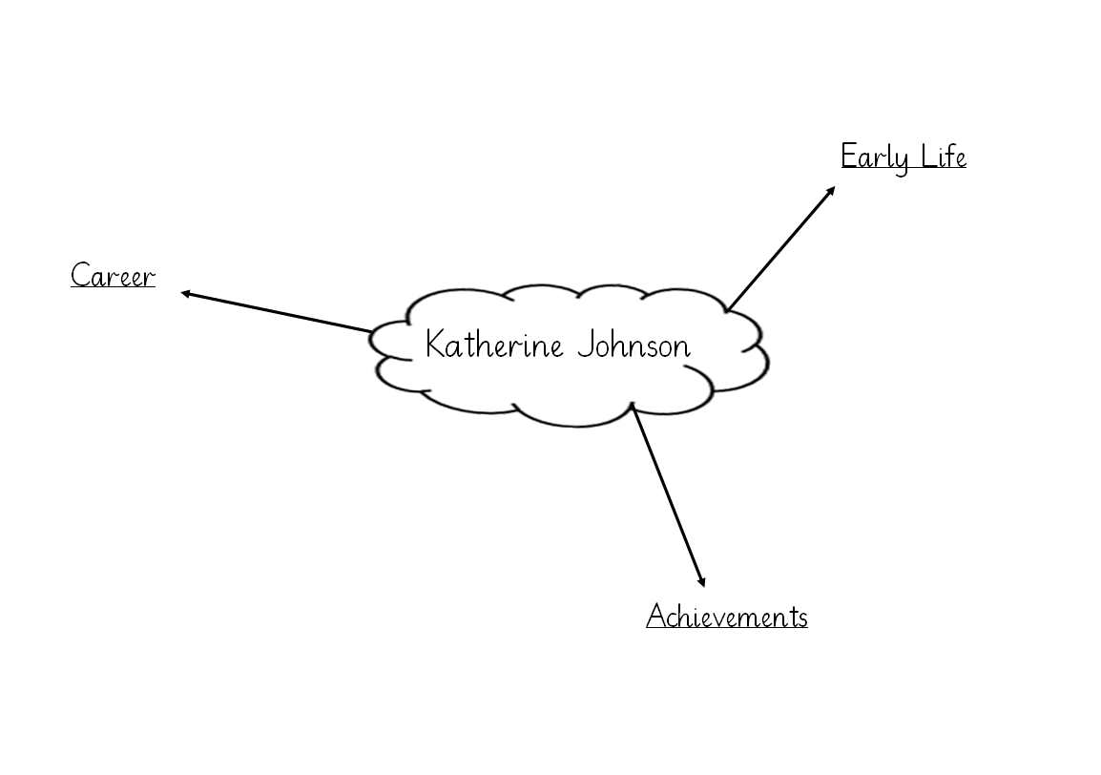
Maths – The Number Line
https://vimeo.com/459320928
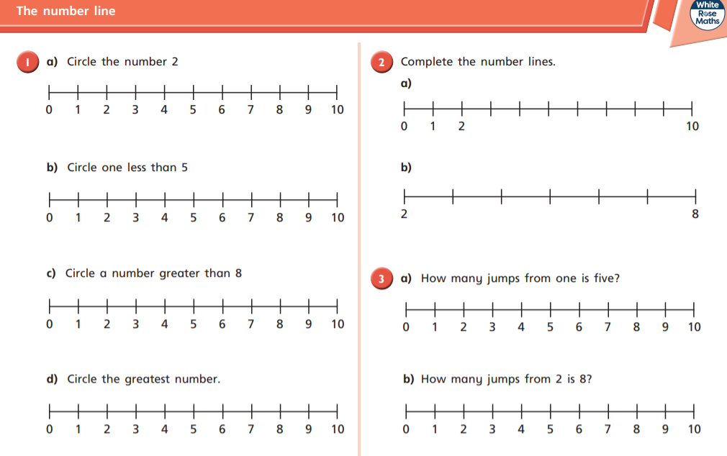

Computing
Try and find and log into Purple Mash on your own, like we have been practising in class.
When you get onto Purple Mash, practise typing on a keyboard using the 2Type activities.
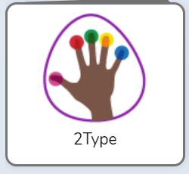

Phonics
Practise the tricky words on your bookmark.
Write a sentence about this photo using the ‘oo’ sound (spoon).

Reading
Please try to read your book every day.

