Micro-habitats

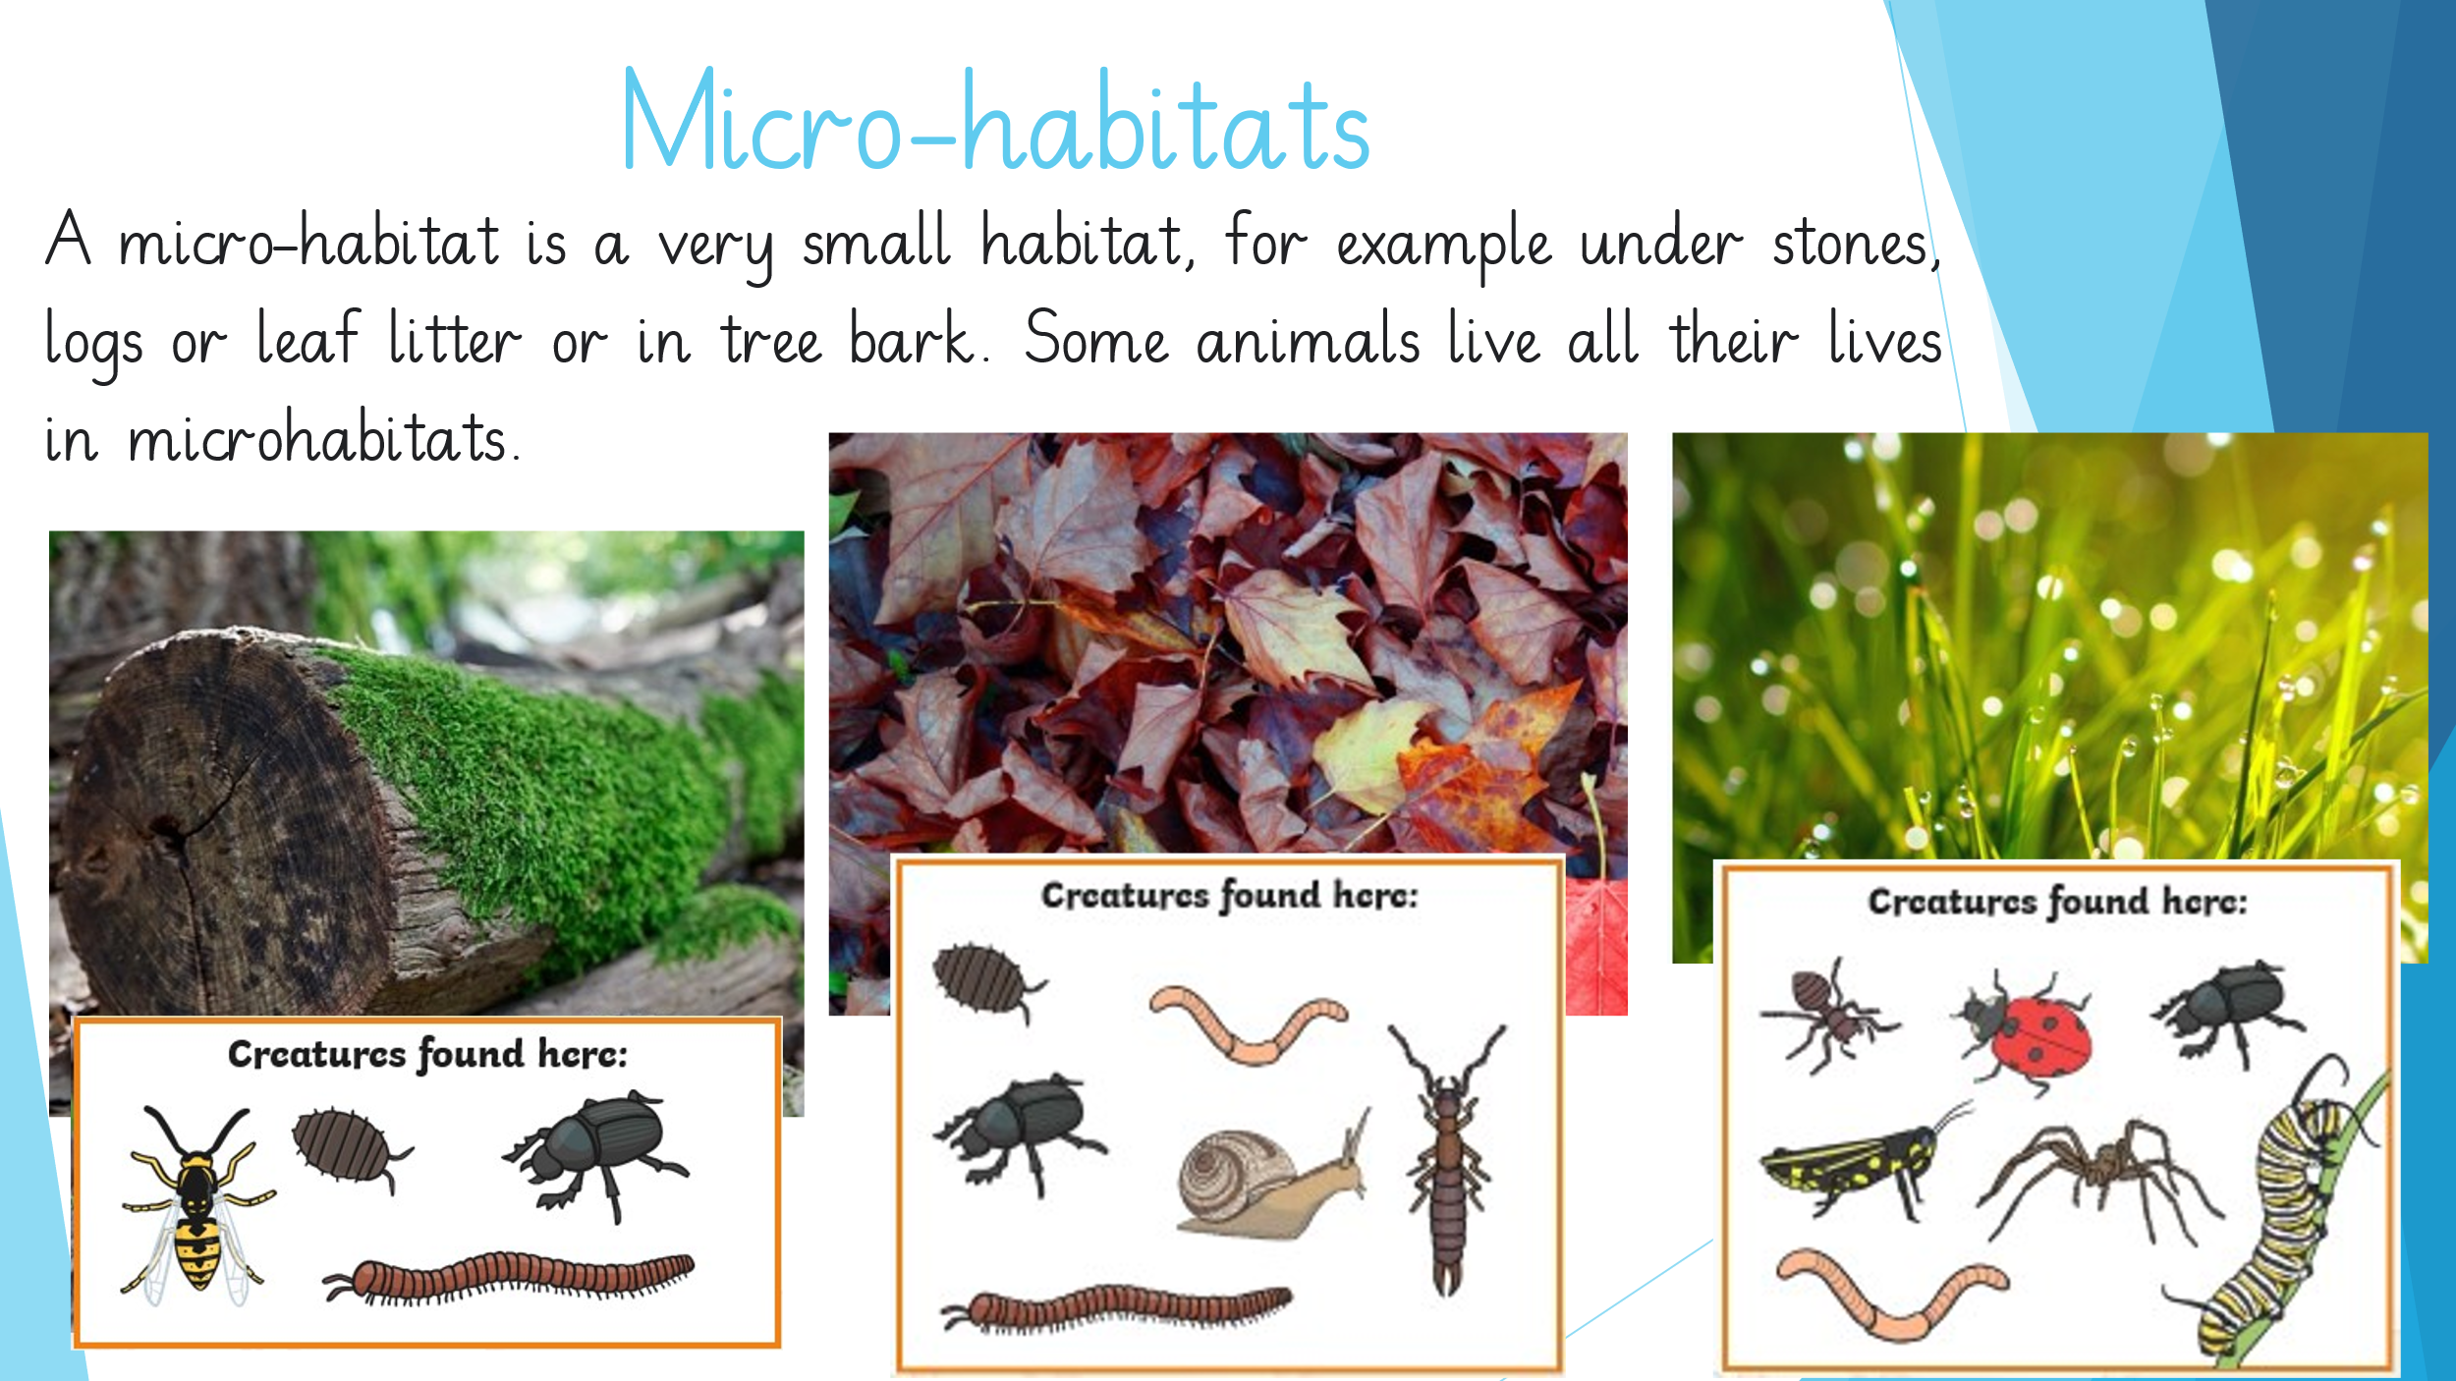

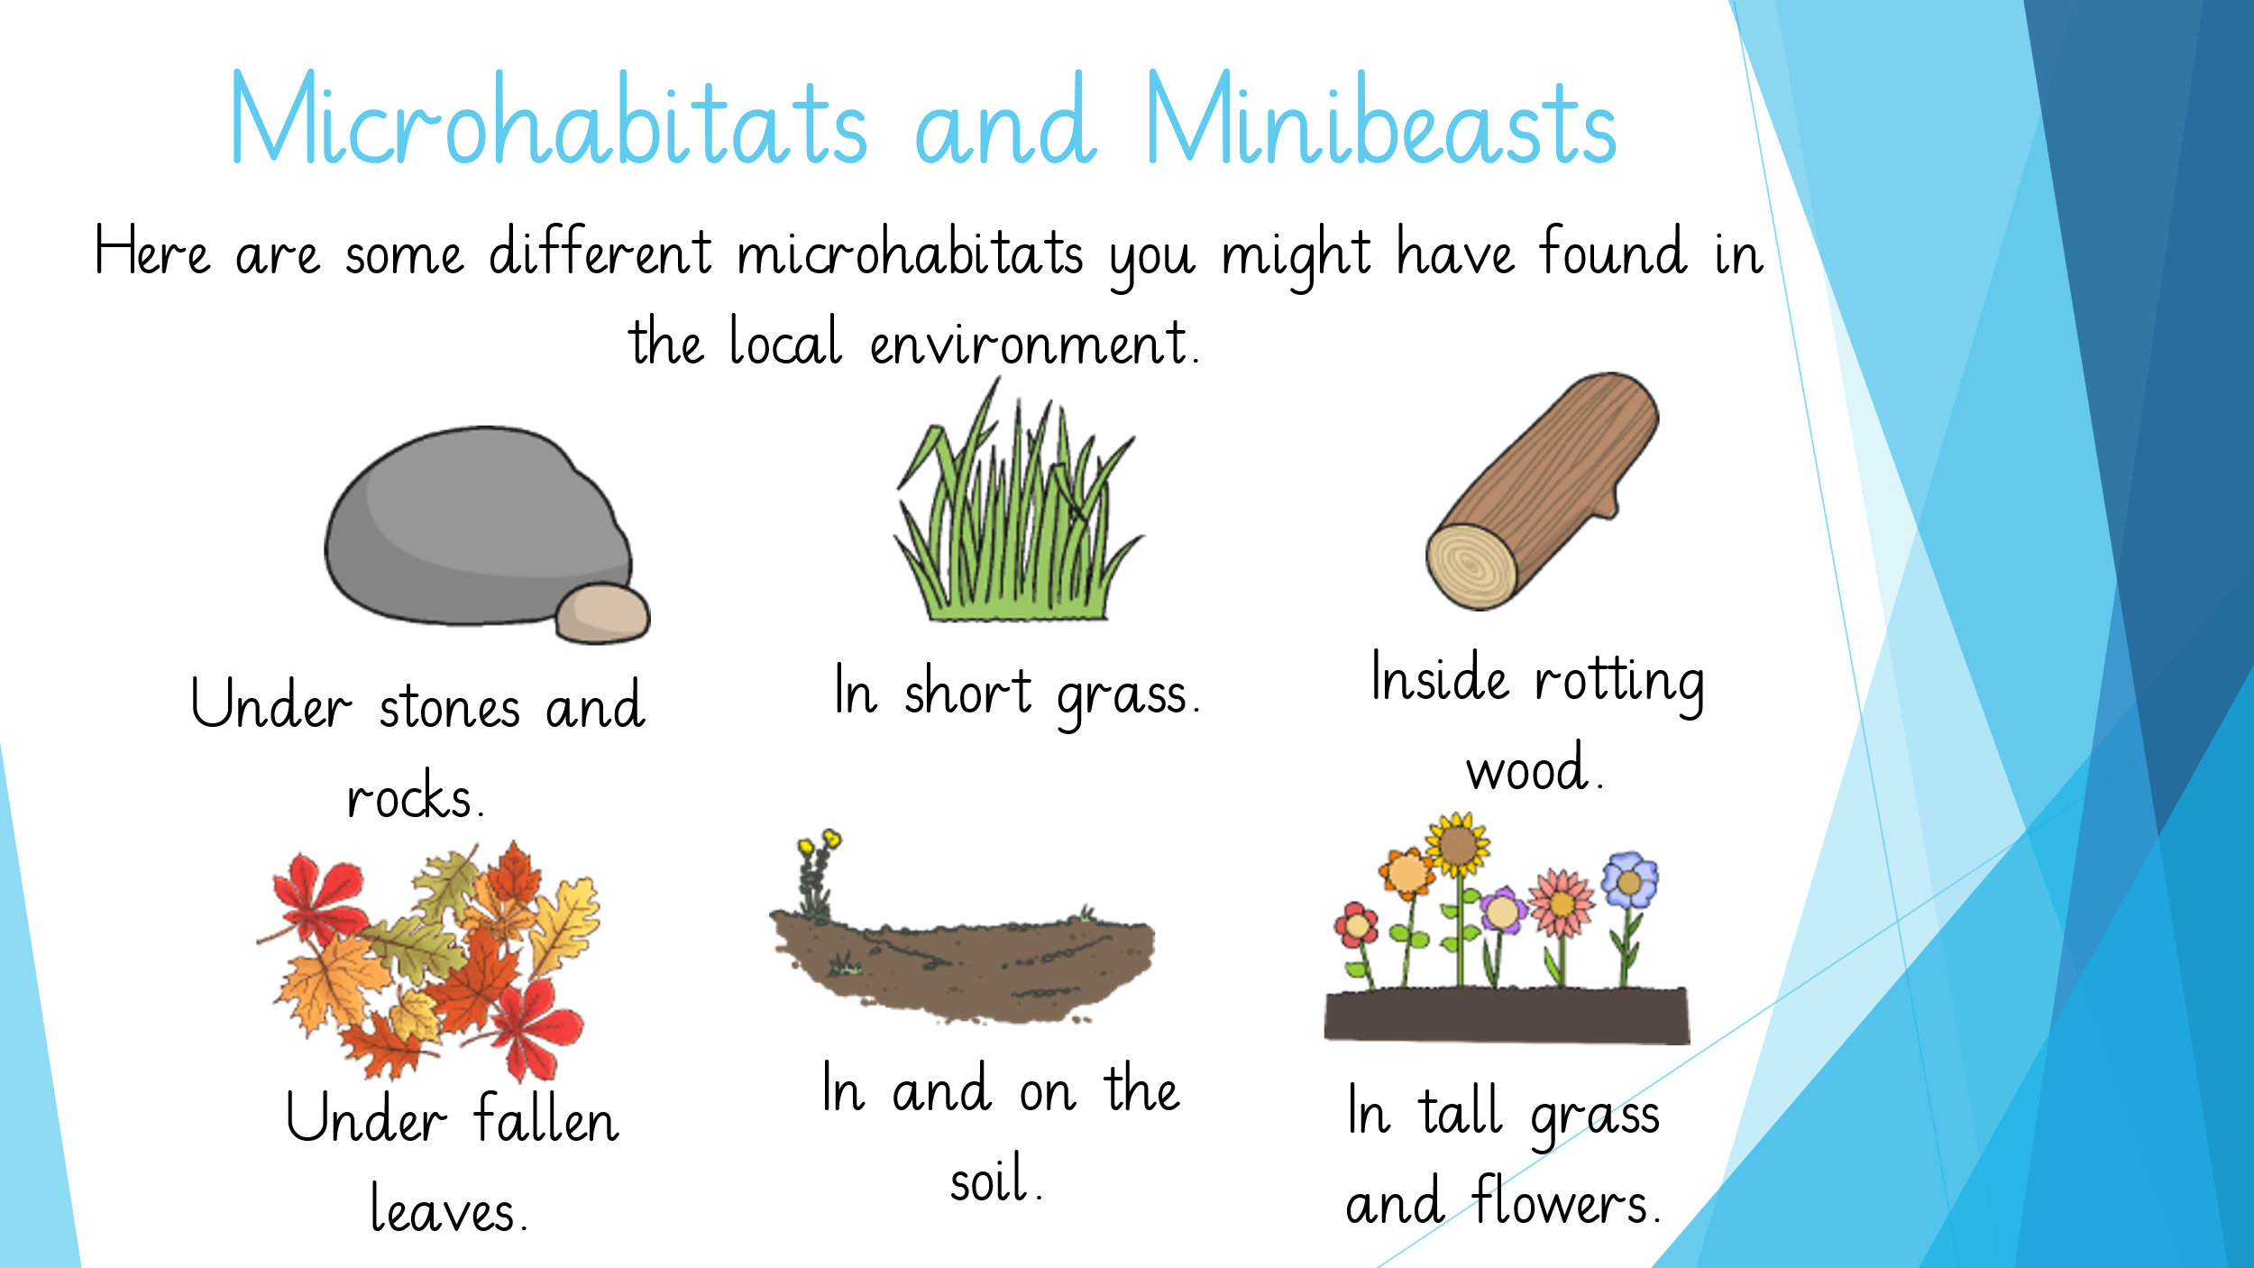

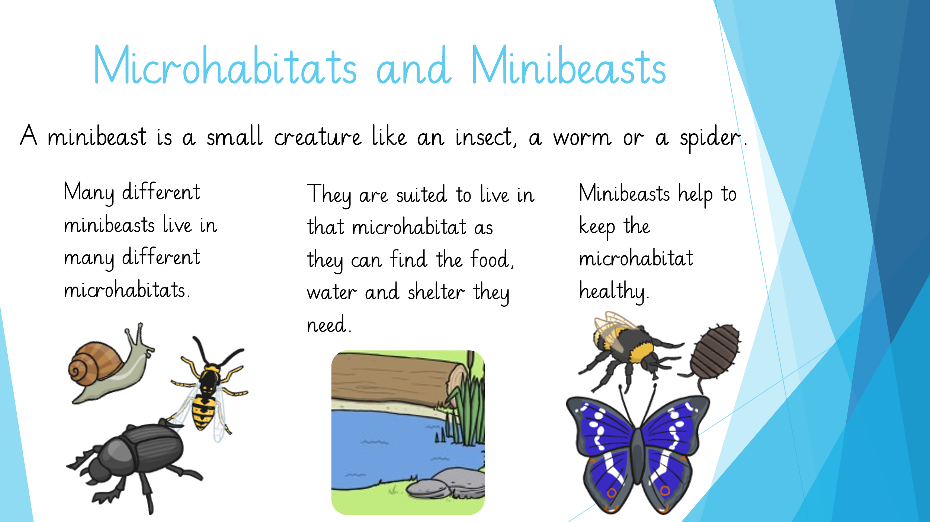

Have a look at a micro-habitat in your garden and show any minibeasts you find on the table below.

