English
Today you are going to write your non-chronological report using the template below. We will be carrying on with this tomorrow, so take your time and make sure you are using your neatest handwriting.
Don’t forget to include the key features we have looks at so far (facts, titles, capital letters and full stops).
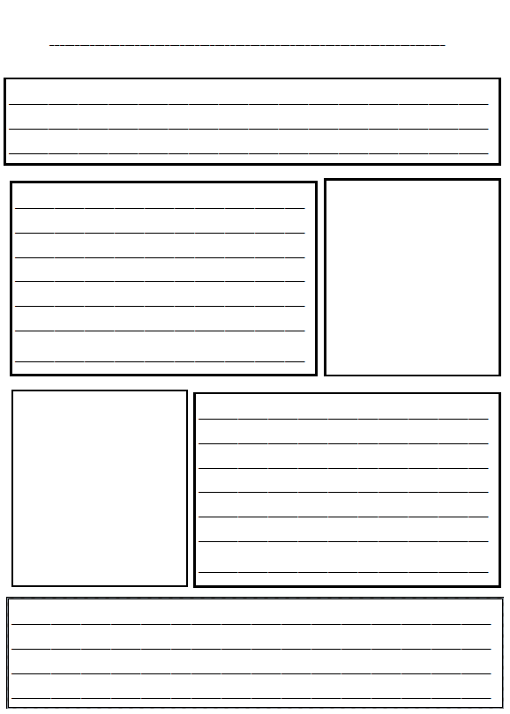

Maths – Part-Whole Model
https://vimeo.com/461446296
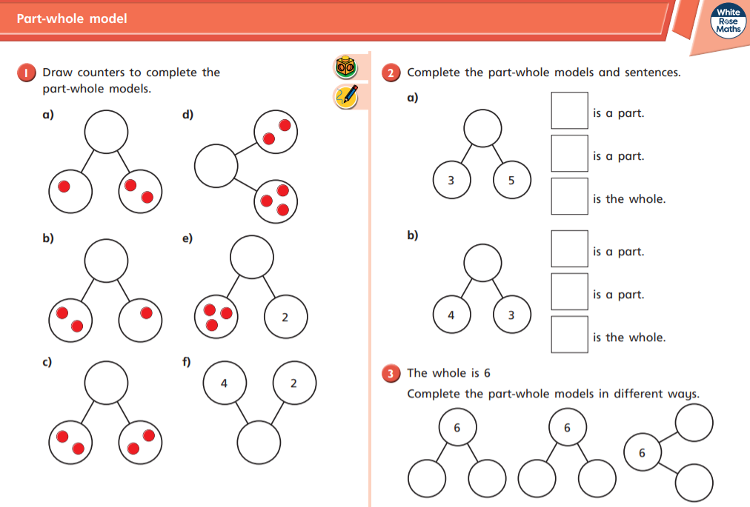

Art
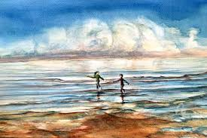
In art we have been looking at using different tints/shades of blue in our work. Today we are going to have a go at creating a splash painting for the background of the Titanic we created a few weeks ago. You might want to use straws or sponges to help you create this effect. Use the pictures below for inspiration.
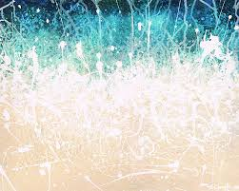

Phonics
Recap the tricky words on your bookmark.
Write a sentence about this picture using the ‘ar’ digraph (shark).
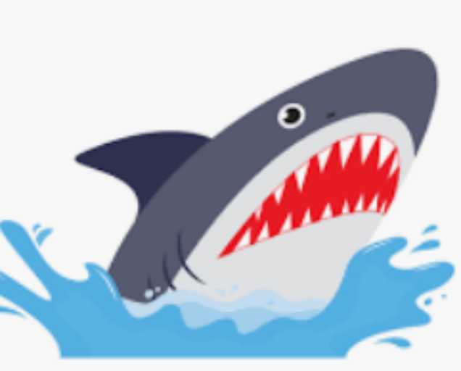
Reading
Please try to read your book every day.

