English
Today you will be identify key features in a non-chronological report WAGOLL (What A Good One Looks Like) about Katherine Johnson.
Colour code each feature using the key provided and underline them in the WAGOLL on the next page.
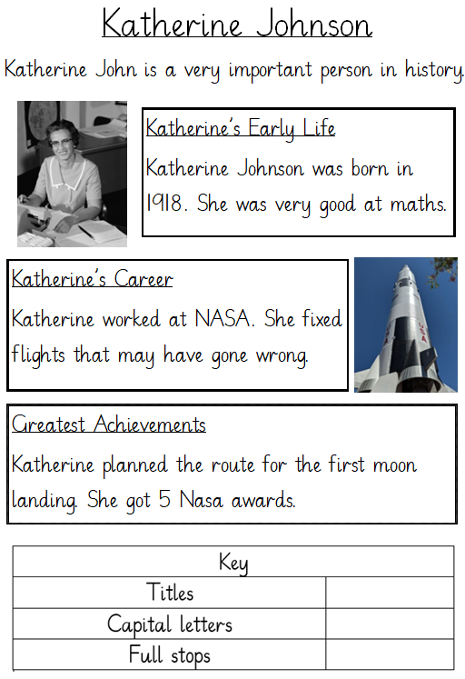
Maths – Recognise Coins
https://vimeo.com/556118312
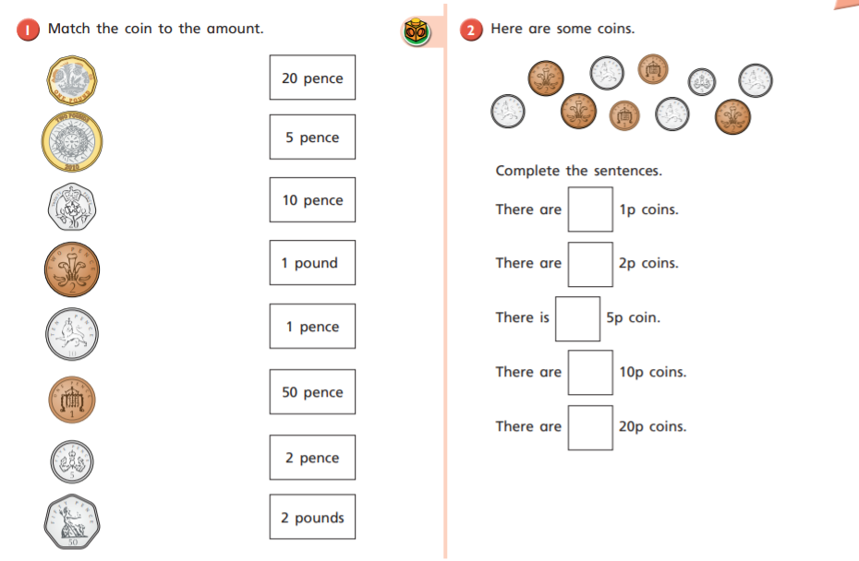
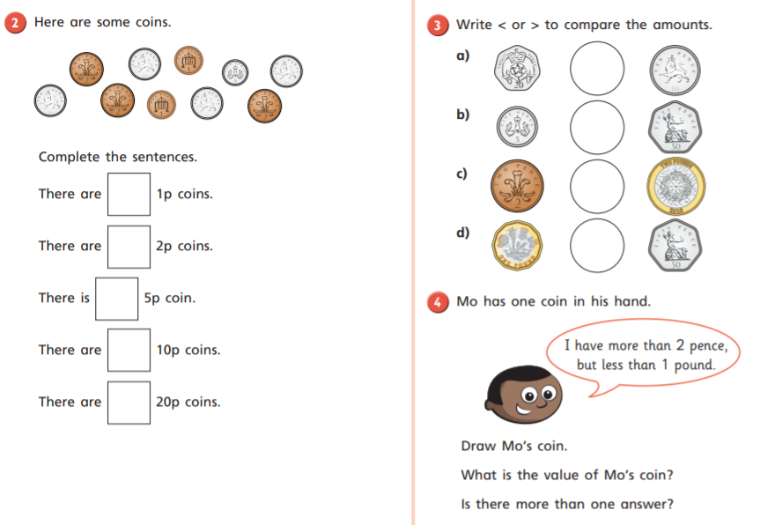
Physical Education
Practise jumping safely by bending your knees and landing on steadily on two feet.
How many ways can you jump? (Hop, star jump).
Today we will be learning how to hopscotch by practising the technique of one foot to two feet jumping, followed by two feet to one foot jumping. Lean forwards and swing your arms to spring forward and land safely with bent knees.
Practise your hopscotching by playing the hopscotch game.

Phonics – Tricky Word Tuesday
I would like you to learn the phase 4 tricky words ‘come’ and ‘little’.
Once you are confident spelling these words, write a sentence that includes them.
Reading
Please try to read your book every day.

