English
Today we will be planning our non-chronological report about Katherine Johnson.
The three sub-headings will be:
- Katherine’s Early Life
- Katherine’s Career
- Katherine’s greatest achievements
Use the work you have done so far this week to help you plan your writing.
Remember, a plan in written in note form.
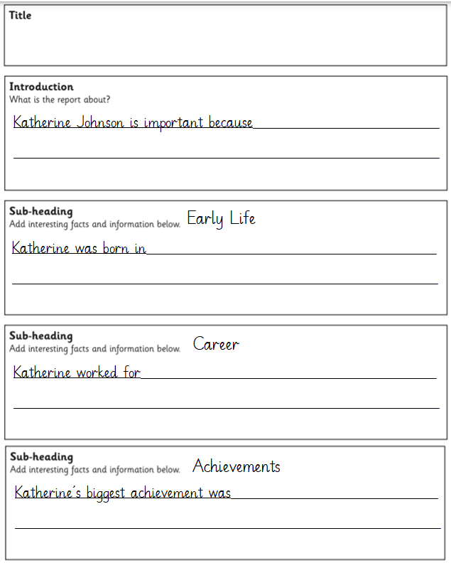

Maths – Recognise Notes
https://vimeo.com/556118433
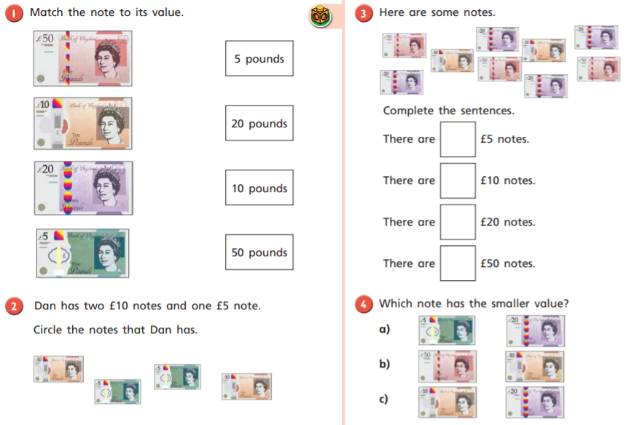
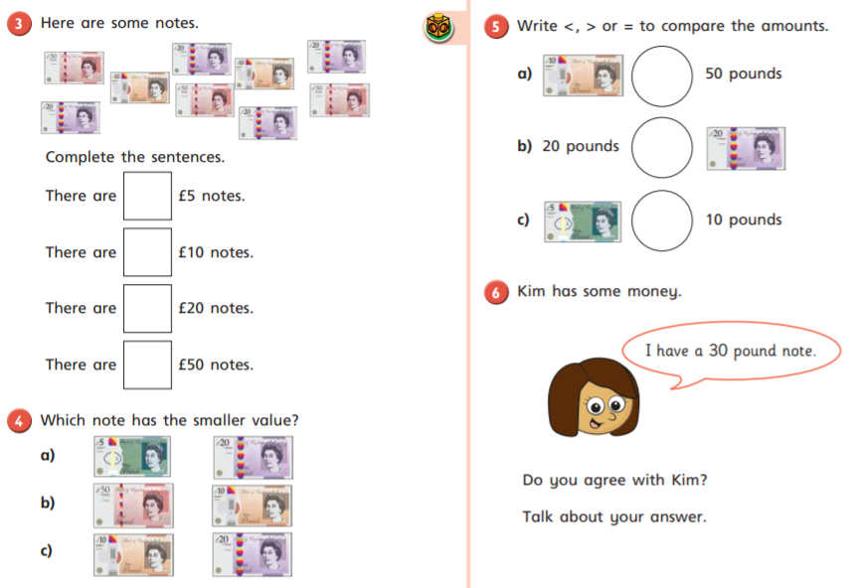
History
Why weren’t more people saved from the Titanic.
Use your own research, along with what you have learnt in class to stick these statements into the categories (made up, not very important, important and most important) as to why more people were not saved.
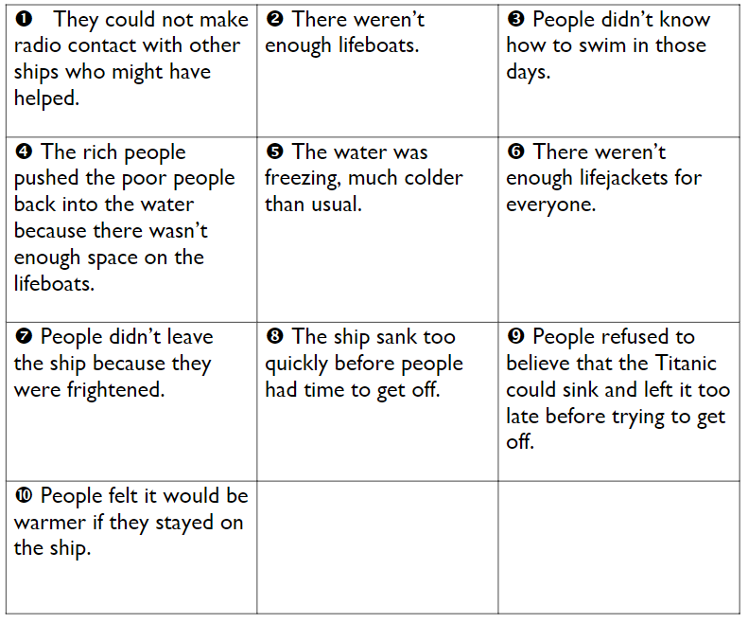

Phonics
Practise the tricky words on your bookmark.
Write a sentence that includes a word using the ‘oo’ digraph (stood).
Reading
Please try to read your book every day.

