Tuesday
English
In English this week we are going to be writing out diary entry as though we were passengers on the RMS Titanic. Today you are going to plan your own diary entry using the template below. Use the WAGOLL (what a good one looks like) to help you structure your plan.
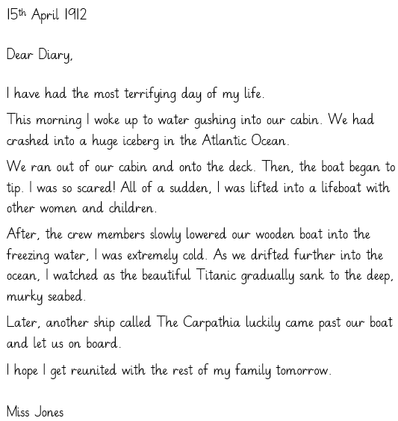
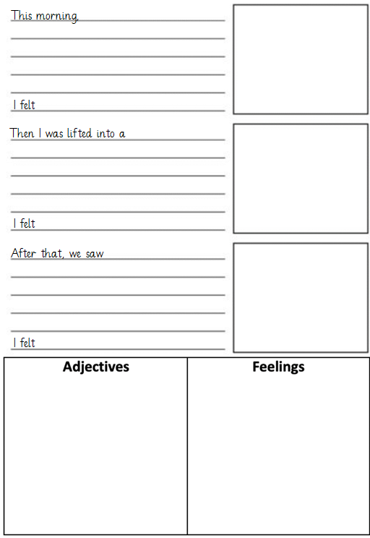
Maths
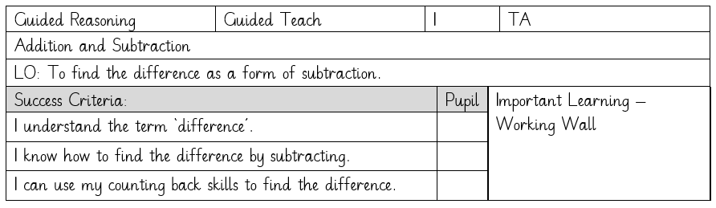

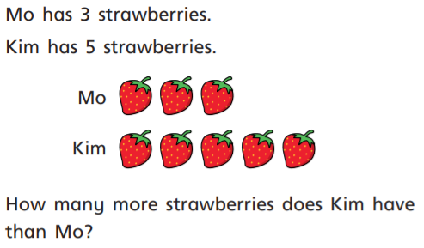
Can you write a subtraction number sentence to show this?

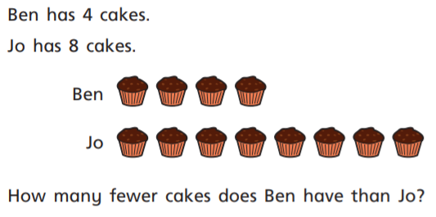
Can you write a subtraction number sentence to show this?

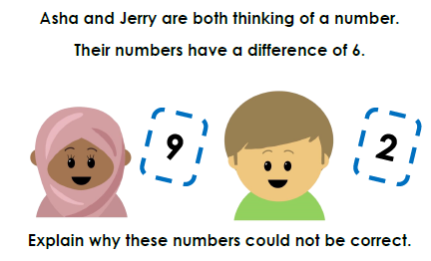
Computing – Coding
For computing today, you will need to search for ‘bubble coding’ on purple mash and open the app pictured below.
Firstly, click on design in the top right corner and draw the coloured bubbles into the scene. Then click on exit design and it will take you to the coding page. Here you can put in the instructions to make the bubbles move and disappear. You are looking to create a scene where all the bubbles are moving in different directions and disappear when clicked. Use the example below to help you.
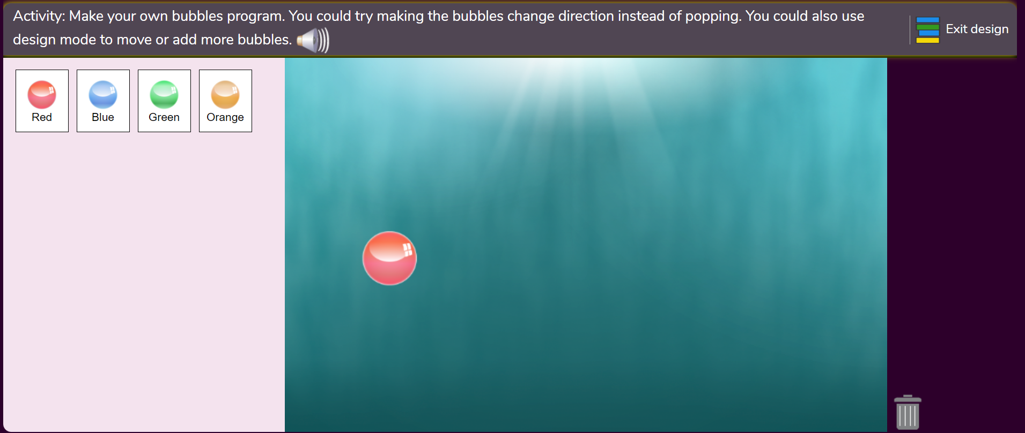
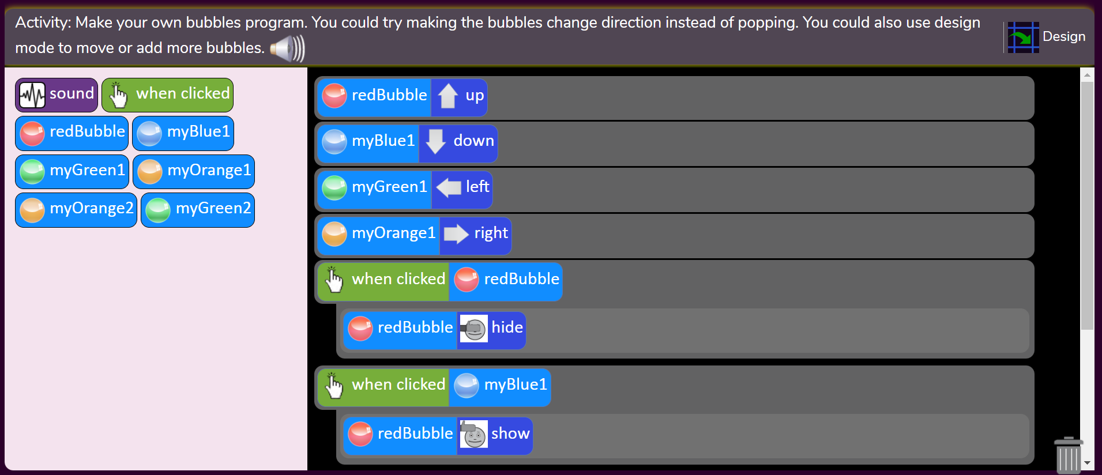
Wednesday
Maths
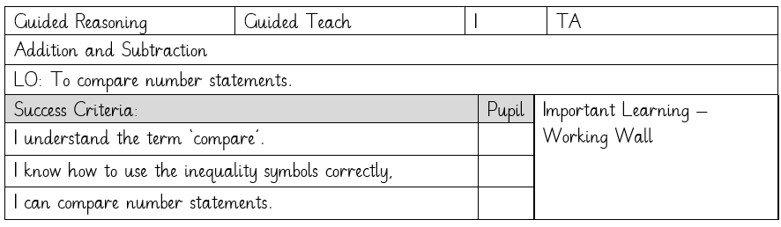
Compare these number sentences by working out their totals and then filling in the circle using the correct inequality symbol.
When you have finished, practise writing your number bonds to 20.
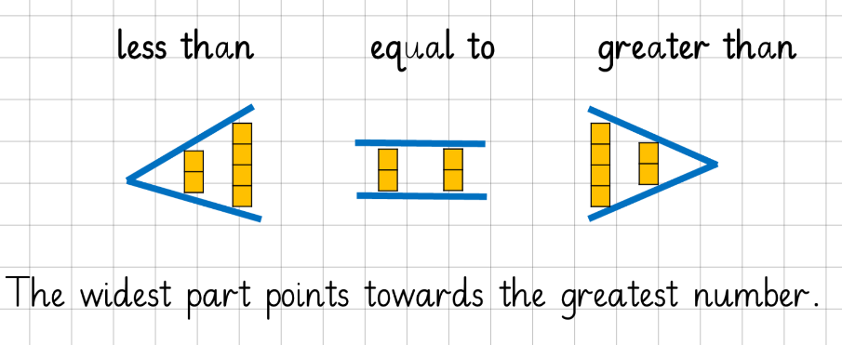
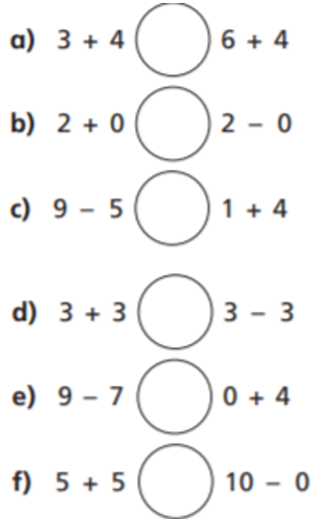
Titanic trip activity
As we are not able to visit the Titanic Museum in person, I would like you to carry out a virtual tour using the link and find the answers to the questions below.
https://www.liverpoolmuseums.org.uk/maritime-museum/titanic-virtual-tour
- What was the date of the Titanic’s sinking?
- How many passengers and crew could the Titanic carry?
- Fact or fiction – people predicted the disaster.
- What was engraved on the large bell from the Britannic?
- How many minutes did it take for the Titanic to sink to the seabed?
- How many chimneys did the Titanic have?
- Where was the Titanic travelling to when it crashed?
- What was May McMurray’s job on the Titanic?
- What was the name of the Titanic’s two sister ships?
- Fact or fiction – It was claimed that the Titanic was unsinkable.

Geography – Seas and Coasts
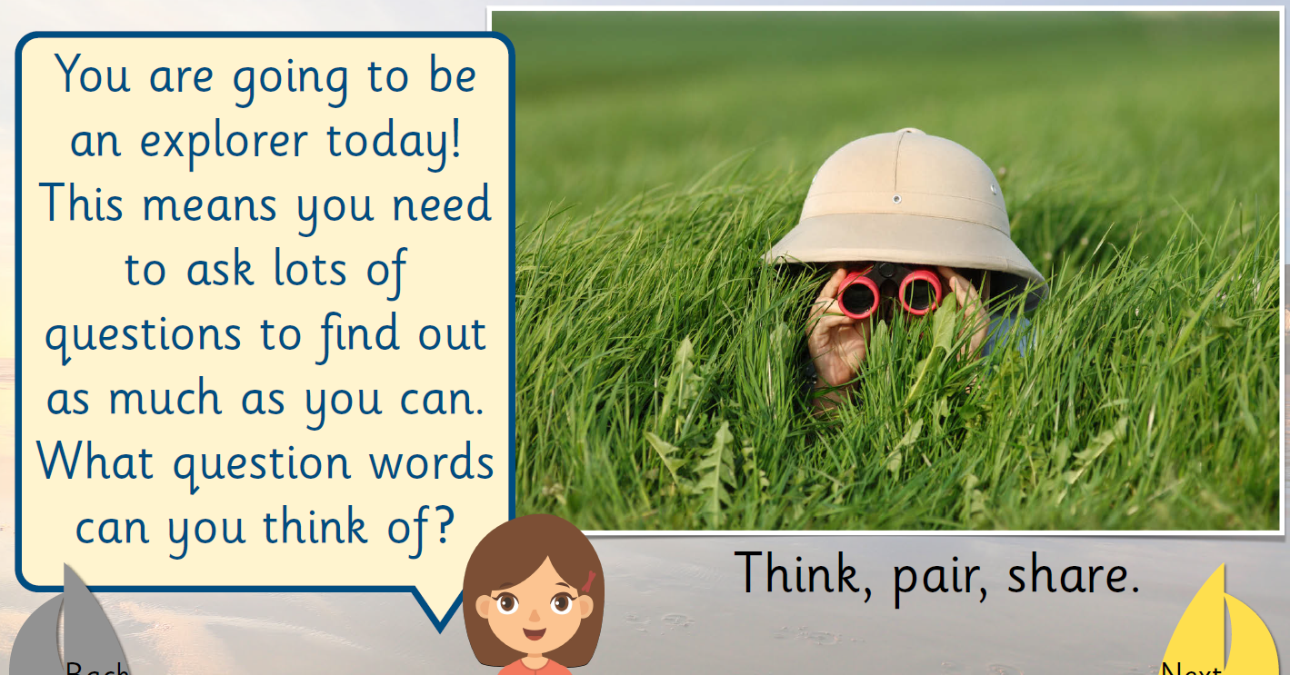
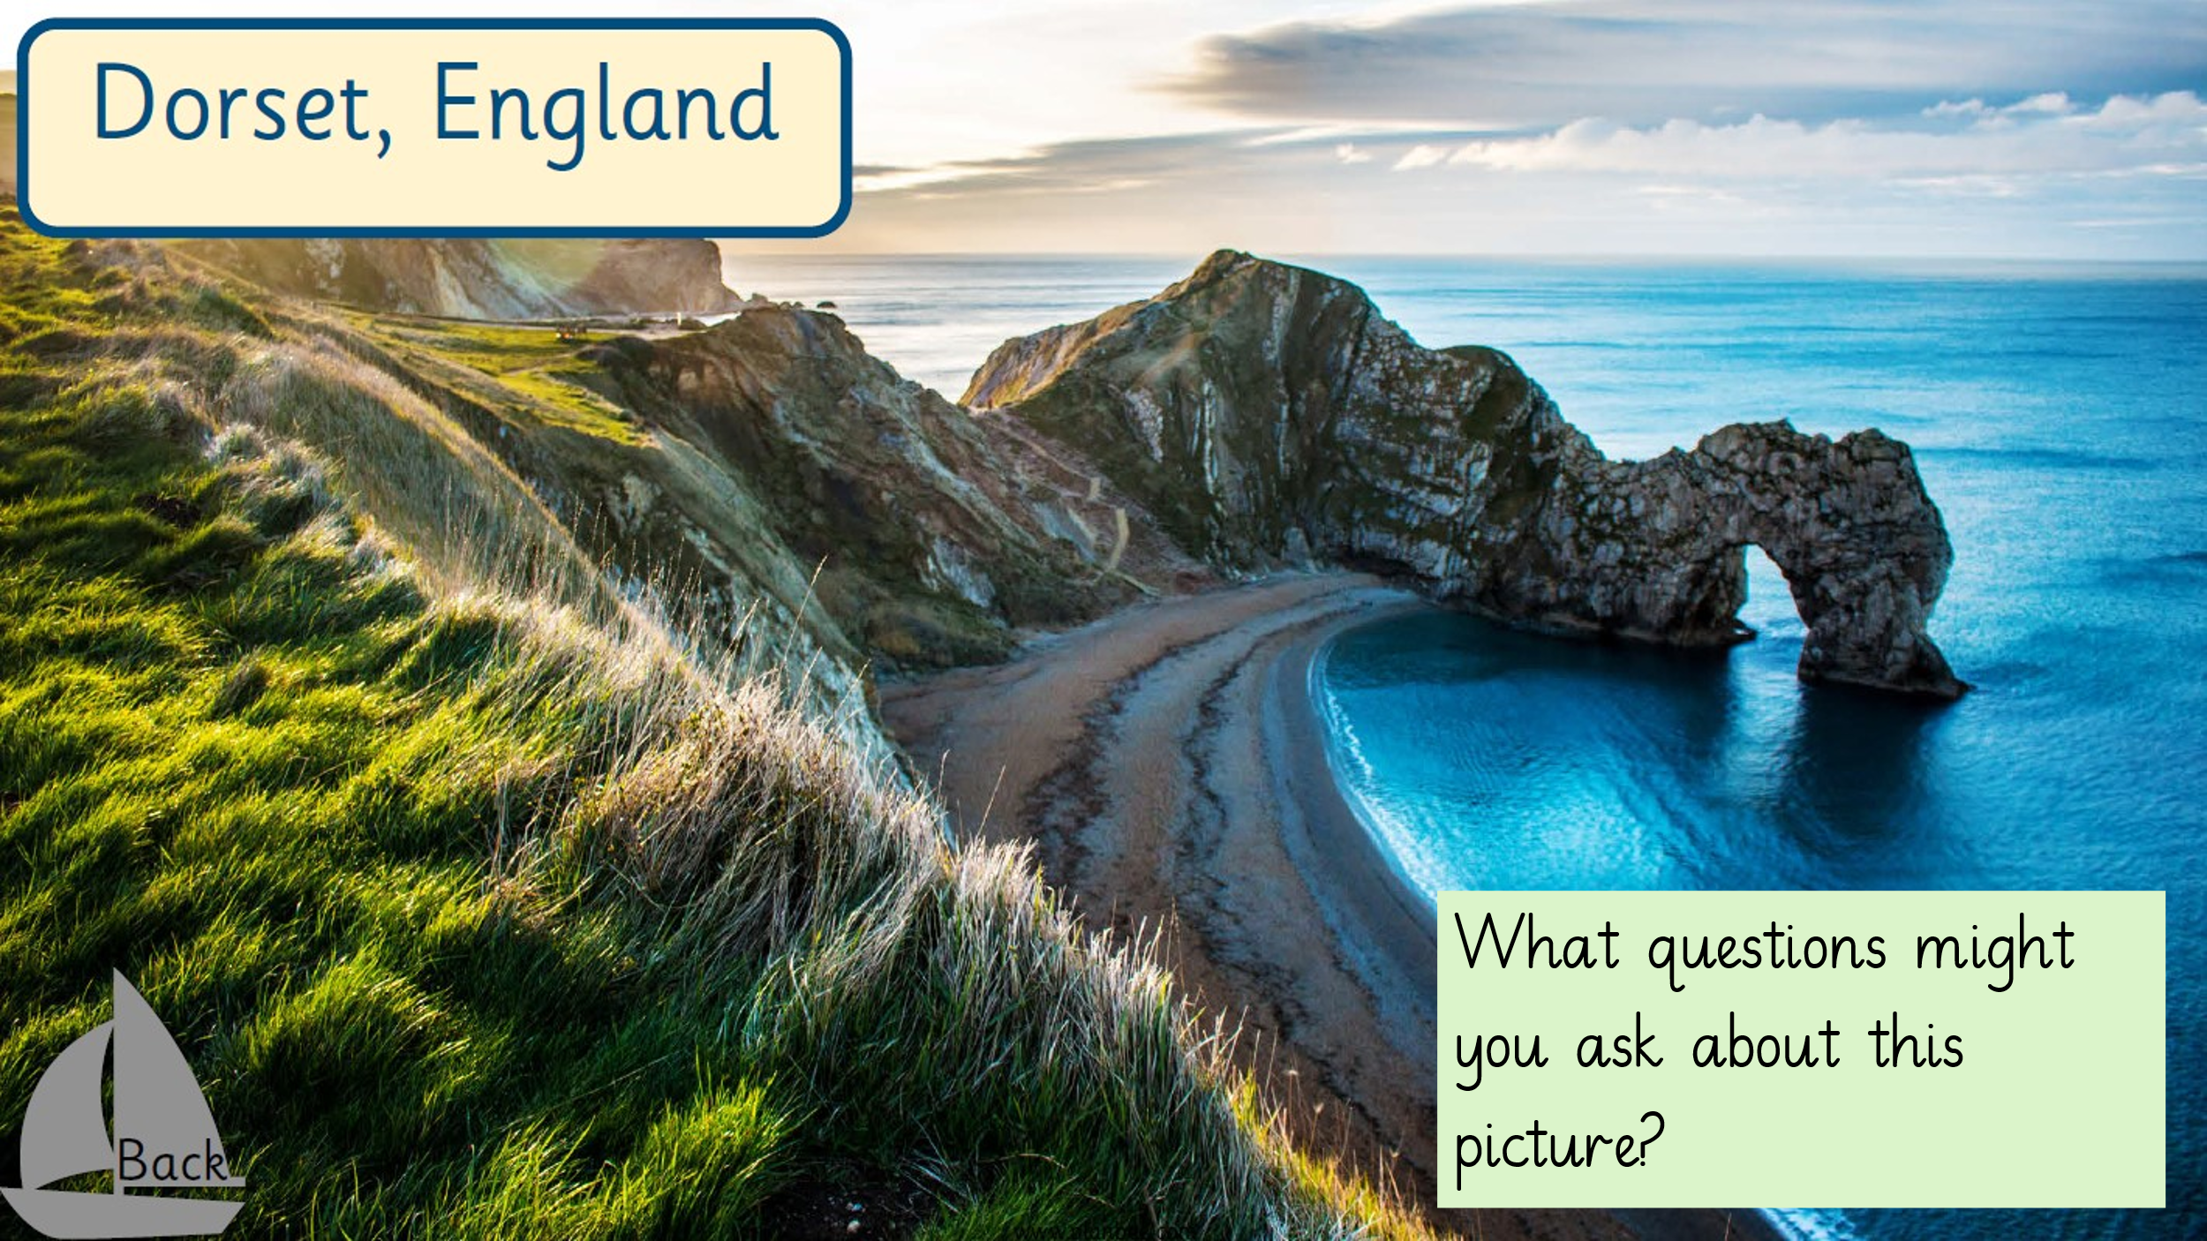

Task – Create a tourist poster about a beach of your choice. Include facts, pictures/ drawings and things to do there. Use the example below to help you.
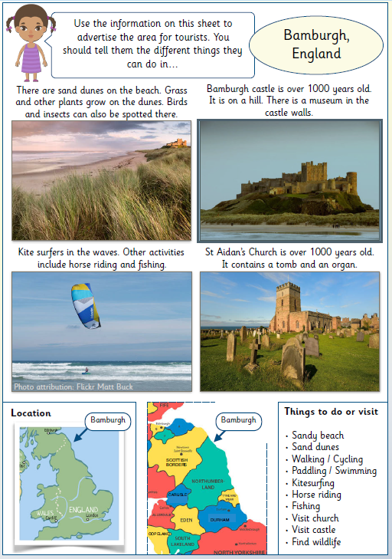

Thursday
Maths
In maths today we will continue to look at comparing number sentences using the inequality symbols.

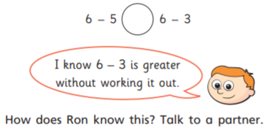

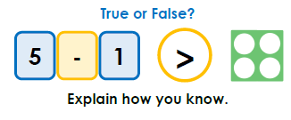

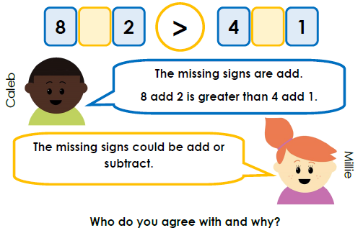

English (Thursday and Friday)
Today you are going to use your plan to write your diary entry. Don’t forget to use the WAGOLL from Tuesday’s lesson to help you write your own diary entry.
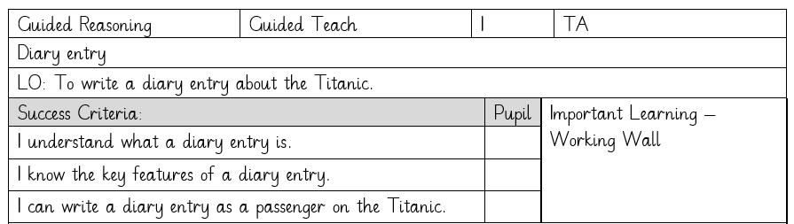
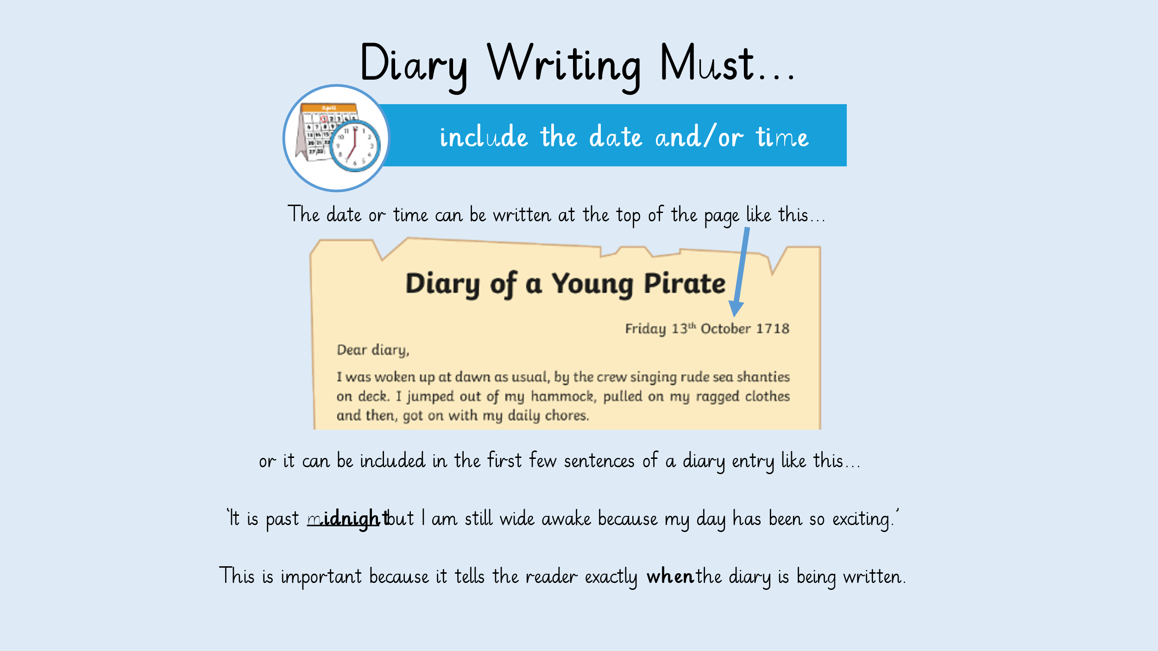
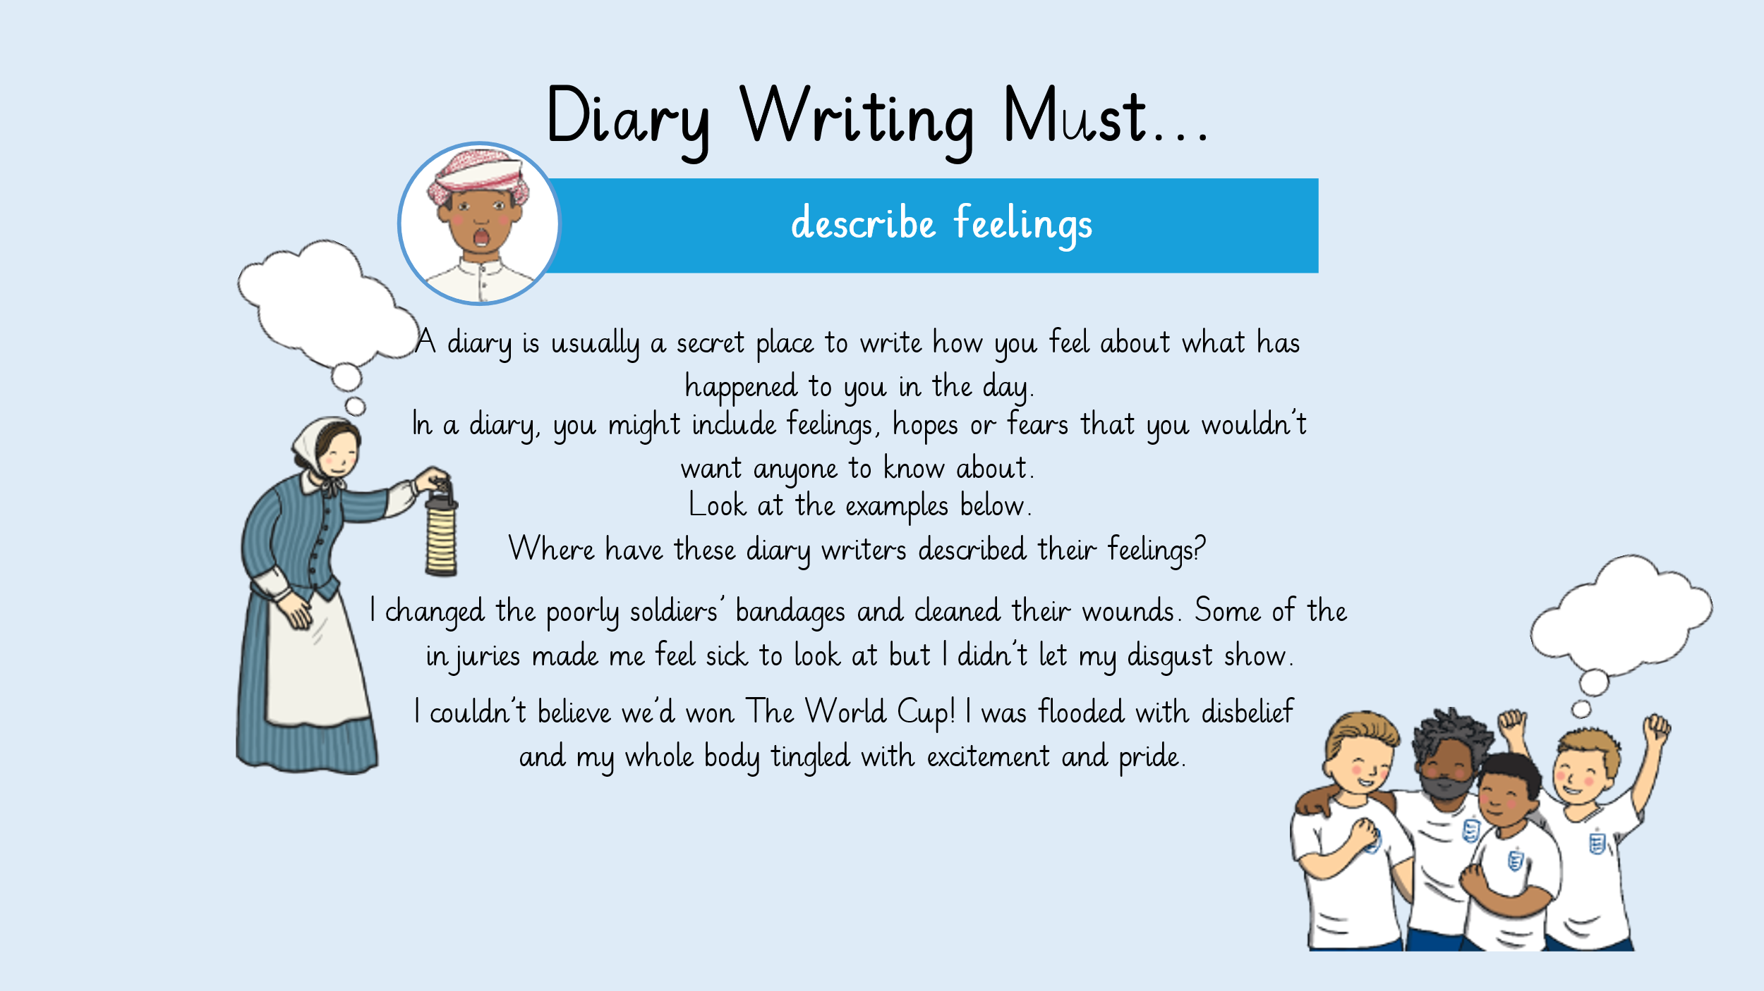
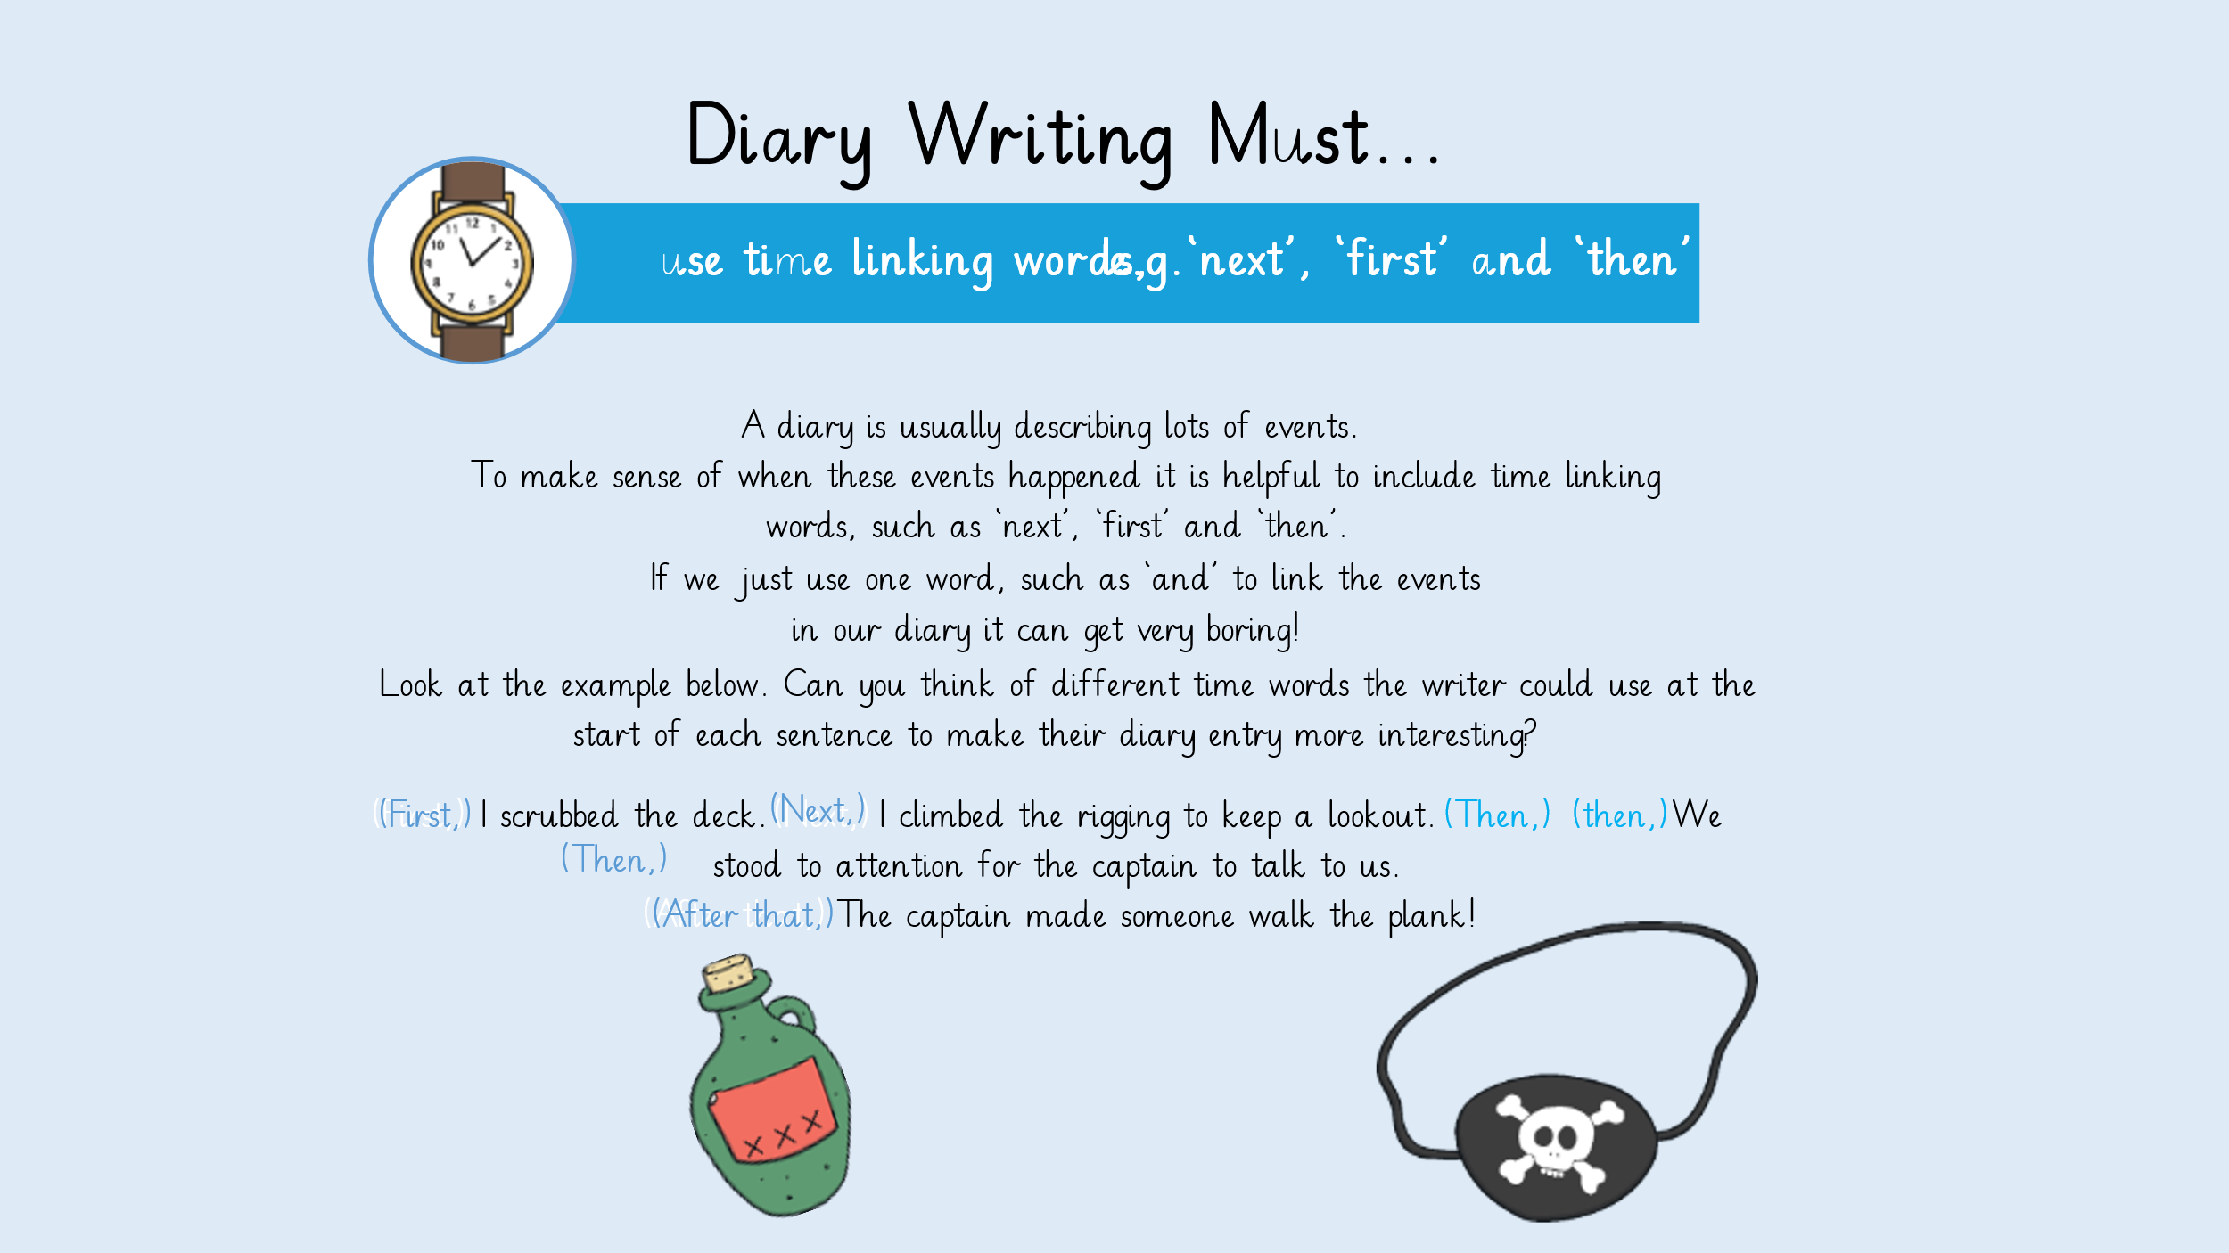

PSHE
LO: To understand the rights and responsibilities as a member of my class.
- Come up with some ideas about how we can help each other learn in class.
- Draw a picture of you learning well with other children in the class and write a sentence explaining how you are helping your friends learn well.

Friday
Maths
We have now come to the end of the addition and subtraction topic in maths. Complete the questions below to showcase your learning.
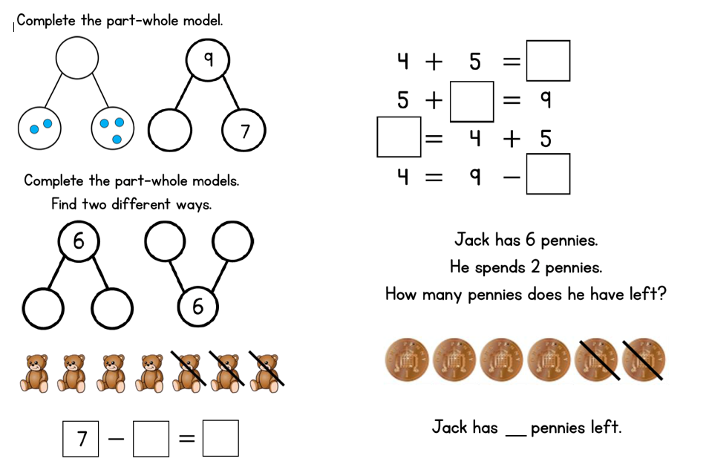
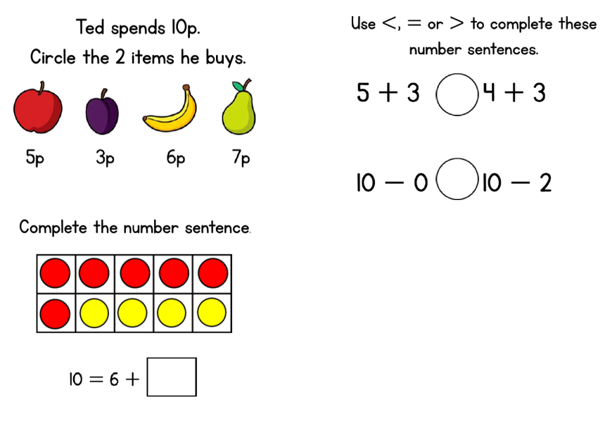
Science
LO: To name the basic parts of a tree.
