Monday
Maths – Add equal groups
https://vimeo.com/488110327
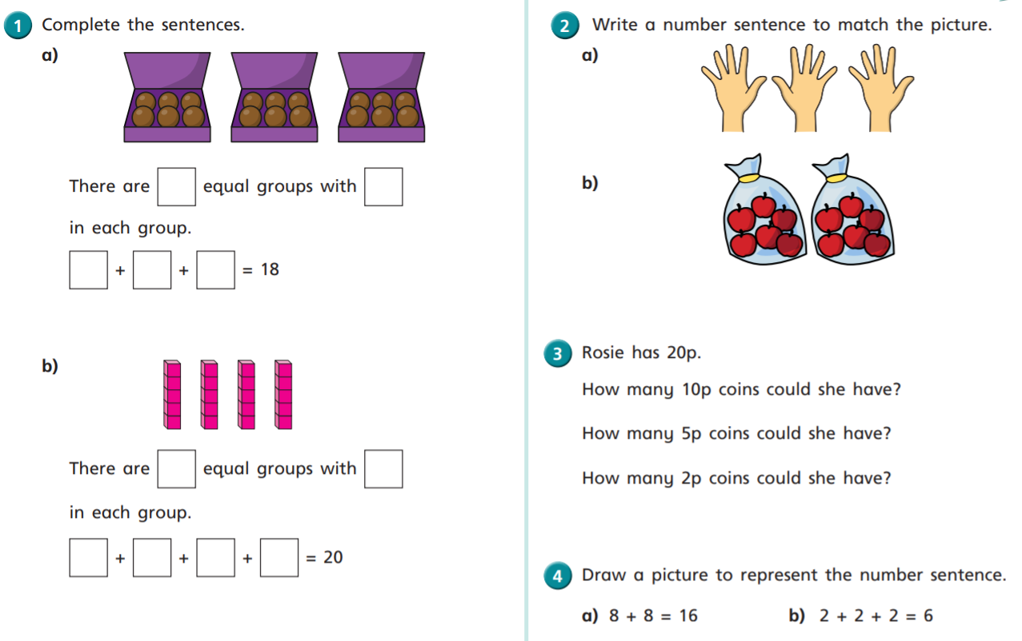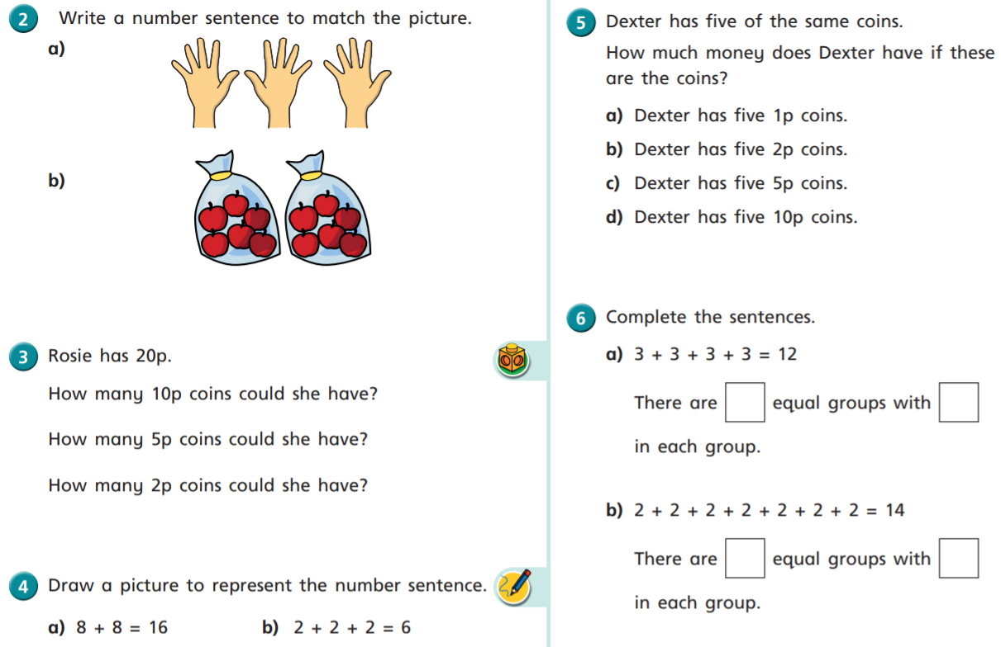
English
Use the key to identify key features in today’s recount WAGOLL.
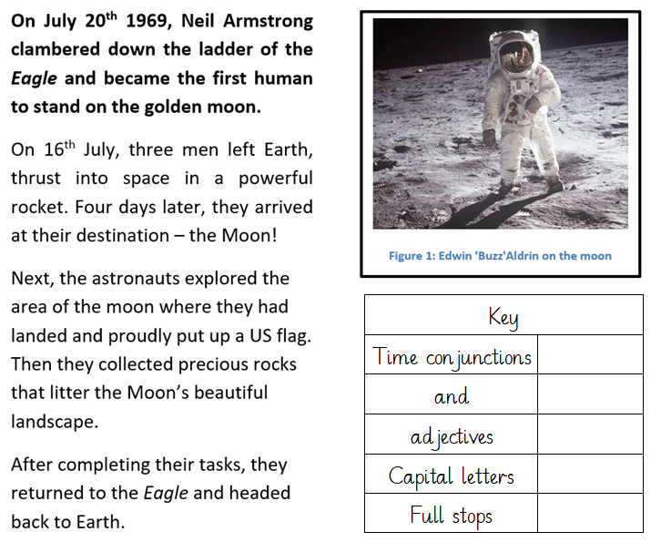

Computing
Our new topic in computing is grouping and sorting. For today’s activity I would like you to open purple mash and complete the activity ‘sorting 2D shapes.’

Tuesday
Maths – Using the multiplication symbol
https://vimeo.com/488111269
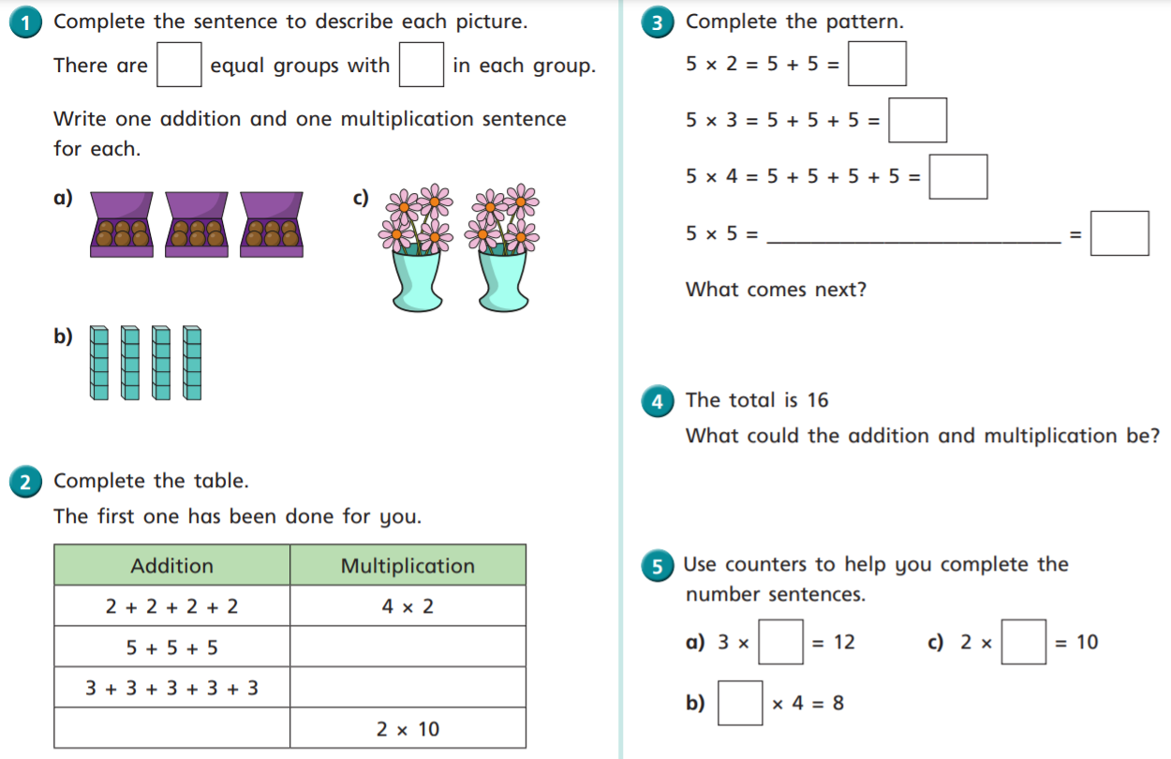
English
Use the key to find the features of a recount in today’s WAGOLL and then answer the questions below.
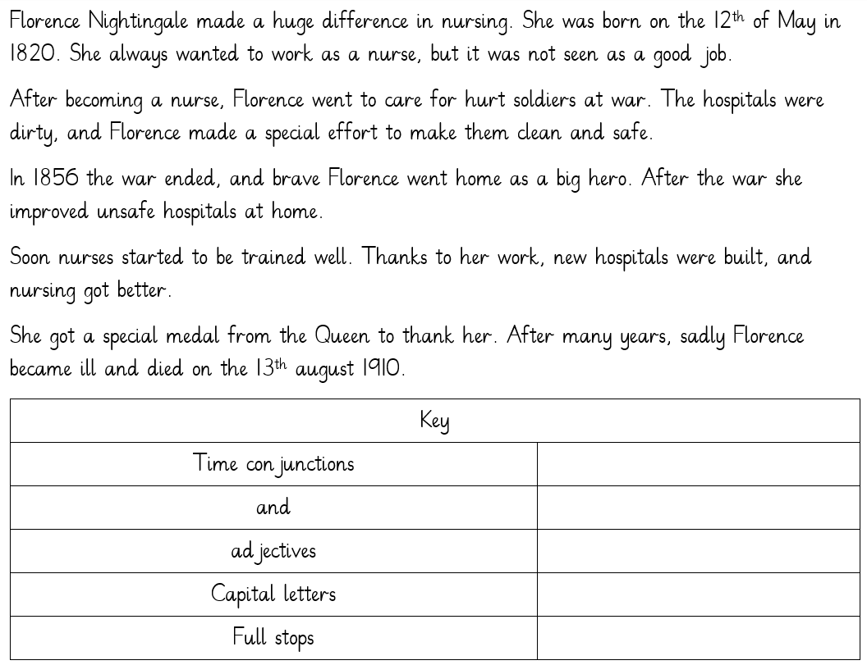
- What word was used to describe the soldiers?
- Can you think of a more interesting adjective than huge?
- What year did the war end?
- Who game Florence a medal?
Reading
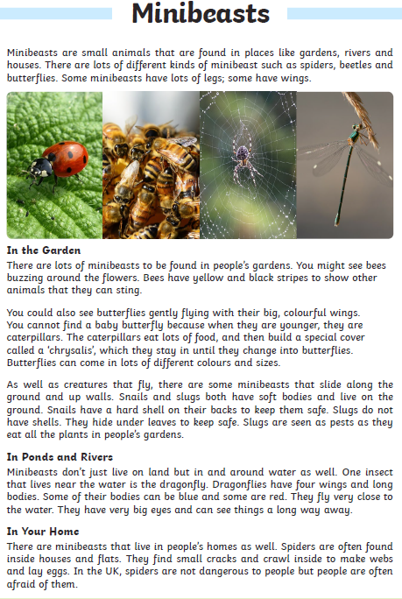
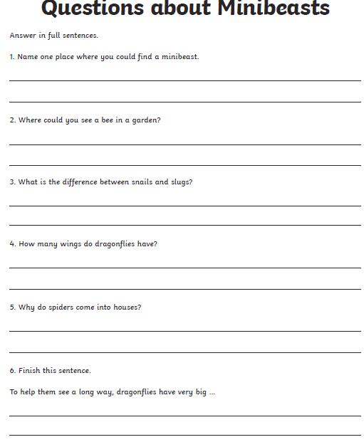

Wednesday
Maths – Multiplication sentences form pictures
https://vimeo.com/488113679
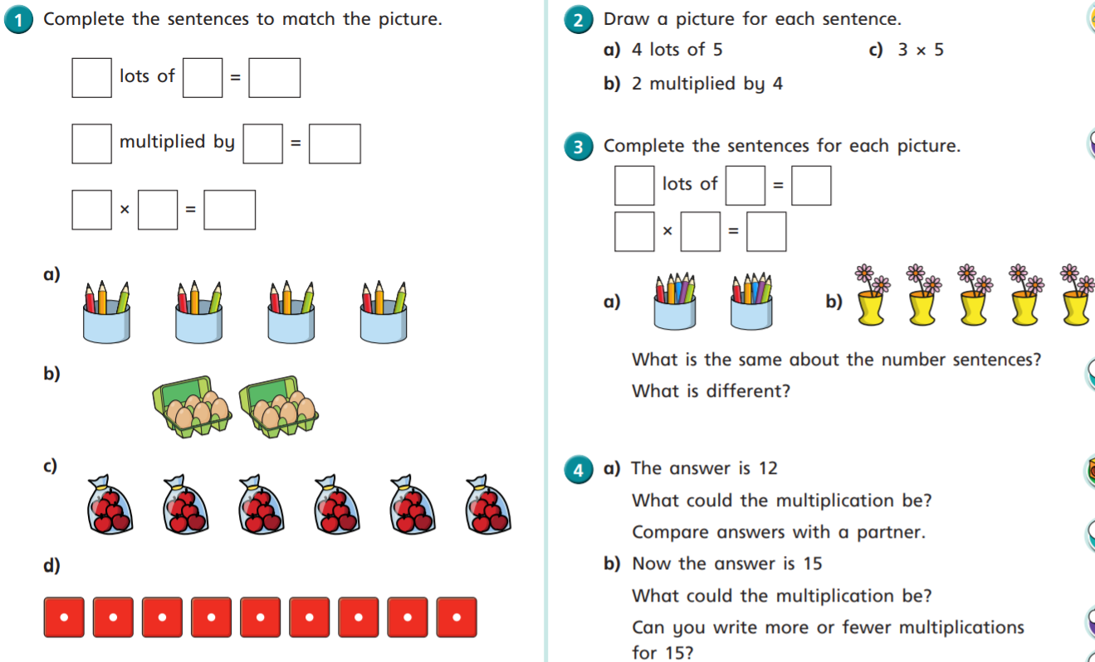

English
Using the conjunction ‘and’ to join words and phrases.
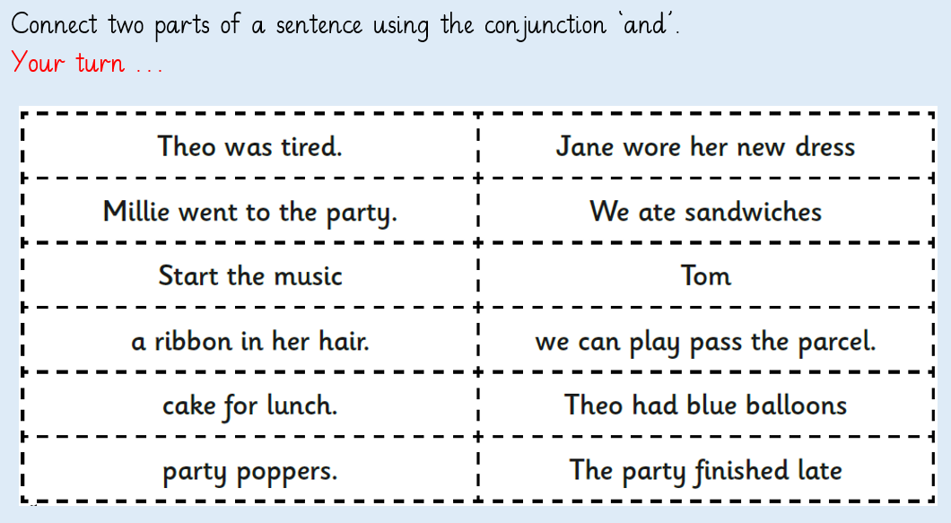

History – Florence Nightingale
Look at the PowerPoint about Florence Nightingale and create a fact file about her life.
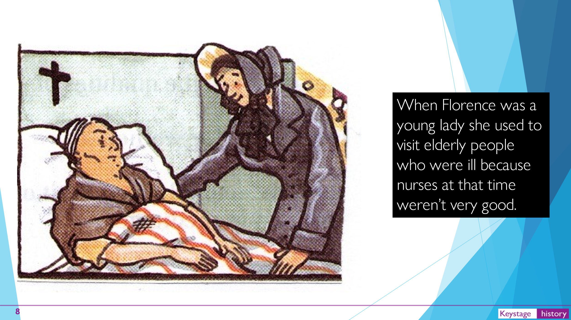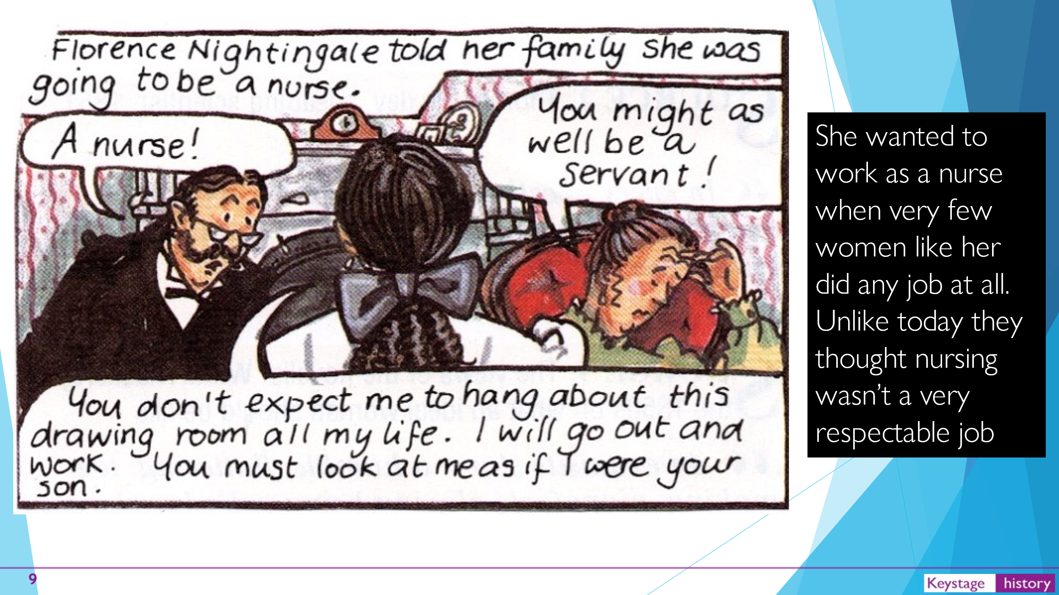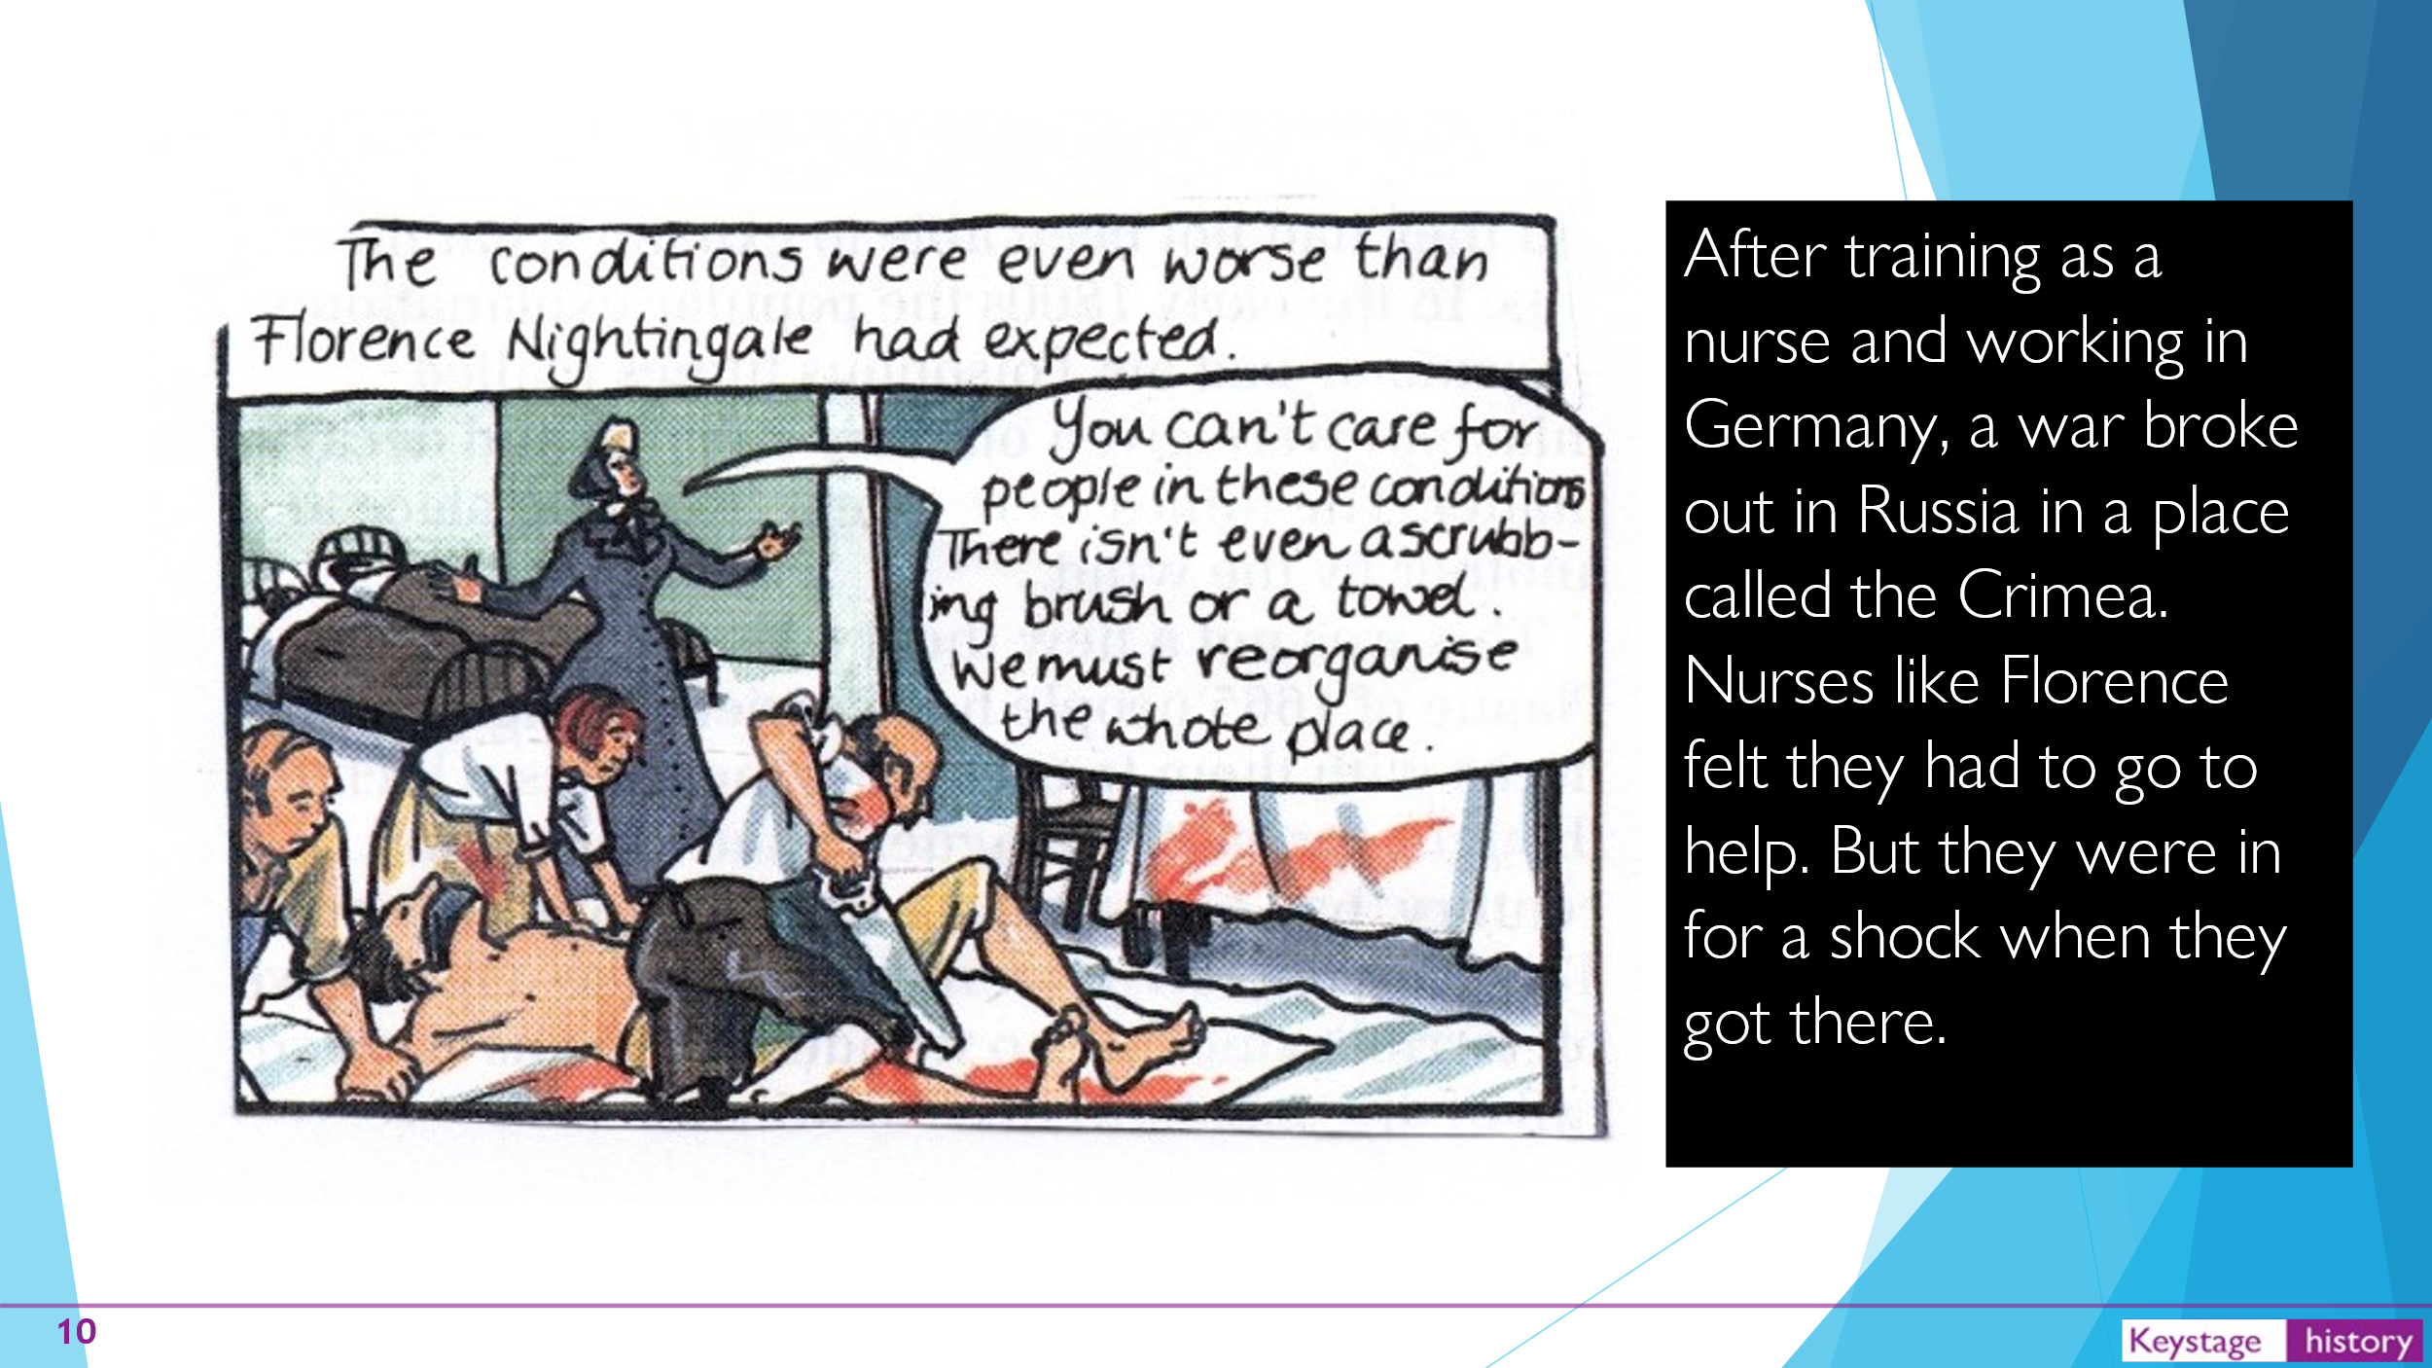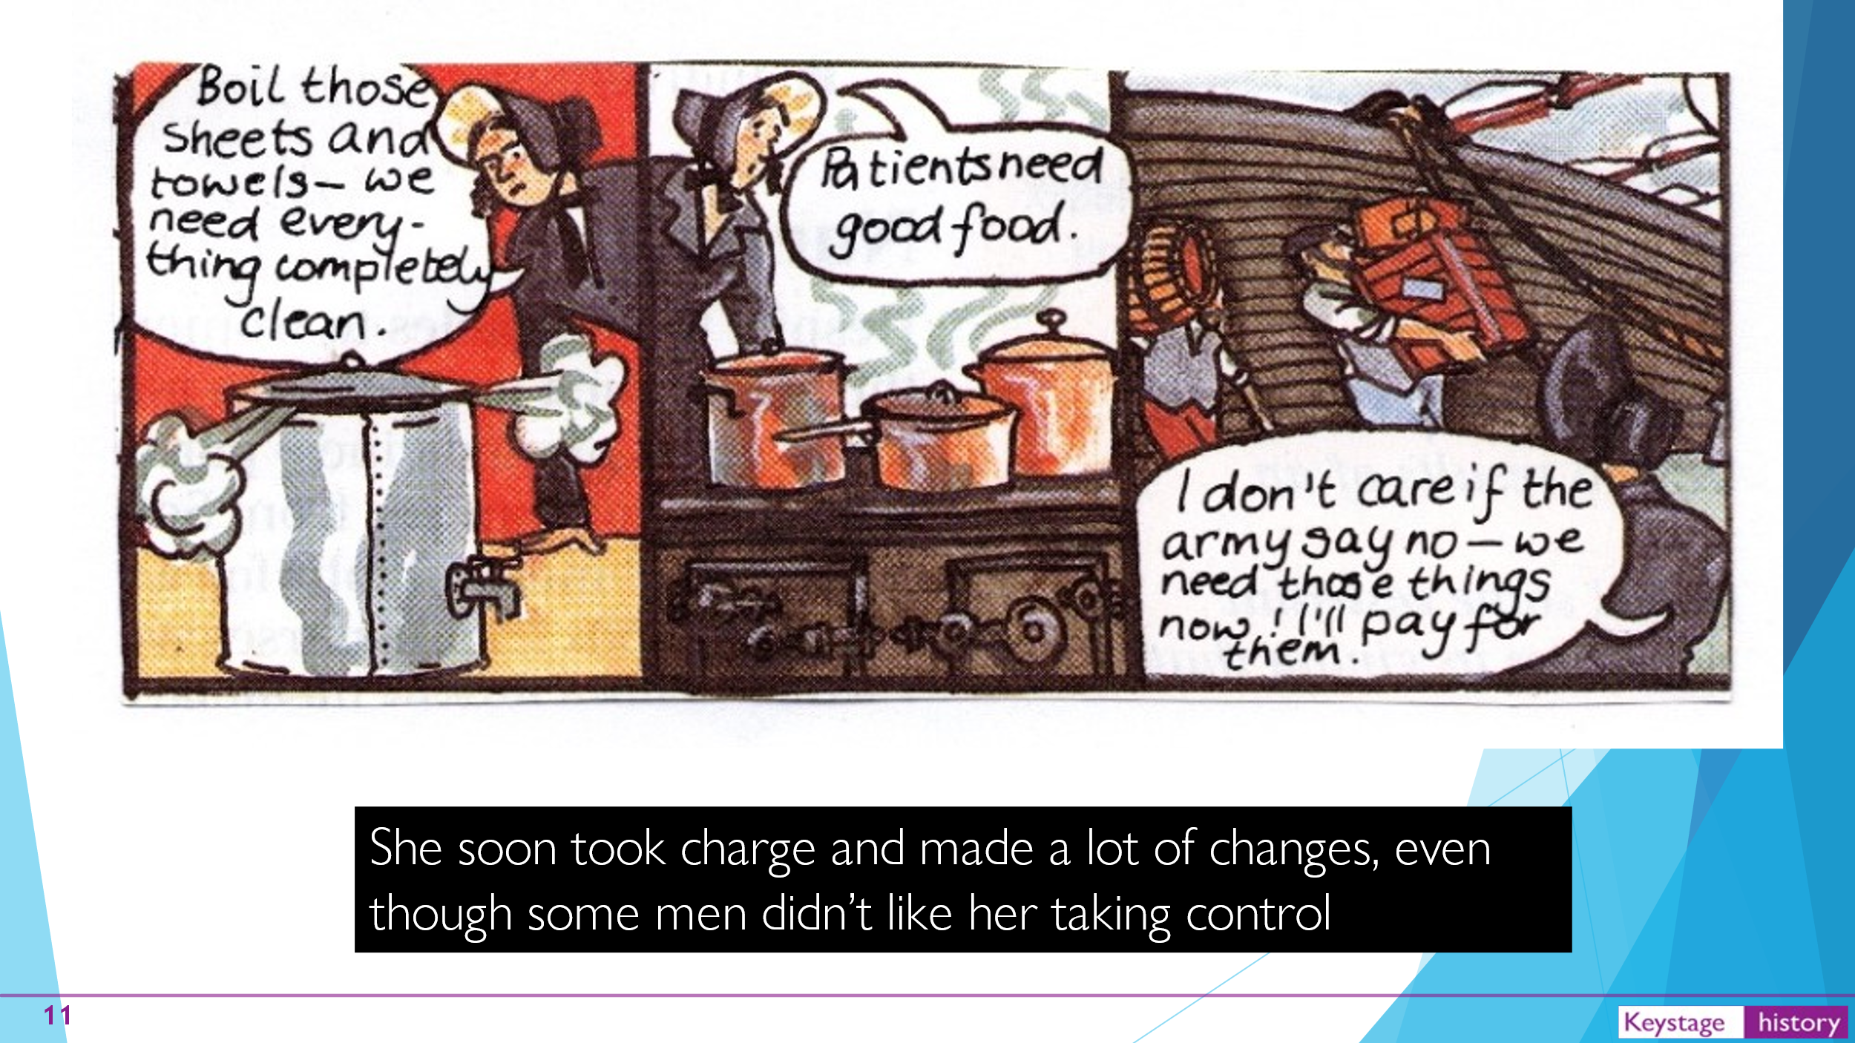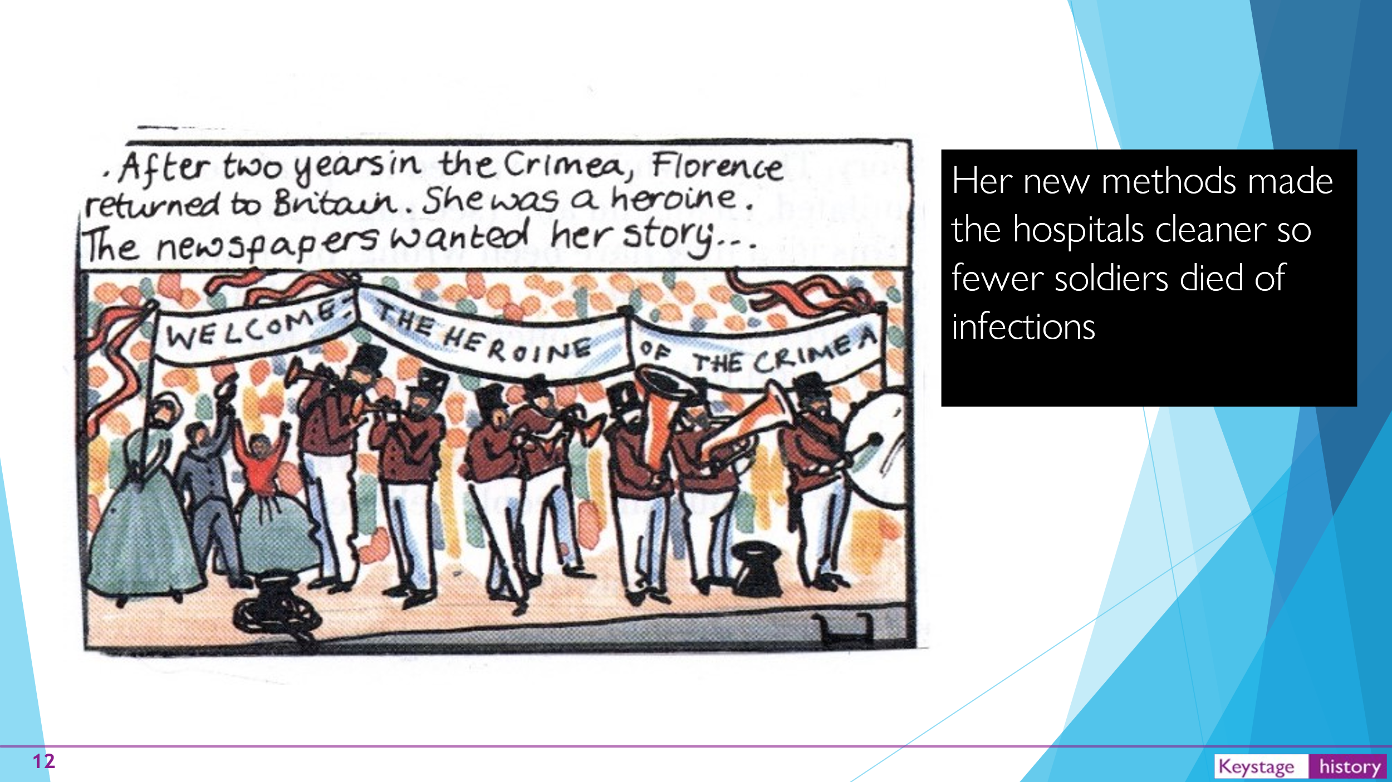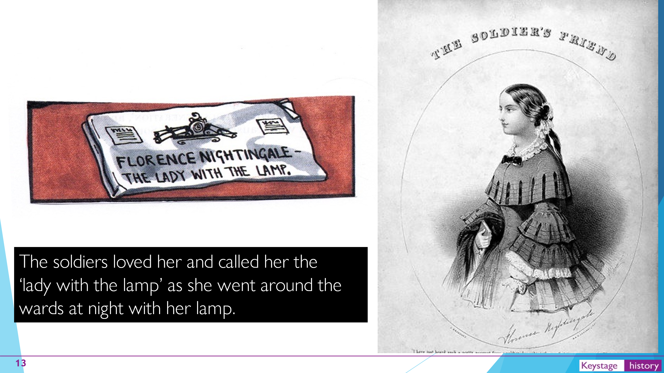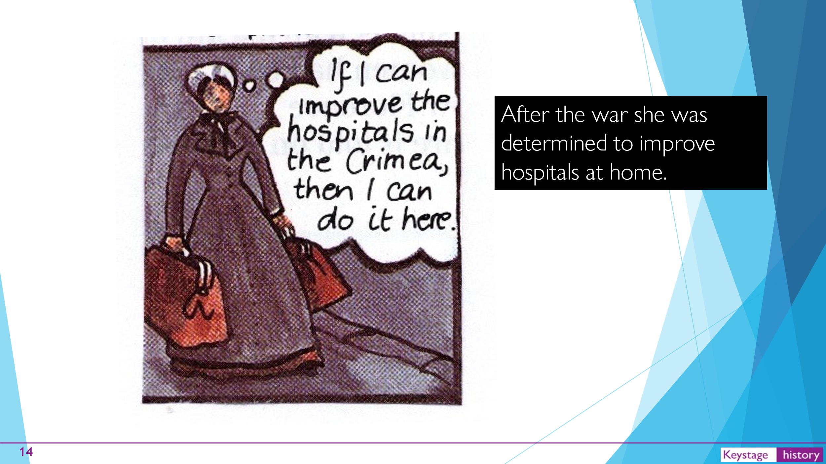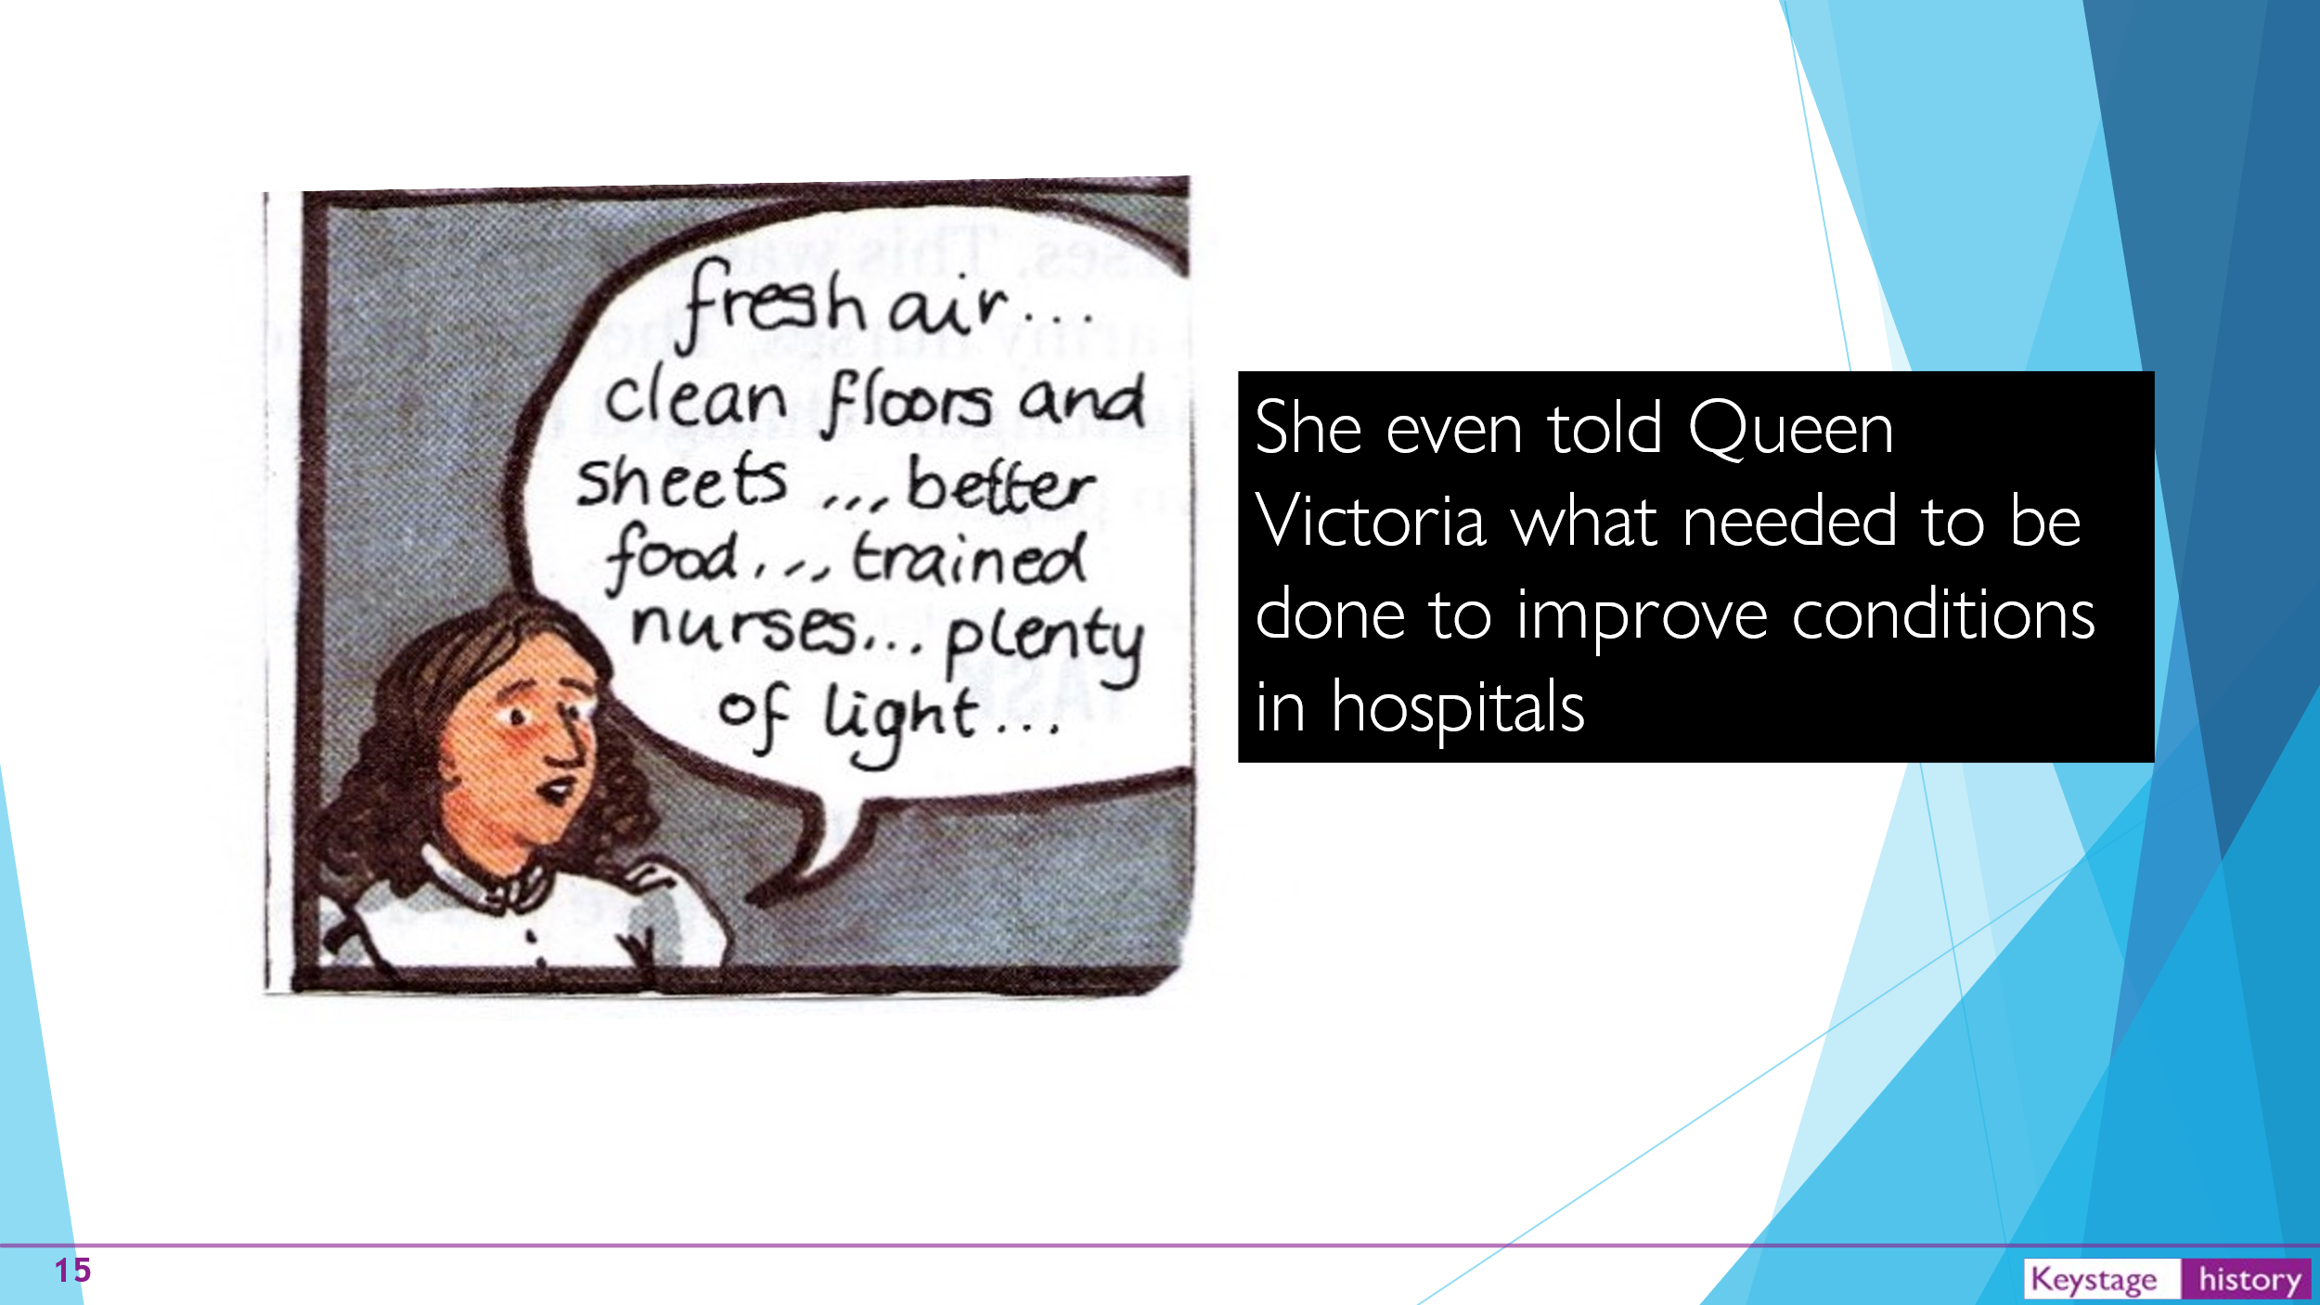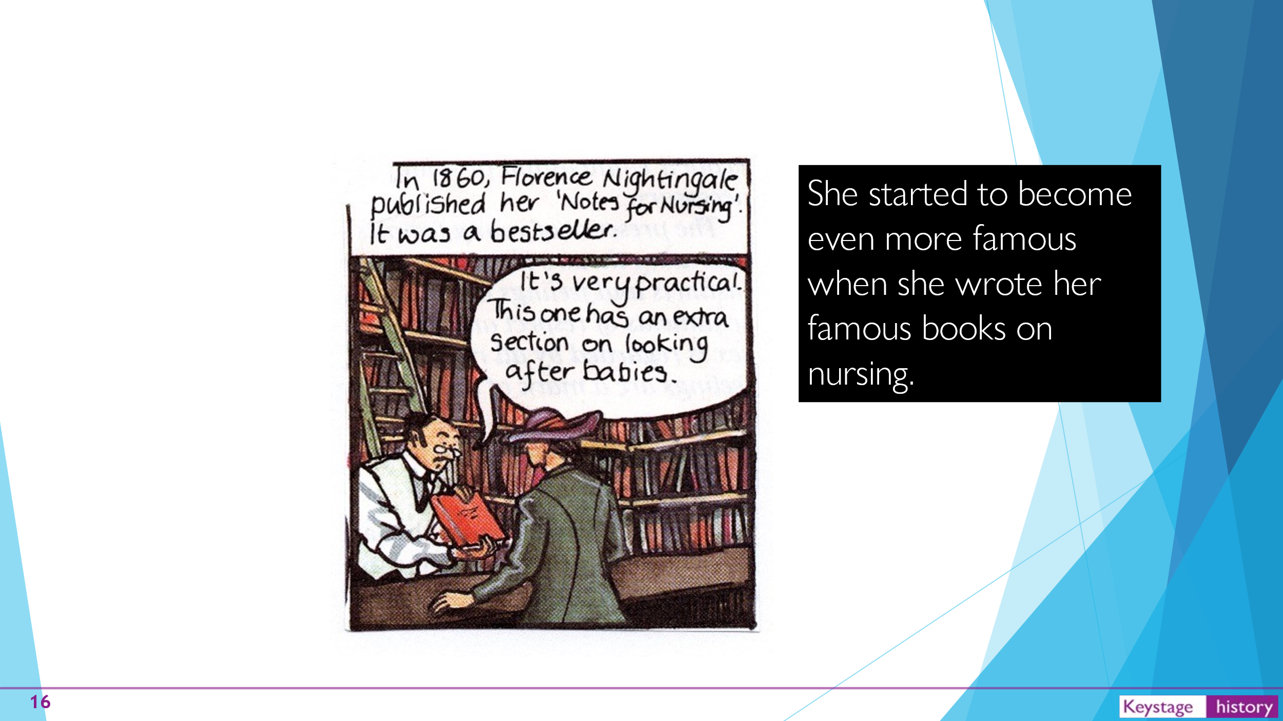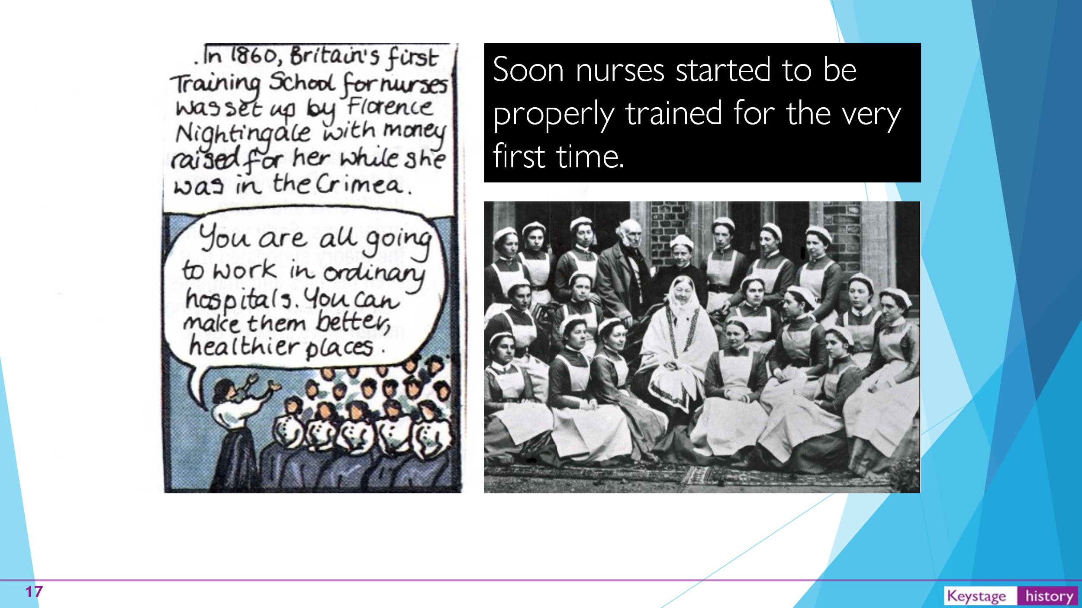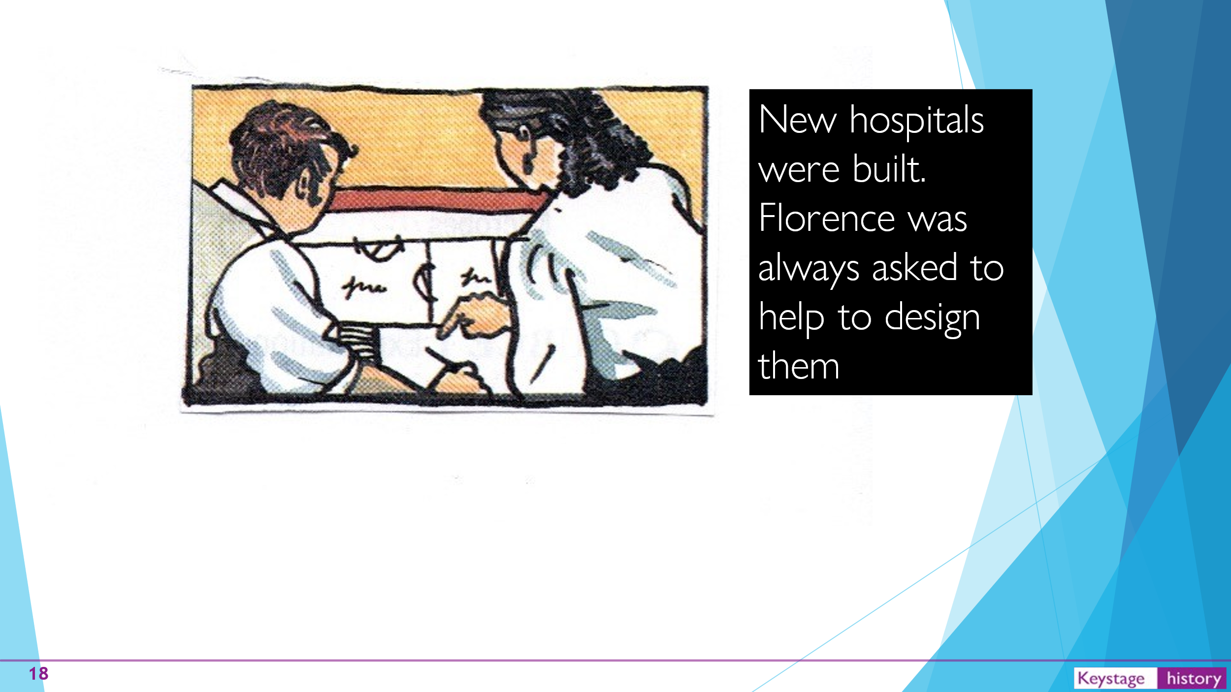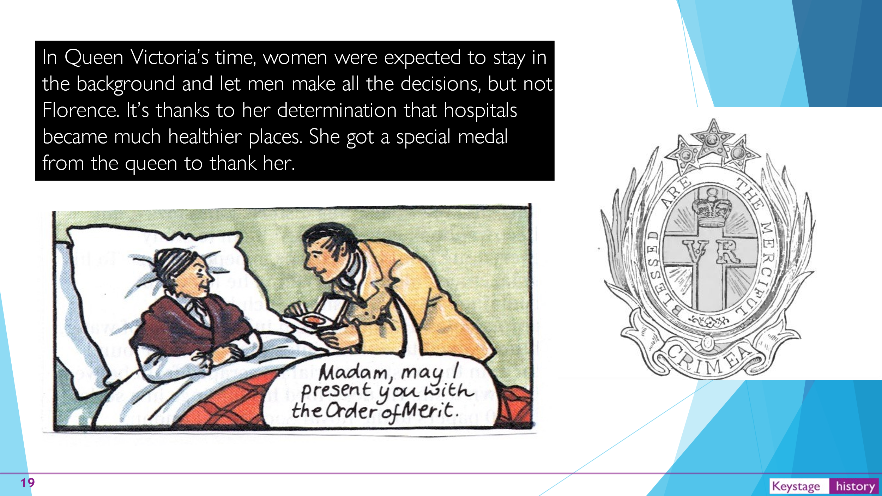

Thursday
Maths – Make arrays
https://vimeo.com/528946476
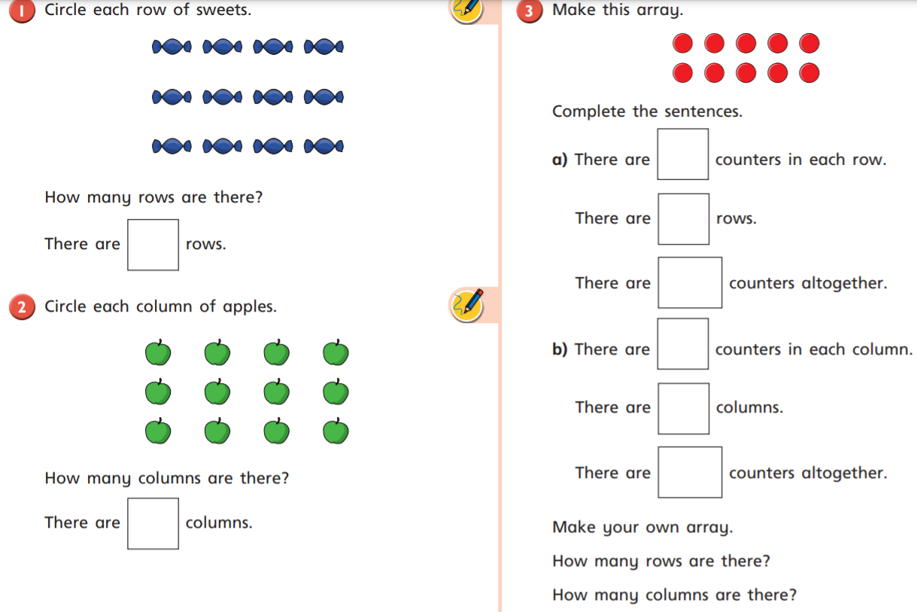
English
Adding the suffix -ing to a word to make a new word.
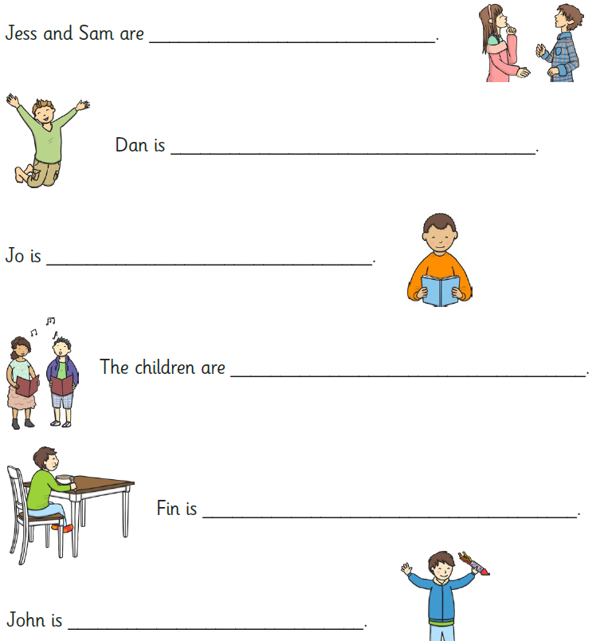
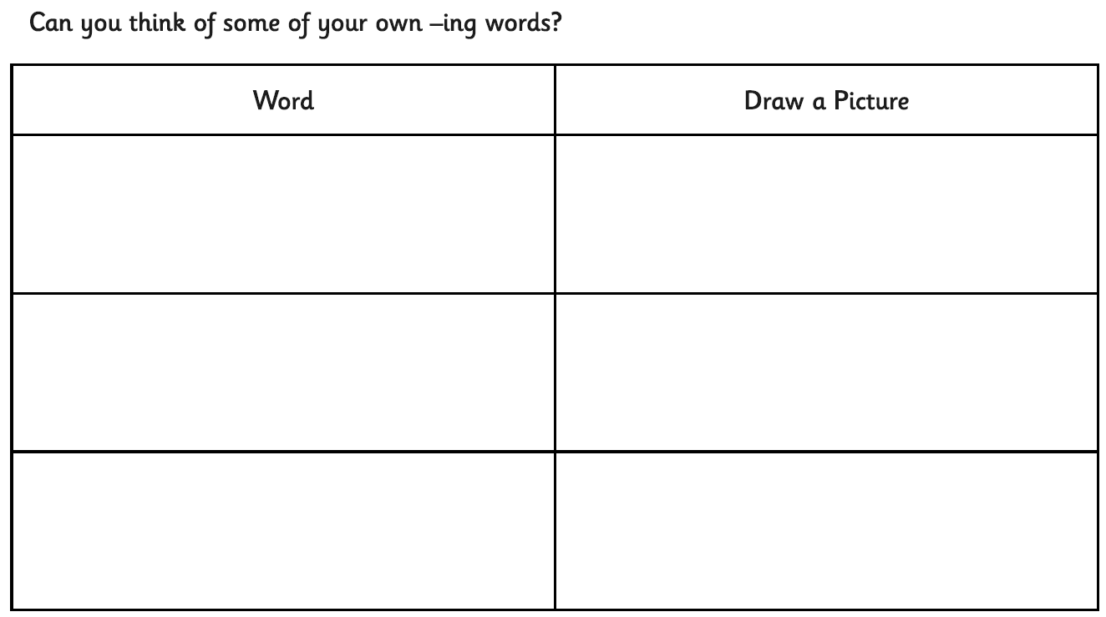
PSHE – Celebrating our differences
Talk to someone in your household and find four things that they have in common or are similarities. It can be appearance, e.g. eye/hair colour, or hobbies, things they like doing, things they are good at, etc.
On the shield templates design your own similarity shield with four of the things that they have in common and to fill in the slogan in the middle: ‘We are special because…’(for example, ‘We both like drawing’ or ‘We both have brown eyes’).
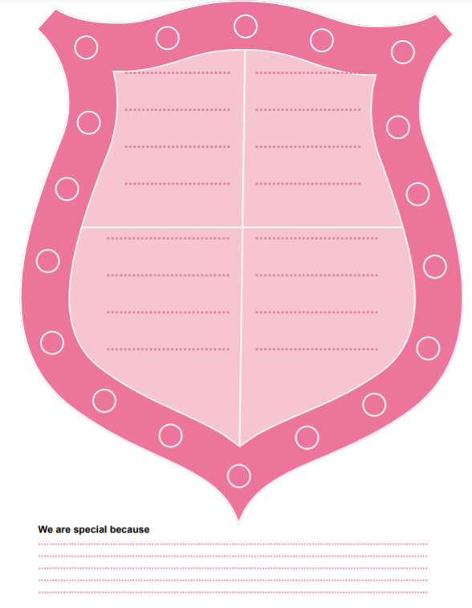

Friday
Maths – Use arrays
https://vimeo.com/490417143
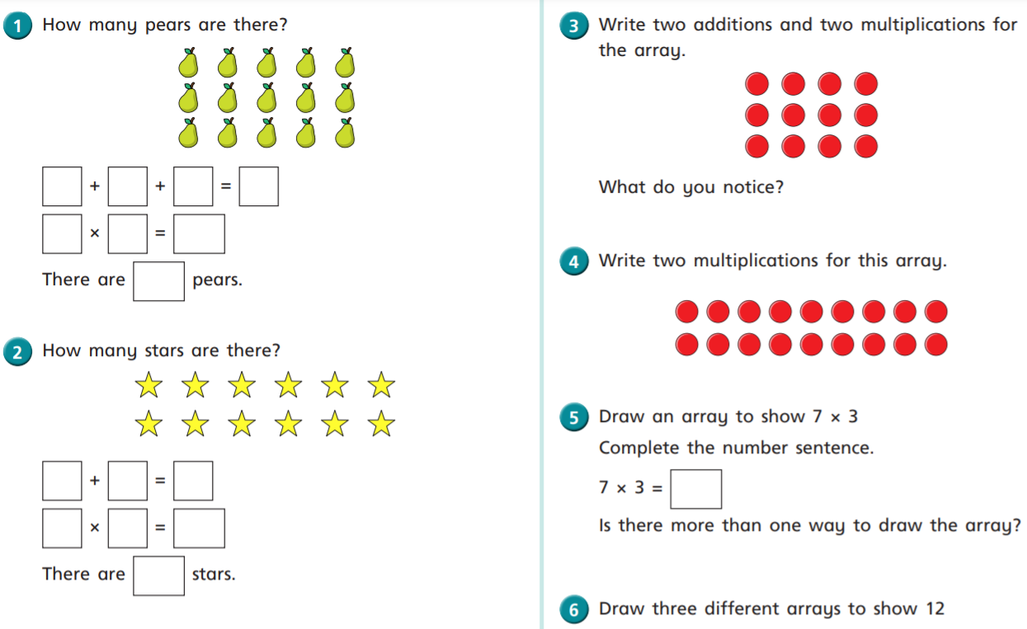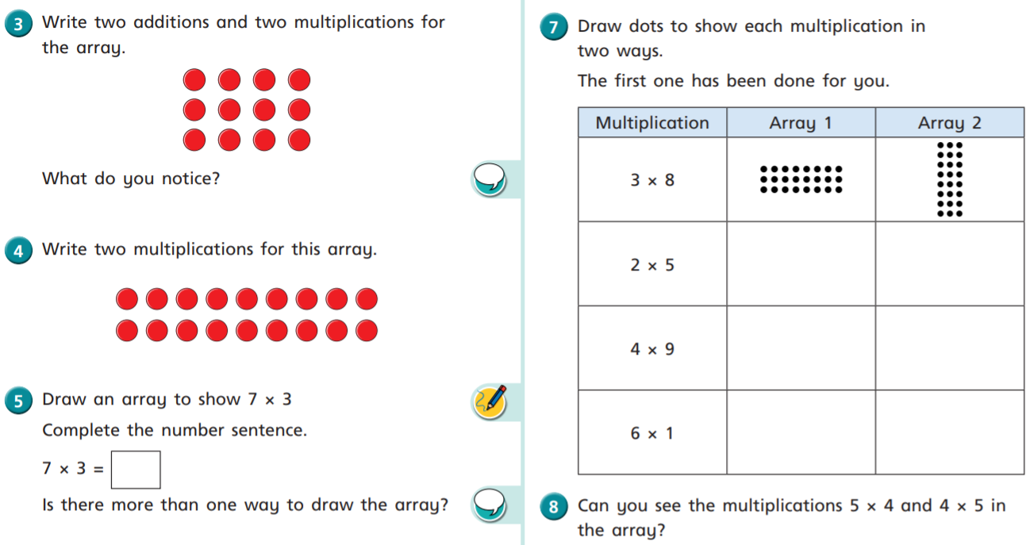

English
To identify and use time conjunctions in a sentence.
Task 1 – Write instructions to inform someone how to make a jam sandwich using time conjunctions (firstly, then, after that).
Task 2 – Choose the most appropriate time conjunctions to complete the sentences.
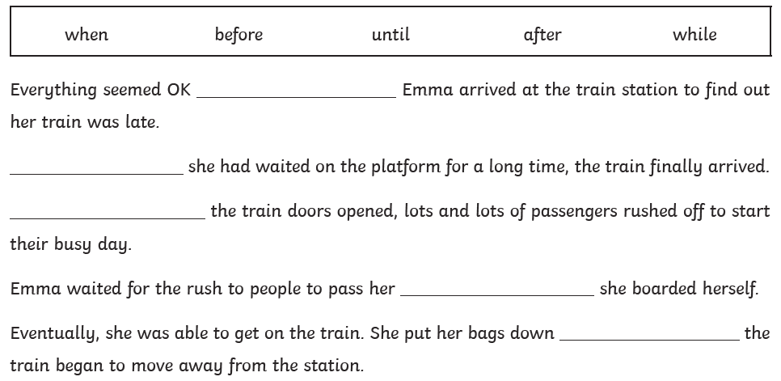

Science – The Human Body
Today we will be looking at the functions of our different body parts. Can you label and explain the function of the body parts below?
