Wednesday
Maths – Doubling
https://vimeo.com/528972666

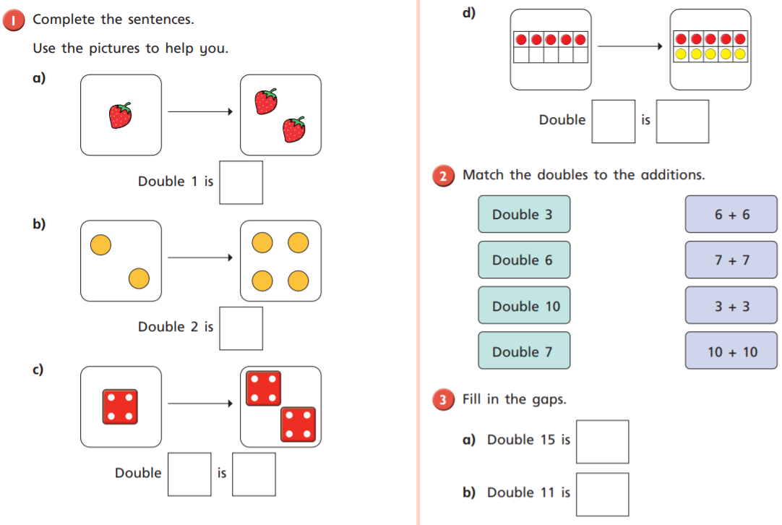
English – Non chronological report
Read this non-chronological report about hedgehogs and use a key to identify the key features. After, answer the questions below by finding the answers in the text.
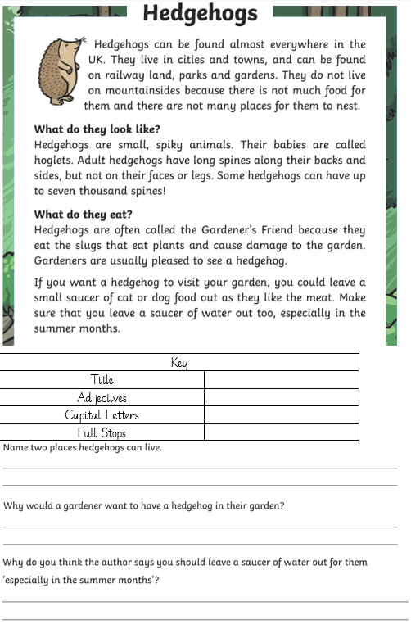
History – Florence Nightingale’s Achievements
Order Florence’s achievements from what you think are most to least important.
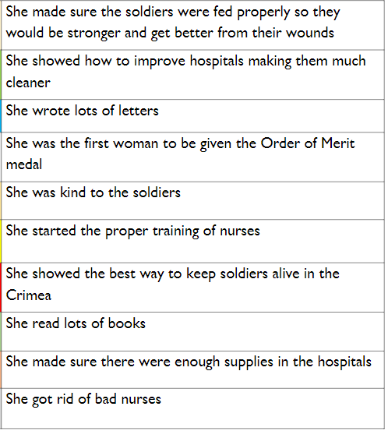

Thursday
Maths – Doubling continued
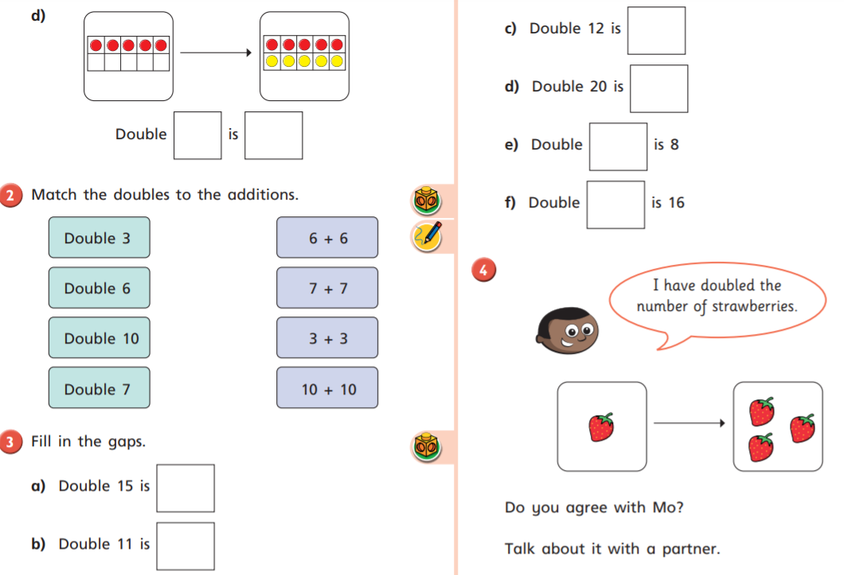
English – Fact and opinion
Fact – Something that is true and can be proved.
Opinion – Something that someone believes to be true but not proved.
Task: Write a fact and a opinion about the following pictures.
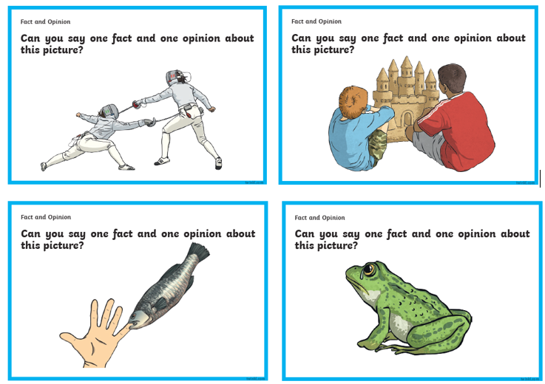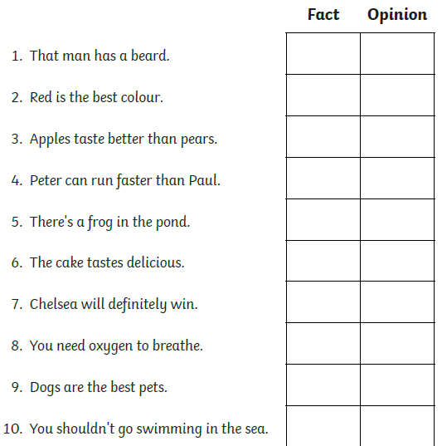
Computing – Impressionist Art
Use the link below to learn about impressionist artists and impressionism.
https://www.tate.org.uk/kids/explore/what-is/impressionism
In the search bar on purple mash type ‘2 Paint A Picture’. Click on the app and select ‘impressionism’ and create a picture of a sunrise.
Friday
Maths – Make equal groups by grouping.
https://vimeo.com/531646216

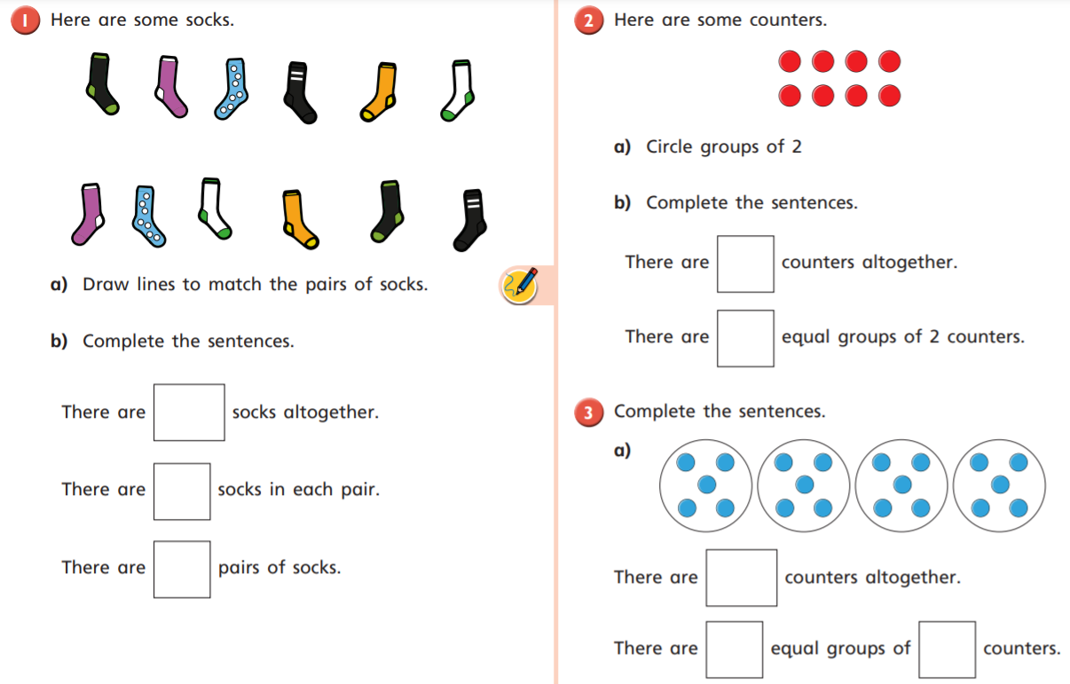
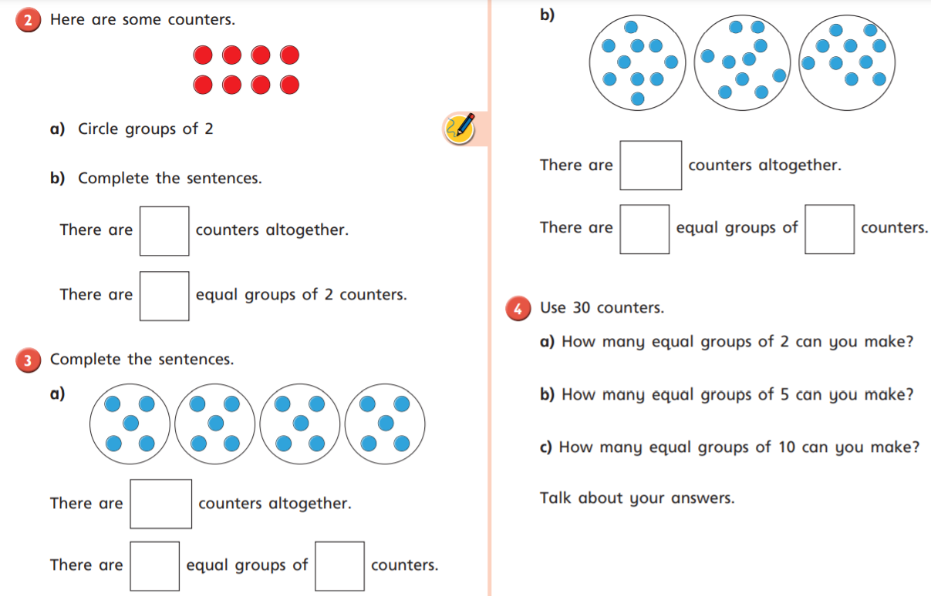
English – Comparative and superlative adjectives.
Comparative and superlative adjectives are used to compare.
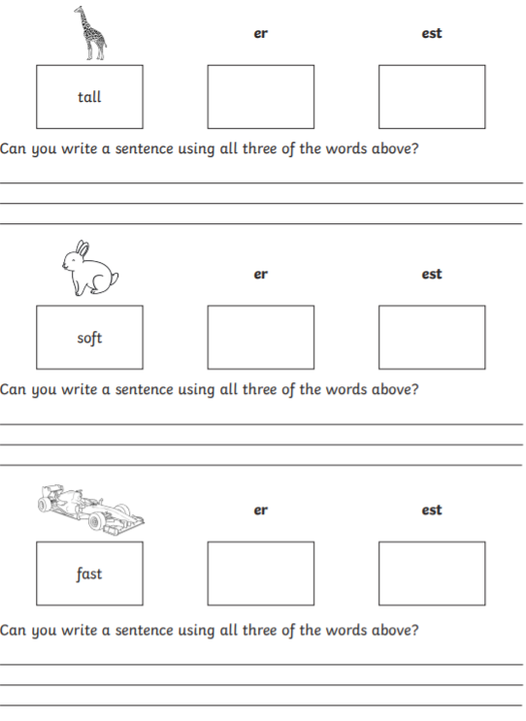
Science – Groups of animals
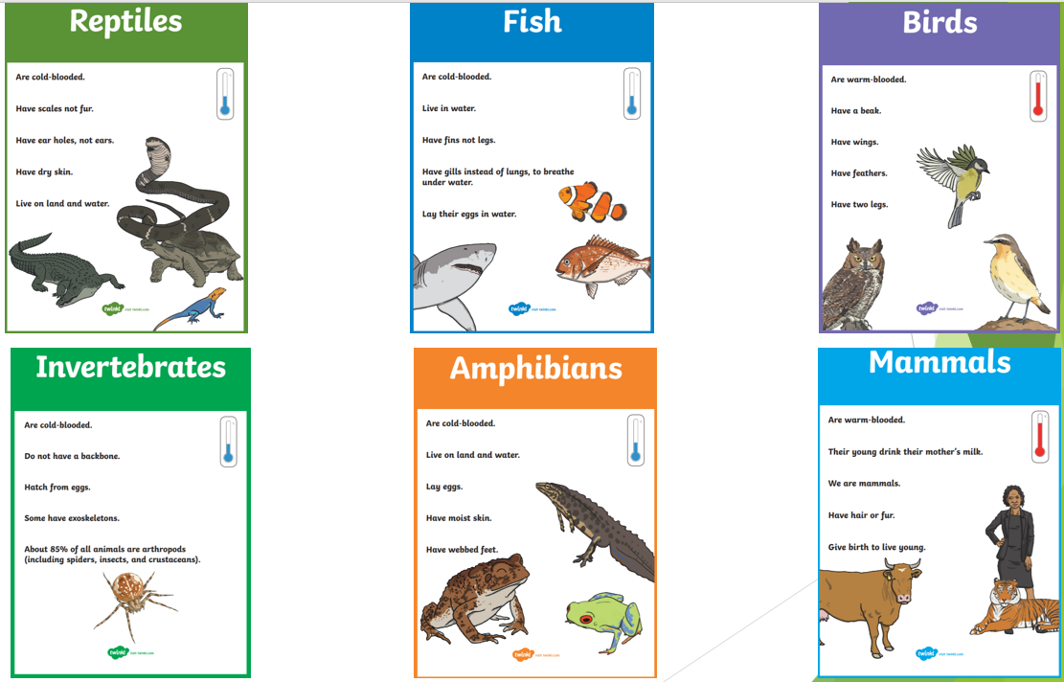
Task – Sort the animals below into their correct animal groups using the criteria above.
