Monday
Maths – Odd and Even Numbers
https://vimeo.com/498261586
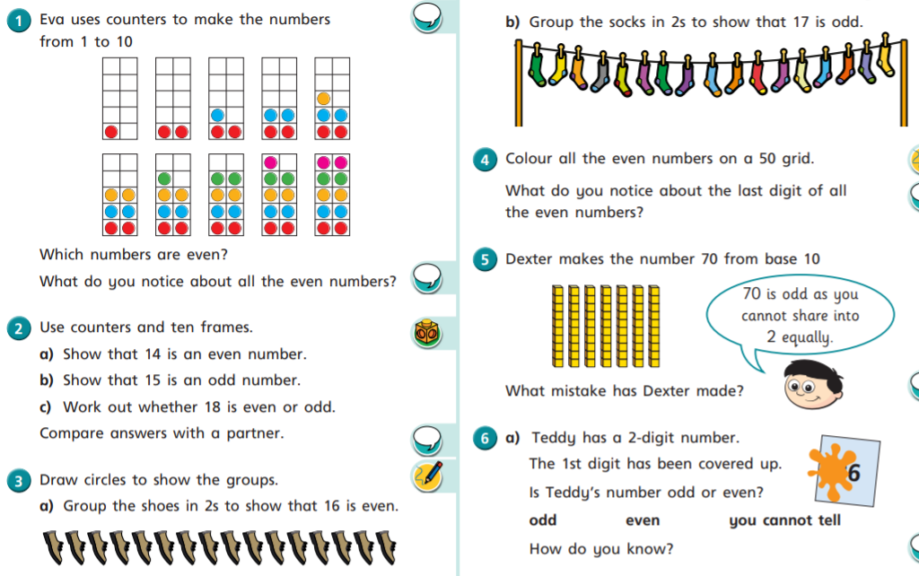
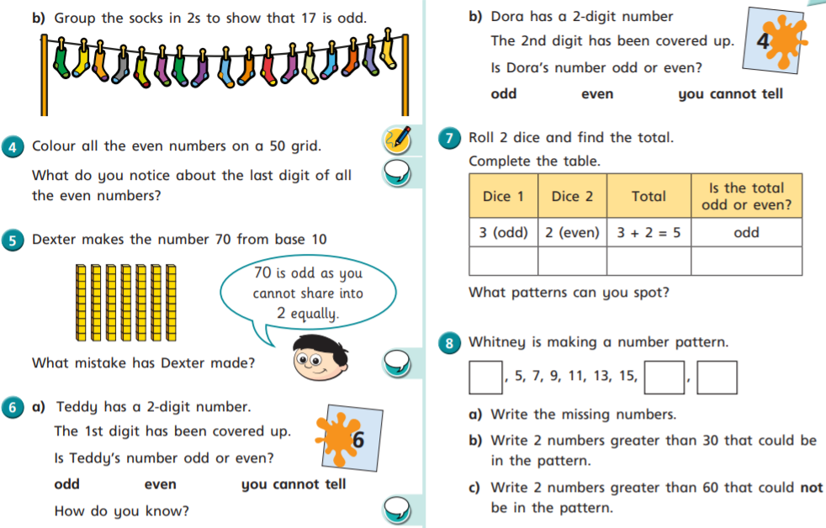
English – Contractions
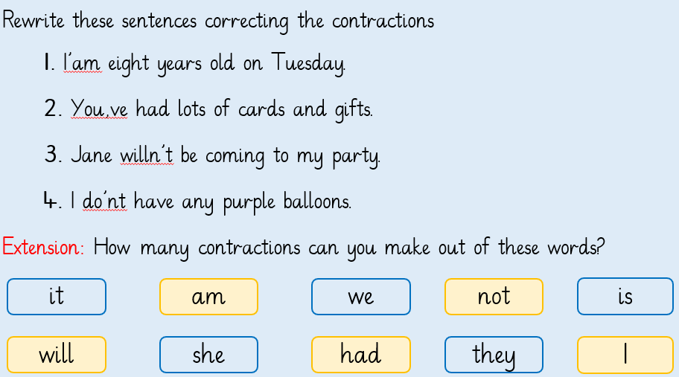
ICT – Pointillist Art
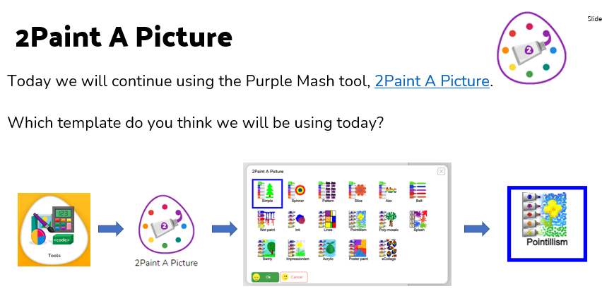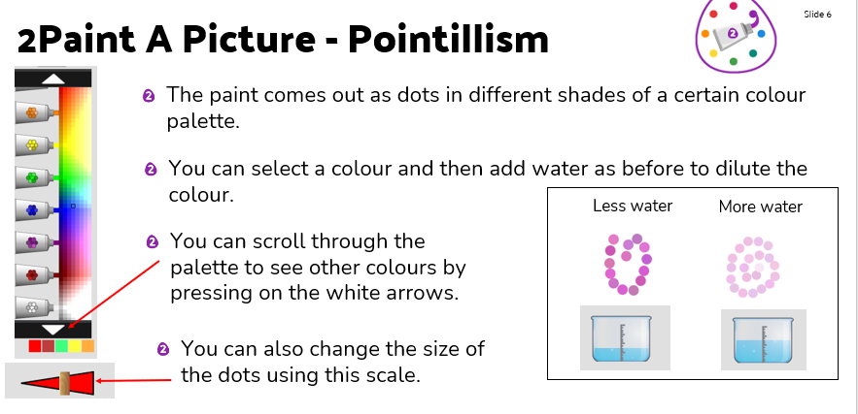
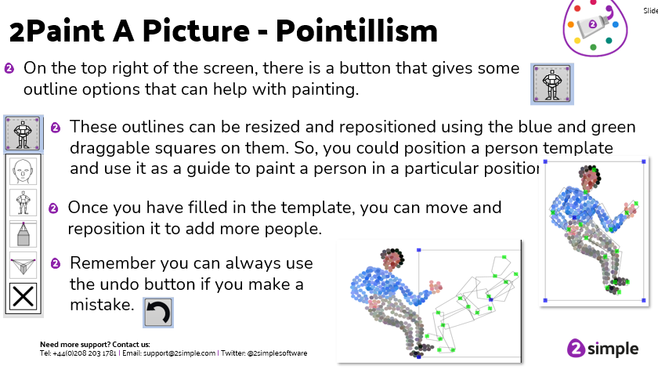
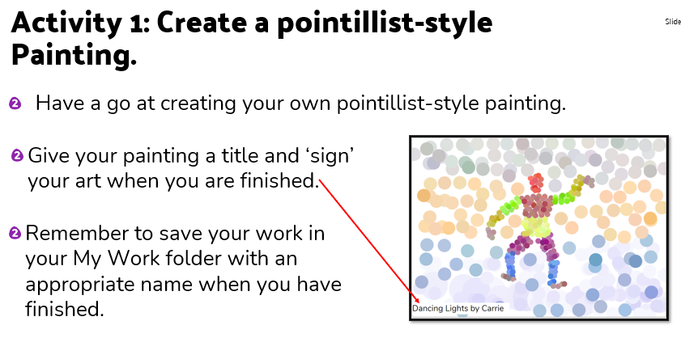
Tuesday
Maths – Divide by 5
https://vimeo.com/498262138
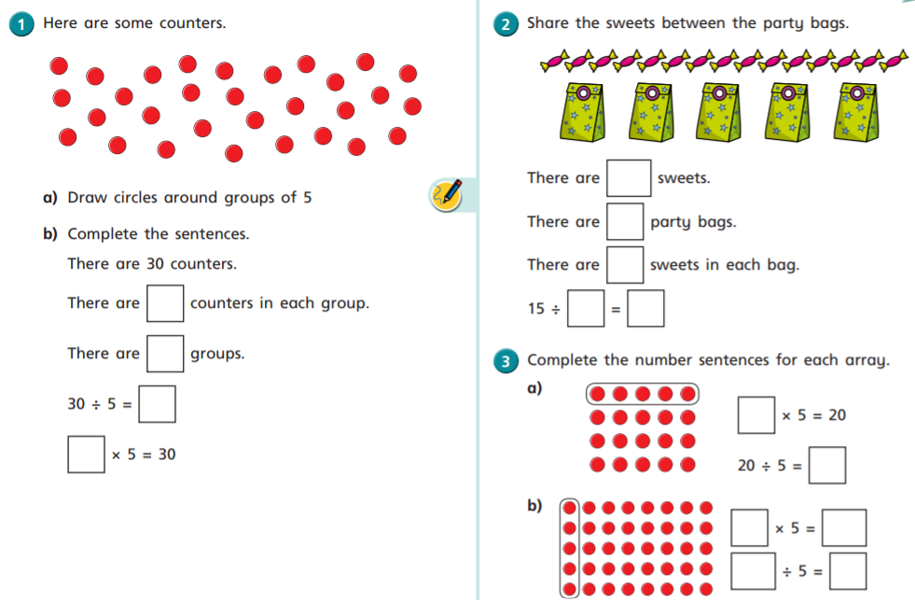
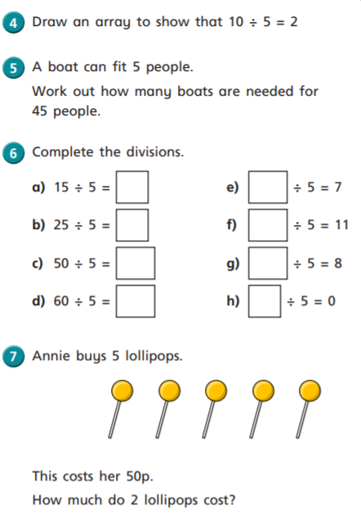
English – Planning
Use the mind map template below and research information about Florence Nightingale’s career, early life and achievements.
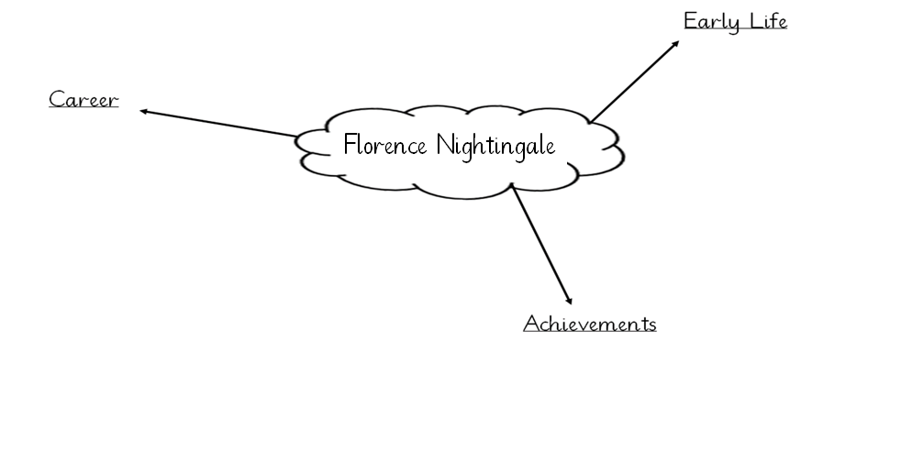
Music – Singing Traditional Songs (Separate PowerPoint)
Wednesday
Maths – Divide by 10
https://vimeo.com/498262386
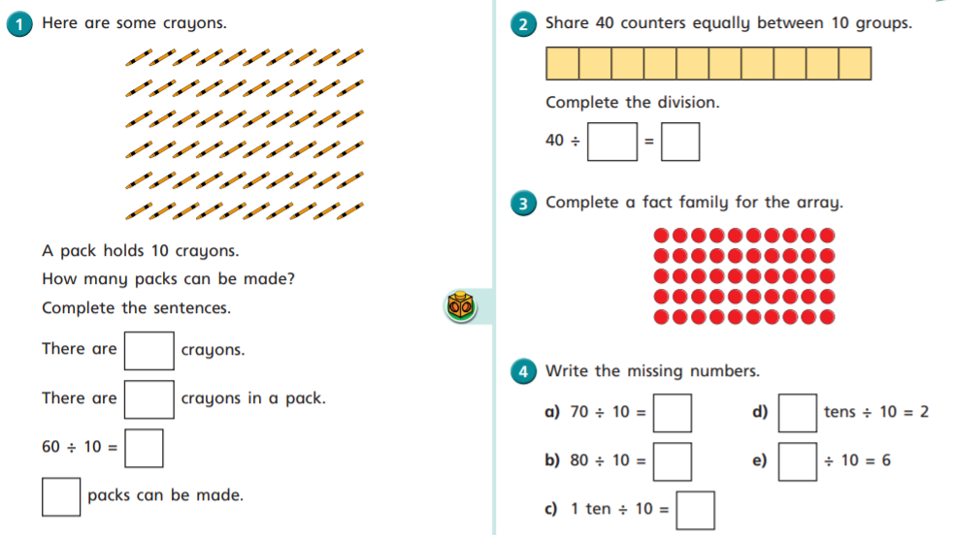
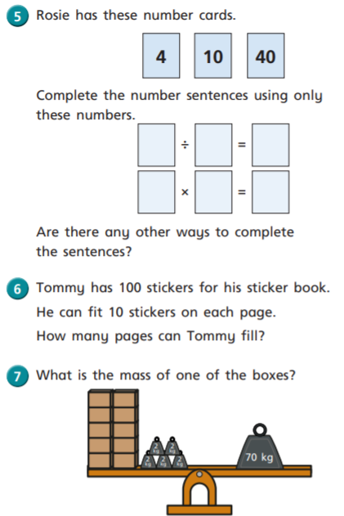
English – Writing
Use the template below (or create your own) to write your non-chronological report about Florence Nightingale using the information you found yesterday. This work will be completed over Wednesday’s and Thursday’s English lessons.
History – Look at separate PowerPoint
Thursday
Maths – Make Equal Groups by Sharing
https://vimeo.com/533496366
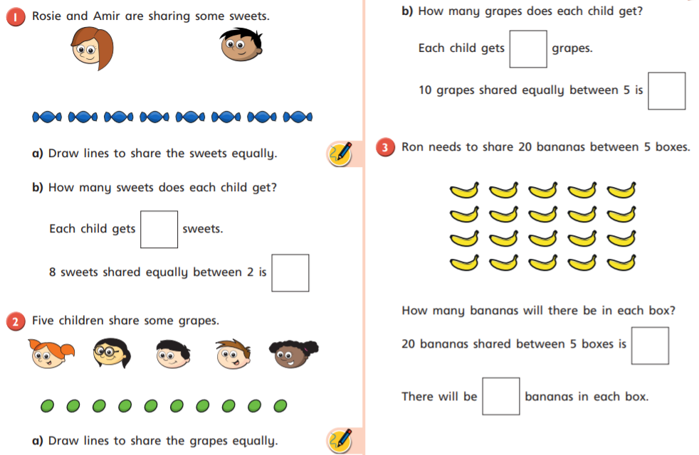
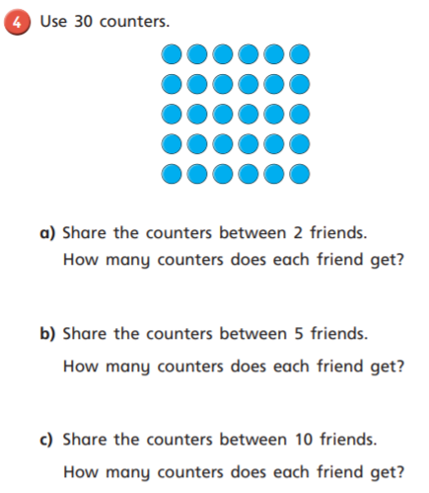
PSHE – What do I do about bullying?
How would be bullied make someone feel?
What could you do to help someone being bullied? (e.g., tell an adult)
Task: Write or draw 2 things you could do if you were being bullied.
Friday
Maths – End of Multiplication and Division Assessment
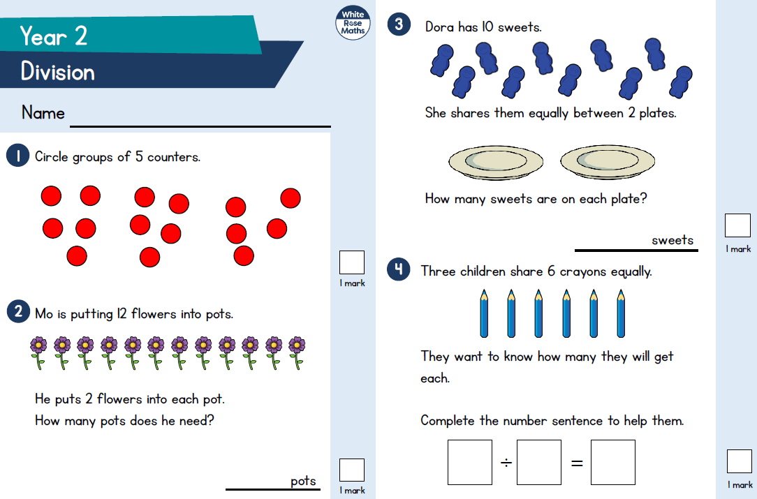
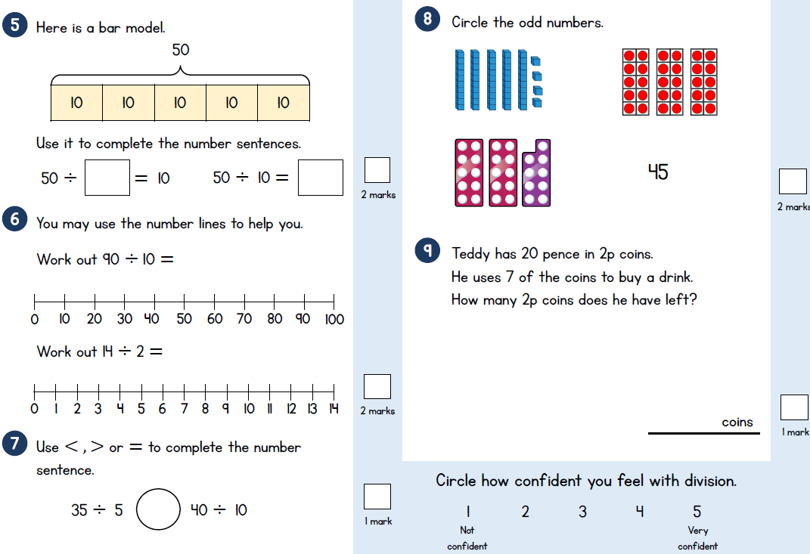
English – Reading comprehension
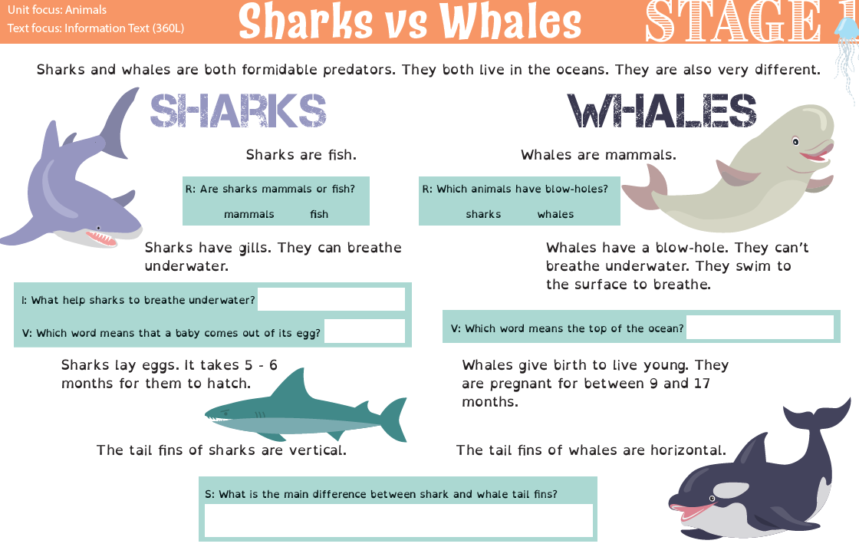
Science – Animal groups
Can you remember the 6 animal groups?
Each animal group has different characteristics.
Task: Use the table below to describe the characteristics of each animal group.
