Phonics:
Reception- https://youtu.be/af5mCjvLoSc
Please click on the link to watch today’s lesson, which will be reviewing sounds ar/oo/oa. Please participate in any speaking, reading and writing aspects of the lesson.
Year 1- https://youtu.be/48O9MgcbLqE
Please click on the link to watch today’s lesson, which is looking at ‘c’ making a ‘s’ sound, i.e. in ‘ice’. Please participate in any speaking, reading and writing aspects of the lesson.
Year 1 follow up task:
Follow the link to play the soft and hard ‘c’ sorting game. Sort the words depending on whether the ‘c’ makes a hard ‘c’ sound, or a soft ‘s’ sound.

https://www.twinkl.co.uk/go/resource/hard-and-soft-c-sound-t-e-2551930
If the link doesn’t work, sort these words below, by writing them onto post it notes.
dice | cart | camera
pace | case | circle
cake | coat | cycle
city | conker | rice

Phonics follow-up task:
Reception: Read the captions and match the pictures.
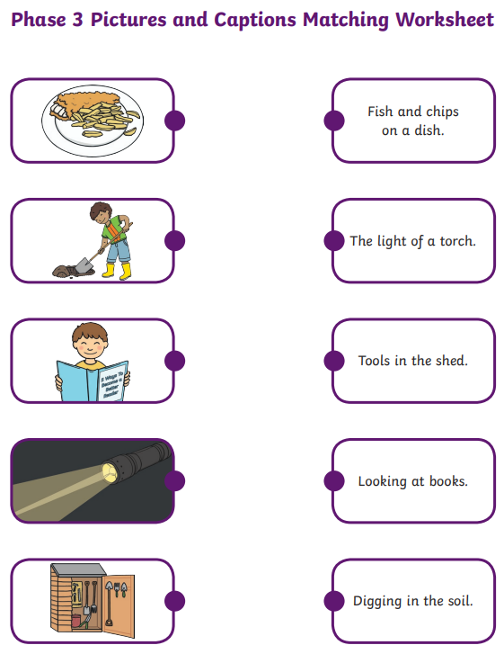

Maths:
Reception Lesson video:
Reception follow up task: You will need to make a set of number cards to 20, by cutting up card/paper, or using post it notes.
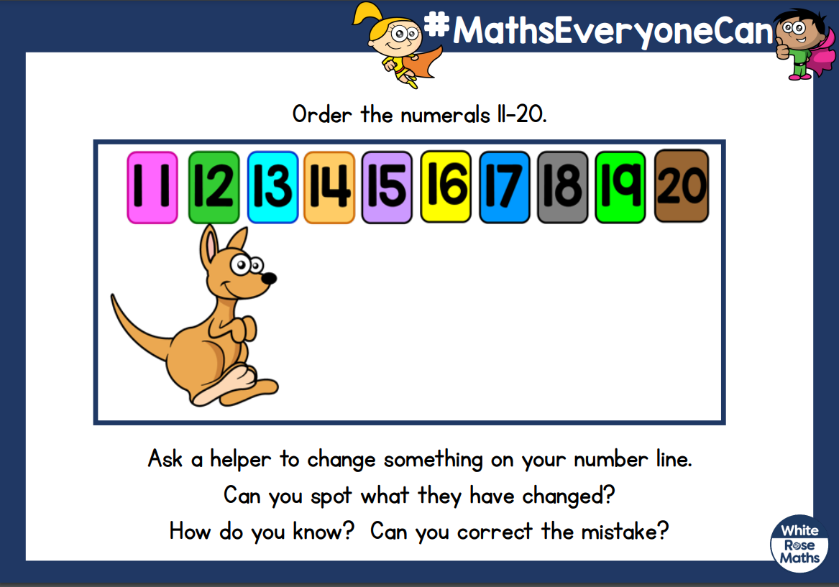
Year 1 lesson video: https://vimeo.com/500467998
Year 1 follow up task:
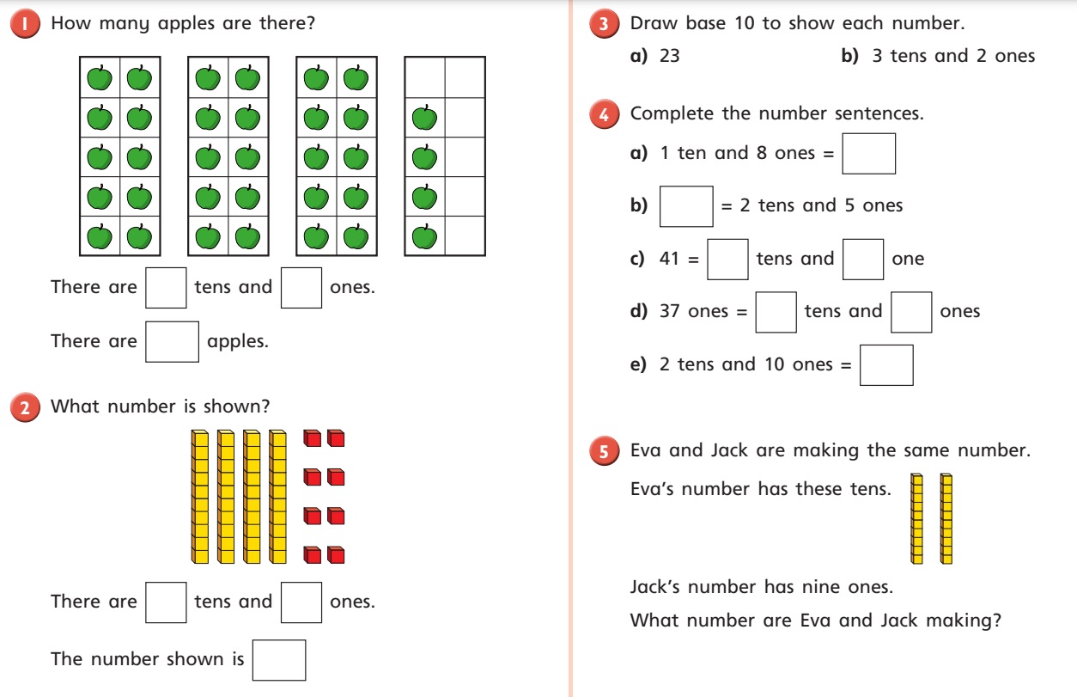
Afternoon activity:
In Art, we have begun to look at the work of Henri Matisse. Please work through the power point I have uploaded to the website, to look at his life and examples of his art work.
I would like you to create a papercut collage in the style of one of his most famous collages, ‘The snail’. You will need to use different brightly coloured paper, scissors and glue. Can you pick complementary colours using a colour wheel below and cut out shapes to collage your own snail. Complementary colours are opposite each other on a colour wheel.
There is also a nice story to watch which could be a good discussion point for different types of modern art: https://www.youtube.com/watch?v=cMKIBoDsWuc

