Dear parents and carers,
As part of the statutory National Curriculum, aspects of relationship and sex education are taught to all pupils is KS1 and KS2. Over the Summer Term, during their PSHE lessons, the children will be covering the topic ‘Changing Me’. This year, we have introduced the Jigsaw PSHE scheme and this final ‘puzzle piece’ combines teaching on relationships, puberty and health education.
The curriculum balances a biological approach to the teaching of Sex Education, with an emphasis on relationships, feelings and values. We believe this curriculum will give children the key skills and knowledge they need to keep themselves safe and healthy, whilst developing their confidence and self- esteem to ensure they are not vulnerable or exploited in any way.
The Health Education and Relationships Education aspects of PSHE education has been compulsory in all primary schools since September 2020. It is important that all children receive this content, covering topics such as friendships and how to stay safe. The Relationships Element to RSE is statutory, however, parents have the right to request that their child be withdrawn from the Sex Education content.
On the page attached to this letter, you will find a curriculum overview for the puberty and reproduction aspects of the module ‘Changing Me’. You may see some lessons highlighted in red. These indicate the lessons which you can choose to withdraw your child from. All other content is statutory.
The programme will be delivered by your child’s classroom teacher where possible. There will be opportunities for the children to work in mixed and single gender groups and exercises will be adapted to consider different levels of maturity and ability.
If your child is in Year 4 or above and you wish for them to be removed from the non-statutory content lessons, please complete and return the consent form below, by Thursday 16th June. Parents of children in Year 3 and below, do not need to return the consent form, as all aspects of the taught curriculum for these ages, are compulsory.
If you have any questions or concerns about the curriculum, would like to take a look at the materials being used, or would like more information before returning the consent form, please book a meeting through the school office or alternatively, send an email to: Natalie.Latham@lct.education.
Kind regards,
Miss Latham

I do not give my consent for …………………………………………………….. (name of child) to take part in the non-statutory RSE lessons.
Signed …………………………………………………. Print name ………………………………………………………

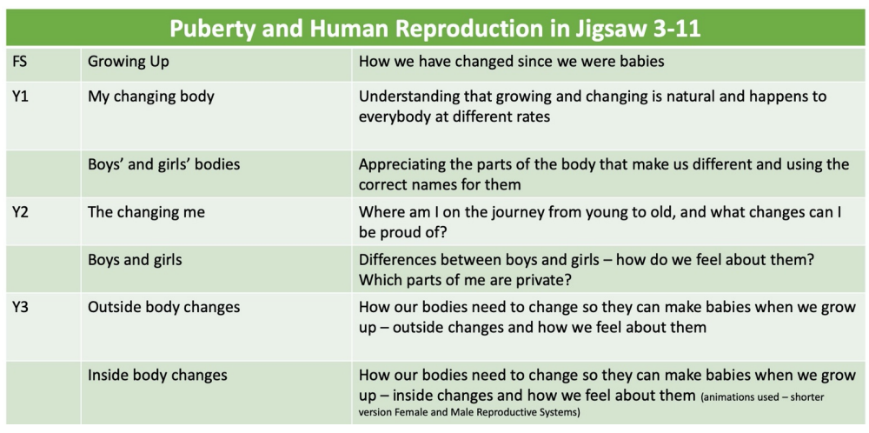
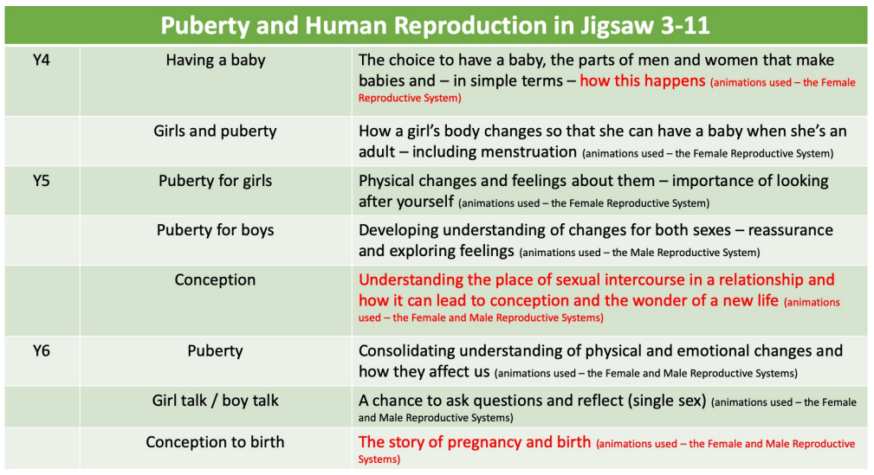
The grids below show a brief summary of the “Changing Me” Puzzle (unit) in Jigsaw with respect to what is taught – when, relating to Puberty and Human Reproduction. The puberty work in Jigsaw fulfils the requirements that sit under the ‘Changing Adolescent Body’ strand of statutory Health Education, and parents cannot withdraw their children from this. However, the lessons highlighted in red relate to ‘human reproduction’, which is non-statutory. Therefore, parents have a right to withdraw their child from these or part of these sessions.

