Class 2 Curriculum Map 2022-23  Year 1 & 2 | Autumn 1 |  | Autumn 2 |  |  | Spring 1 |  |  |  | Spring 2 |  |  |  |  |  | Summer 1 |  |  | Summer 2
Value Focus | Humility | Joyfulness | Honesty |  | Equality | Trust |  | Helpfulness |  | Forgiveness |  | Diversity/  Tolerance |  |  |  | Courage | Empathy |  | Respect | Hope
 | Democracy |  | The Rule of Law |  |  | Individual Liberty |  |  |  | Mutual Respect |  |  |  |  |  | Tolerance |  |  | Recap & Revisit
 | Family | Health | Protection From Harm |  | Privacy | Identity |  | Freedom of Thought |  | The Arts |  | Government Responsibility |  |  |  | Non-discrimination | Reparation |  | Education | Access to Information
PSHE: | Being Me in My World  Hopes and fears for the year Rights and responsibilities Rewards and consequences Safe and fair learning environment Valuing contributions Choices Recognising feelings |  | Celebrating difference  Assumptions and stereotypes about gender Understanding bullying Standing up for self and others Making new friends Gender diversity Celebrating difference and remaining friends |  |  | Dreams and Goals  Achieving realistic goals Perseverance Learning strengths Learning with others Group co-operation Contributing to and sharing success |  |  |  | Healthy Me  Motivation Healthier choices Relaxation Healthy eating and nutrition Healthier snacks and sharing food |  |  |  |  |  | Relationships  Different types of family Physical contact boundaries Friendship and conflict Secrets Trust and appreciation Expressing appreciation for special relationships |  |  | Changing Me  Life cycles in nature Growing from young to old Increasing independence Differences in female and male bodies (correct terminology) Assertiveness Preparing for transition
RE: | Respect for everyone |  | Find out about Christian and Jewish holy buildings. |  |  | Theme: Passover Key Question: How important is it for Jewish people to do what God asks them to do? Religion: Judaism |  |  |  | Holy books: Words which are special. |  |  |  |  |  | Theme: The Covenant Key Question: How special is the relationship Jews have with God? Religion: Judaism |  |  | Theme: Rites of Passage and good works Key Question: What is the best way for a Jew to show commitment to God? Religion: Judaism. Add Humanism if appropriate
Events: | Macmillan Coffee  Morning (25th September)  Black History Month (October) |  | Remembrance Sunday  (11th November)  Anti-Bullying Week  (16th-21st November)  Children In Need (13th November) |  |  | Safer Internet Day  (9th February)  Children’s Mental Health Week  (February 2023) |  |  |  | World Book Day (4th March)  World Maths Day  (March 2023)  Comic Relief (March 2021)  British Science Week (March 2023) |  |  |  |  |  | Walk to School Week |  |  | Sports Day (July  2023)
Cultural Capital:  (Development of self: Personally Socially  Physically Spiritually  Morally  Culturally) to enable social mobility) | Transition Programme  Black History Week  Global Learning Theme (Democracy)  Election of School Parliament  Remembrance Day artwork  Anti-Bullying Week  Children in Need  Online Safety in computing |  |  |  |  | Safer Internet Day  Mental Health and wellbeing Programme  World Book Day  World Maths Day  Comic Relief  Refugee work  Email work (Computing) |  |  |  |  |  |  |  |  |  | Projects for the community  Sports Day  SRE Program
History: | The Great Fire of London  NC- events beyond living memory |  |  |  |  | Caxton and Bell  NC- changes within living memory |  |  |  |  |  |  |  |  |  | Flight – Amy Johnson  NC- events beyond living memory
History Concepts | Settlement |  |  |  |  | Trade |  |  |  |  |  |  |  |  |  | Kingdom
Geography | Local area study – Crudgington Fields  (Comparing a UK city to a rural area) |  |  |  |  |  | Continents and Oceans |  |  |  |  |  |  | Mugurameno Village, Zambia
English: | Character description  Setting description  Recount – biography |  |  | Narrative Historical  Newspaper report  Structured poems |  |  | Non -chronological report  Explanation  Adventure narrative |  |  |  | Film narrative  Diary  Free verse poetry |  |  |  | Visual poetry  Explanation  Character description |  |  |  | Speech campaign  Dilemma narrative  Persuasion
Whole-Class Reading Book | 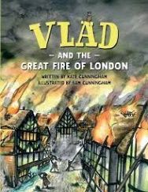 |  |  | 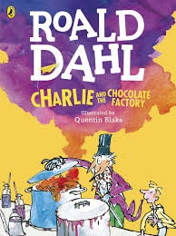 |  |  | 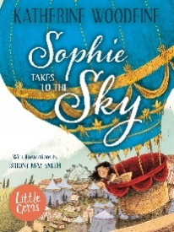 |  |  |  | 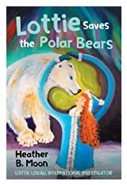 |  |  |  | 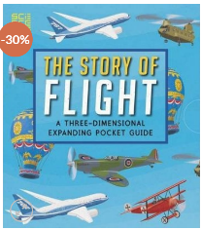 |  |  |  | 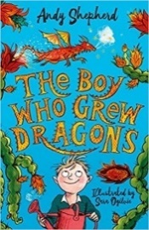
Maths: | Place Value  Addition and Subtraction  Geometry |  |  |  |  |  | Measurement  Four Operations  Fractions |  |  |  |  |  |  | Statistics  Measurement  Geometry  Four Operations
Science | Our Environment  How does the environment change over the course of the year? |  |  | Materials  Name common materials and describe their basic properties.  Group materials |  |  | Habitats  Identify and name a range of different plants and animals in their habitats.  Food chains |  | Animals and their needs  Describe the basic needs of animals, including humans, for survival |  |  |  | Plants  Observe and describe how seeds and bulbs grow  Know what plants need to stay healthy
Science Experiments  investigation | Diary of seasonal changes across the year |  |  | Testing material strength – through designing a fair test |  |  | Investigate the features of different habitats |  | Sorting foods into different groups & designing a healthy meal/diet |  |  |  | Compare the growth of plants in different conditions
Science links with maths | Days  Weeks  Months of the year |  |  | Weight  Graphing  Table of results |  |  | Directions |  | Pie chart |  |  |  | Measuring  Units cm
Computing | Technology Around Us  Online Safety |  |  | Digital Photography  Online Safety |  |  | Moving a robot |  | Pictograms  Online Safety |  |  |  | Digital writing  Online Safety |  |  |  |  | Programming quizzes

Art & Design | Sculpture |  | Painting |  | Drawing
Design & Technology | Food  Food preparation – fruit and vegetables. |  | Textiles  Templates and joining techniques |  | Structures  Freestanding structures
Music | Reading & Composing Music (Level 1)  To learn to read pitch and rhythm to create, notate and improve my own compositions and other pieces of music from around the world and great composers. |  | The Big Sing  Technique  Expression  Accuracy |  | Music Through Time  Knowledge & Understanding  Musical Elements  Musical Contexts  Musical Language
PE | Hockey | Dance | Gymnastics | Cricket | Maypole | Athletics

