Term  Class 4 Curriculum Map 2022-23  Year 4 & 5 | Autumn 1 |  | Autumn 2 |  |  | Spring 1 |  |  |  | Spring 2 |  |  |  |  |  | Summer 1 |  |  | Summer 2
Value Focus | Humility | Joyfulness | Honesty |  | Equality | Trust |  | Helpfulness |  | Forgiveness |  | Diversity/  Tolerance |  |  |  | Courage | Empathy |  | Respect | Hope
 | Democracy |  | The Rule of Law |  |  | Individual Liberty |  |  |  | Mutual Respect |  |  |  |  |  | Tolerance |  |  | Recap & Revisit
 | Family | Health | Protection From Harm |  | Privacy | Identity |  | Freedom of Thought |  | The Arts |  | Government Responsibility |  |  |  | Non-discrimination | Reparation |  | Education | Access to Information
PSHE: | Being Me in My World  Planning the forthcoming year  Being a citizen  Rights and responsibilities  Rewards and consequences  How behaviour affects groups  Democracy, having a voice,  participating |  | Celebrating difference  Cultural differences and how  they can cause conflict  Racism  Rumours and name-calling  Types of bullying  Material wealth and  happiness  Enjoying and respecting  other cultures |  |  | Dreams and Goals  Future dreams  The importance of money  Jobs and careers  Dream job and how to get there  Goals in different cultures  Supporting others (charity)  Motivation |  |  |  | Healthy Me  Smoking, including vaping  Alcohol  Alcohol and anti-social behaviour  Emergency aid  Body image  Relationships with food  Healthy choices  Motivation and behaviour |  |  |  |  |  | Relationships  Self-recognition and self-worth  Building self-esteem  Safer online communities  Rights and responsibilities online  Online gaming and gambling  Reducing screen time  Dangers of online grooming  SMARRT internet safety |  |  | Changing Me  Self- and body image  Influence of online and media on  body image  Puberty for girls  Puberty for boys  Conception (including IVF)  Growing responsibility  Coping with change  Preparing for transition
RE: | Theme: Beliefs and Practices Key Question: How special is the relationship Jews have with God? Religion: Judaism |  | Theme: Christmas Concept: Incarnation Key Question: What is the most significant part of the nativity story for Christians today? Religion: Christianity |  |  | Theme: Passover Key Question: How important is it for Jewish people to do what God asks them to do? Religion: Judaism |  |  |  | Theme: Easter Concept: Salvation Key Question: Is forgiveness always possible for Christians? Religion: Christianity |  |  |  |  |  | Theme: Rites of Passage and good works Key Question: What is the best way for a Jew to show commitment to God? Religion: Judaism |  |  | Theme: Prayer and Worship Key Question: Do people need to go to church to show they are Christians? Religion: Christianity
Events: | Macmillan Coffee  Morning (25th September)  Black History Month (October) |  | Remembrance Sunday  (11th November)  Anti-Bullying Week  (16th-21st November)  Children In Need (13th November) |  |  | Safer Internet Day  (9th February)  Children’s Mental Health Week  (February 2023) |  |  |  | World Book Day (4th March)  World Maths Day  (March 2023)  Comic Relief (March 2021)  British Science Week (March 2023) |  |  |  |  |  | Walk to School Week |  |  | Sports Day (July  2023)
Cultural Capital:  (Development of self: Personally Socially  Physically Spiritually  Morally  Culturally) to enable social mobility) | Transition Programme  Black History Week  Global Learning Theme (Democracy)  Election of School Parliament  Remembrance Day artwork  Anti-Bullying Week  Children in Need  Online Safety in computing |  |  |  |  | Safer Internet Day  Mental Health and wellbeing Programme  World Book Day  World Maths Day  Comic Relief  Refugee work  Email work (Computing) |  |  |  |  |  |  |  |  |  | Projects for the community  Sports Day  SRE Program
History: | The Mayans  NC-the achievements of the earliest civilizations |  |  |  |  | Benin  NC-a non-European society that provides contrasts with British history |  |  |  |  |  |  |  |  |  | Tudors – Thematic Study: Monarchy  NC-a study of an aspect or theme in British history that extends pupils’ chronological  knowledge beyond 1066
History Concept Lens | Kingdom |  |  |  |  | Trade |  |  |  |  |  |  |  |  |  | Monarchy
Geography | Volcanoes |  |  |  |  |  | Earthquakes |  |  |  |  |  |  | Mountains
English: | Character description  Setting description  Recount – biography |  |  | Narrative Historical  Newspaper report  Structured poems |  |  | Non -chronological report  Explanation  Adventure narrative |  |  |  | Film narrative  Diary  Free verse poetry |  |  |  | Visual poetry  Explanation  Character description |  |  |  | Speech campaign  Dilemma narrative  Persuasion
Whole-Class Reading Book | 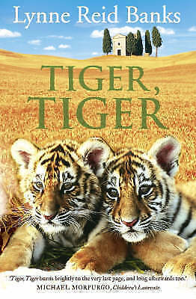 |  |  | 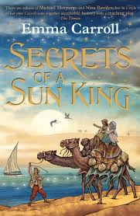 |  |  | 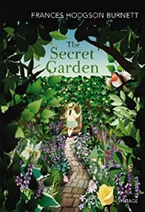 |  |  |  |  |  |  |  | 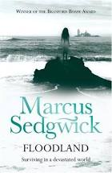 |  |  |  | 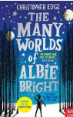
Maths: | Place Value  Four operations  Measurement  Fractions, Decimals and Percentages |  |  |  |  |  | Fractions, Decimals and Percentages  Multiplication and Division  Geometry  Statistics |  |  |  |  |  |  | Measurement  Geometry  Decimals  Four operations
Science | Digestion  Animals including humans  Digestive system  Teeth  Food chain |  |  | Respecting our Environment  Survey a wild area of land and note down any signs that humans have been there. Discuss and evaluate the impact of humans on the wildlife |  |  | Mixtures & Reactions  Properties and changes of materials  Solubility  Separating mixtures  Reversible & chemical change |  | Sound  Making sounds  Transmission of sound  Changing pitch & loudness  Dissipation of sound |  |  |  | Forces  Falling  Drag and friction  Simple machines – force changers |  |  |  |  | Classification  Living things and habitats  Classification  Changing environments
Science Experiments  investigation | The digestive system and the journey of food through the body – chemically, physically recreating the pathway |  |  | Wild area survey |  |  | Dissolving and recovering substances from a solution |  | Muffling sound – designing and implement a range of effective ways to reduce sound |  |  |  | Friction investigation  Fair testing and data tables |  |  |  |  | Using and making keys to identify plants and animals
Science links with maths | Measure/weighing quantities  Timing |  |  | Area  Perimeter  Tally |  |  | Weight, volume temperature, mass |  | Units – decibel  Data logger  Measures - distance |  |  |  | Weight  Acceleration  Results table |  |  |  |  | Use of a key  Branching database  True/false conditions
Computing | Internet communication  Online Safety |  |  | Video production  Online Safety |  |  | Repetition in Shapes |  | Flat-file databases |  |  |  | Photo Editing  Online Safety |  |  |  |  | Selection in quizzes

Art & Design | Sculpture |  | Drawing |  | Painting
Design & Technology | Structures  Bridges & Reinforcing Structures |  | Food  A healthy and varied diet |  | Mechanical Systems  Pneumatics (moving pictures)
Music | Reading & Composing Music (Level 2)  To learn to read pitch and rhythm to create, notate and improve own compositions and other pieces of music from around the world and the great composers. |  | The Big Sing  Technique  Expression  Accuracy |  | Music Through Time  Knowledge & Understanding  Musical Elements  Musical Contexts  Musical Language
PE | Hockey | Dance | Fitness | Cricket | Maypole | Athletics
French | Family (intermediate)  Using nouns and article for members of the family.  Say the members and their ages for a family (factual or fictitious).  Continue working with numbers (reaching 100) to enable them to say the age of various family members. |  | The Date  (intermediate)  Using months of the year and the key dates in the French calendar.  Say the date in French and includes role play activities asking and answering the question 'when is your birthday?' |  | Clothes (intermediate)  Increasing the learners' range of vocabulary as 21 items of clothing are introduced with their correct gender.

