Class 5 Curriculum Map 2022-23  Year 5 & 6  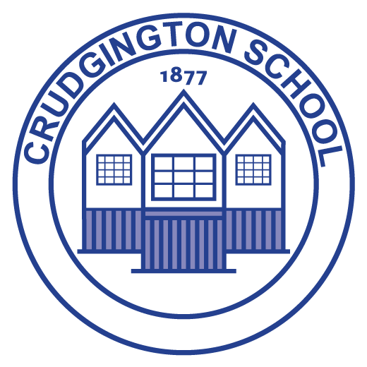 | Autumn 1 |  | Autumn 2 |  |  | Spring 1 |  |  |  |  |  | Spring 2 |  |  |  | Summer 1 |  |  | Summer 2
Value Focus | Humility | Joyfulness | Honesty |  | Equality | Trust |  |  |  | Helpfulness |  | Forgiveness |  | Diversity/  Tolerance |  | Courage | Empathy |  | Respect | Hope
 | Democracy |  | The Rule of Law |  |  | Individual Liberty |  |  |  |  |  | Mutual Respect |  |  |  | Tolerance |  |  | Recap & Revisit
 | Family | Health | Protection From Harm |  | Privacy | Identity |  |  |  | Freedom of Thought |  | The Arts |  | Government Responsibility |  | Non-discrimination | Reparation |  | Education | Access to Information
PSHE: | Being Me in My World  Identifying goals for the year  Global citizenship  Children’s universal rights  Feeling welcome and valued  Choices, consequences and rewards  Group dynamics  Democracy, having a voice  Anti-social behaviour |  | Celebrating difference  Perceptions of normality  Understanding disability  Power struggles  Understanding bullying  Inclusion/exclusion  Differences as conflict,  difference as celebration  Empathy |  |  | Dreams and Goals  Personal learning goals, in and  out of school  Success criteria  Emotions in success  Making a difference in the world  Motivation  Recognising achievements  Compliments |  |  |  |  |  | Healthy Me  Taking personal responsibility  How substances affect the body  Exploitation, including ‘county-lines’ and gang culture  Emotional and mental health  Managing stress |  |  |  | Relationships  Mental health  Identifying mental health worries and  sources of support  Love and loss  Managing feelings  Power and control  Assertiveness  Technology safety  Take responsibility with technology  use |  |  | Changing Me  Self-image  Body image  Puberty and feelings  Conception to birth  Reflections about change  Physical attraction  Respect and consent  Boyfriends/girlfriends  Sexting
RE: | Theme: Beliefs and Practices Key Question: What is the best way for a Muslim to show commitment to God? Religion: Islam |  | Theme: Christmas Concept: Incarnation Key Question: How significant is it that Mary was Jesus’ mother? Religion: Christianity |  |  | Theme: Beliefs and Meaning Concept: Salvation Key Question: Is anything ever eternal? Religion: Christianity |  |  |  |  |  | Theme: Easter Concept: Gospel Key Question: Is Christianity still a strong religion 2000 years after Jesus was on Earth? Religion: Christianity |  |  |  | Theme: Beliefs and moral values Key Question: Does belief in Akhirah (life after death) help Muslims lead good lives? Religion: Islam
Events: | Macmillan Coffee  Morning (25th September)  Black History Month (October) |  | Remembrance Sunday  (11th November)  Anti-Bullying Week  (16th-21st November)  Children In Need (13th November) |  |  | Safer Internet Day  (9th February)  Children’s Mental Health Week  (February 2023) |  |  |  |  |  | World Book Day (4th March)  World Maths Day  (March 2023)  Comic Relief (March 2021)  British Science Week (March 2023) |  |  |  | Walk to School Week |  |  | Sports Day (July  2023)
Cultural Capital:  (Development of self: Personally Socially  Physically Spiritually  Morally  Culturally) to enable social mobility) | Transition Programme  Black History Week  Global Learning Theme (Democracy)  Election of School Parliament  Remembrance Day artwork  Anti-Bullying Week  Children in Need  Online Safety in computing |  |  |  |  | Safer Internet Day  Mental Health and wellbeing Programme  World Book Day  World Maths Day  Comic Relief  Refugee work  Email work (Computing) |  |  |  |  |  |  |  |  |  | Projects for the community  Sports Day  SRE Program
History: | Ancient Greece  NC-a study of Greek life and achievements and their influence on the  western world |  |  |  |  | Victorians- was it really a revolution?  NC-a study of an aspect or theme in British history that extends pupils’ chronological  knowledge beyond 1066 |  |  |  |  |  |  |  |  |  | The sinking of the Titanic  NC-a study of an aspect or theme in British history that extends pupils’ chronological  knowledge beyond 1066
History Concept Lens | Kingdom |  |  |  |  | Monarchy |  |  |  |  |  |  |  |  |  | Trade
Geography | European Region |  |  |  |  |  |  | The United Kingdom |  |  |  |  |  |  | North America – The Rockies
English: | Character description  Setting description  Recount – biography |  |  | Narrative Historical  Newspaper report  Structured poems |  |  | Non -chronological report  Explanation  Adventure narrative |  |  |  |  |  | Film narrative  Diary  Free verse poetry |  | Visual poetry  Explanation  Character description |  |  | Speech campaign  Dilemma narrative  Persuasion
Whole-Class Reading Book | 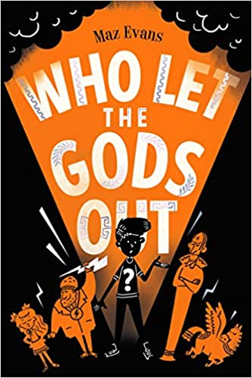 |  |  | 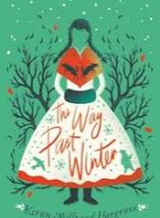 |  |  | 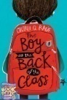 |  |  |  |  |  | 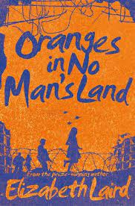 |  | 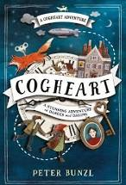
Maths: | Place Value  Four operations  Fractions, Decimals and Percentages  Measurement |  |  |  |  |  |  | Fractions, Decimals and Percentages  Ratio  Measurement  Statistics  Geometry |  |  |  |  |  |  | Geometry  Algebra  Fractions, Decimals and Percentages  Four operations
Science | Classification  Living things and habitats |  |  | Evolution  The life and work of Charles Darwin  Introduction to evolution  Adaptation & survival of the fittest  fossils |  |  |  |  | Heart & Lungs  The circulatory system  Keeping Healthy  Transport of water and nutrients |  | Forces  Falling  Drag & Friction  Simple machines – force changers |  |  |  | Electricity  Effect of changing voltage  Symbols used in drawing circuitry |  |  | Field Study  Sampling techniques  Populations – annual change  Reasons for change
Science Experiments  investigation | Investigating Yeast  Observe the growth of yeast and the waste products of yeast  Investigate the things yeast needs to grow |  |  |  |  |  |  |  | Investigating Pulse  Collect, graph and analyse breathing and heart rate data collected whilst exercising |  | Investigating Friction  Planning & writing up an investigation focussed on how surface type may affect friction |  |  |  | Investigating Wires  Investigate the effect of length and thickness on the flow of electricity in a circuit |  |  | Sampling Techniques  Using a range of sampling techniques to assist with field studies
Science links with maths | Graphing  Volume  Time |  |  |  |  |  |  |  | Branching databases |  | Length  Distance |  |  |  | Units  Volts  Amps  equations |  |  | Distance  Area  frequency
Computing | Internet communication  Online Safety |  |  | Video production  Online Safety |  |  |  |  | Variables in games |  | Flat-file databases |  |  |  | 3D modelling  Online Safety |  |  | Selection in quizzes

Art & Design | Sculpture  Link with Ancient Greece |  | Painting |  | Drawing
Design & Technology | Textiles  Combing different fabric shapes (Tudor purse) |  | Structures  Frame Structures |  | Food  Celebrating culture and seasonality (breads and comparing food)
Music | Reading & Composing Music (Level 2)  To learn to read pitch and rhythm to create, notate and improve own compositions and other pieces of music from around the world and the great composers. |  | The Big Sing  Technique  Expression  Accuracy |  | Music Through Time  Knowledge & Understanding  Musical Elements  Musical Contexts  Musical Language
PE | Hockey | Dance | Gymnastics | Cricket | Maypole | Athletics
French | School Subjects and opinions (progressive)  Repeat and recognise the vocabulary for school subjects.  Say what subjects they like and dislike at school.  Say why they like/ dislike certain school subjects.  Tell the time (on the hour) in French |  | The Olympics (intermediate)  Learning Olympic history (looking at the ancient Olympics and the beginnings of what we now refer to as the modern Olympic games), a selection of Olympic sports, how to say 'I play' and 'I do not play' a sport using the verb 'faire' and we also introduce the children to a selection of famous Olympians (examining how we express sports and nationality using correct grammar). |  | My Home  (Intermediate)  Say whether they live in a house or an apartment and say where it is.  Repeat, recognise and attempt to spell up to ten nouns (including the correct article for each) for the rooms of the house in French.  Tell somebody in French what rooms they have.

